**AWS CODE PIPELINE**

**SECTION 1: OVERVIEW**

* AWS Code Pipeline: Continuous delivery service of AWS to model ,Visualize and automate your software release process.
* Stage: Group of one or more actions in a pipeline .In a stage ,Only one source revision can be processed at the same time
* Action: A task performed on a source revision. Actions can be run sequentially or parallel in the stage they belong to.
* Transition: A connection between two stages. It can be enabled or disabled.

Sample pipeline Between S3 buckets

1)Create two S3 buckets for our pipeline ,one is using as source of pipeline and second can be used as production.

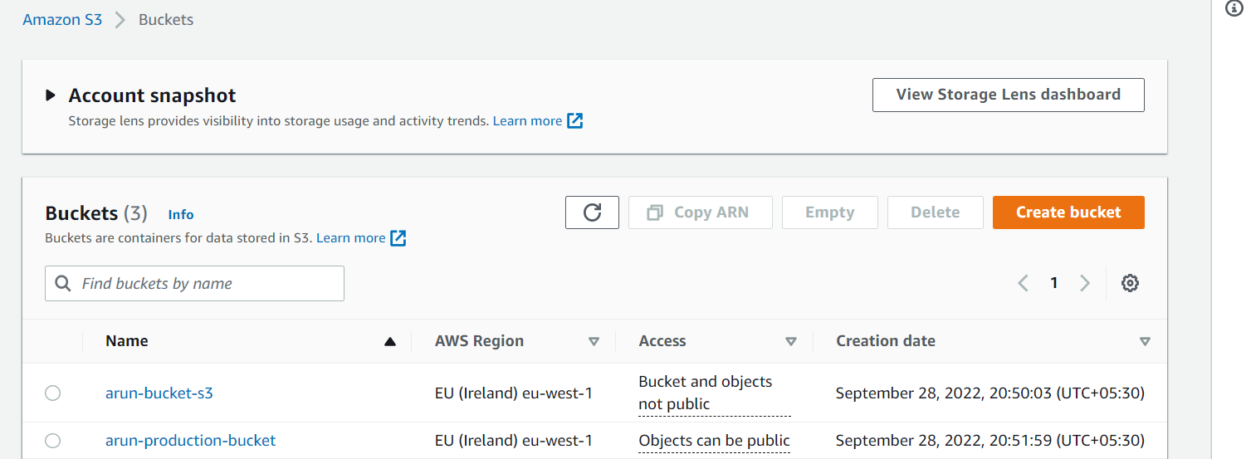

* Enable static website option in production bucket and also disable the checkbox : block all public access

2)Zip our index.html file and error.html file in local machine and upload it to our Source S3 Bucket as Zip folder.

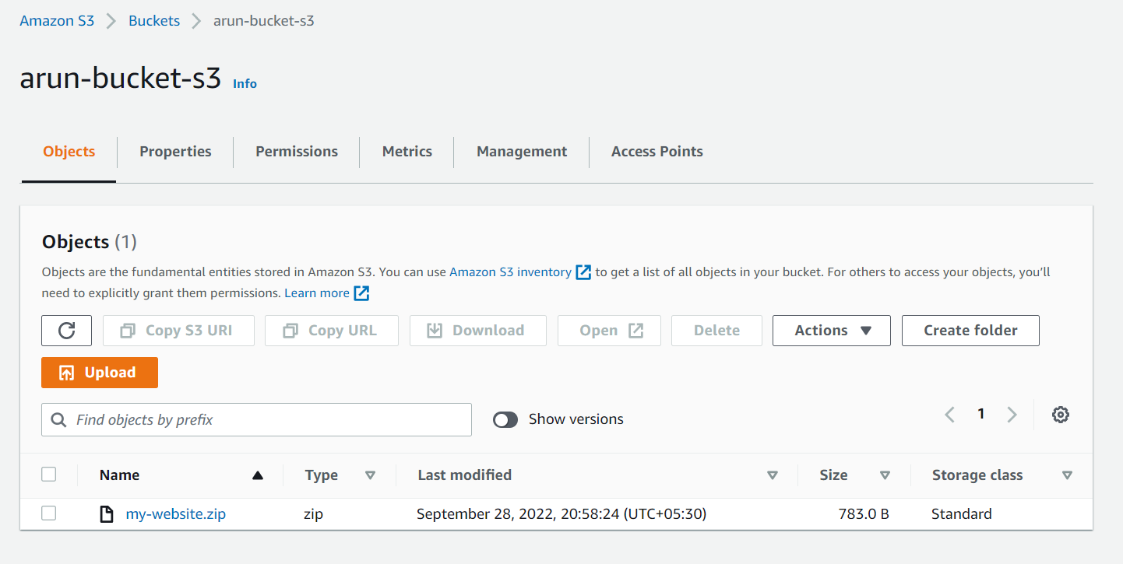

3)Open Code pipeline and select option create a pipeline.

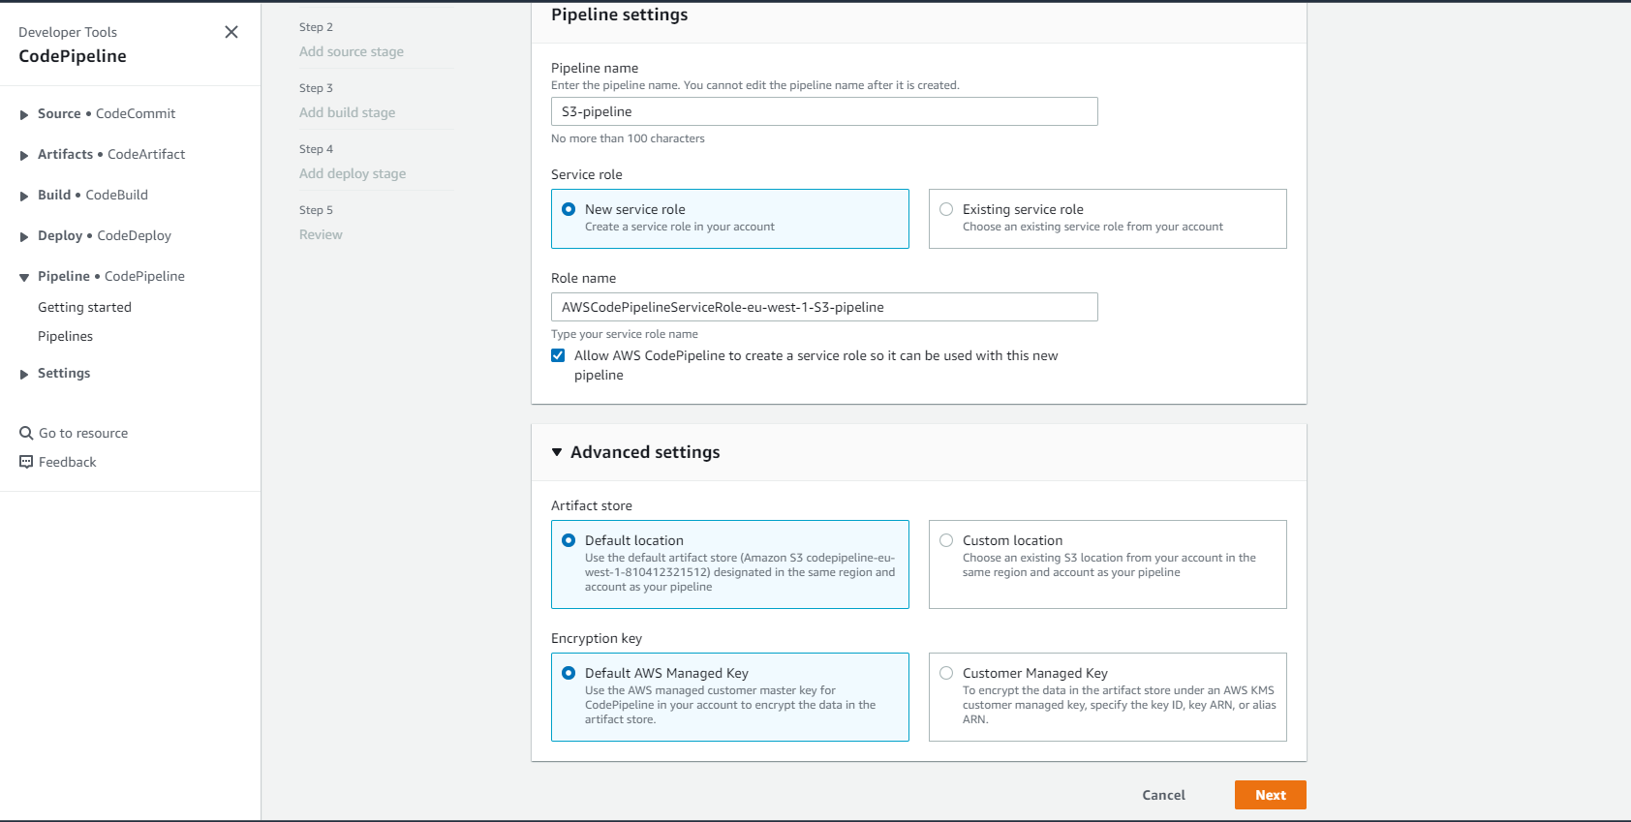

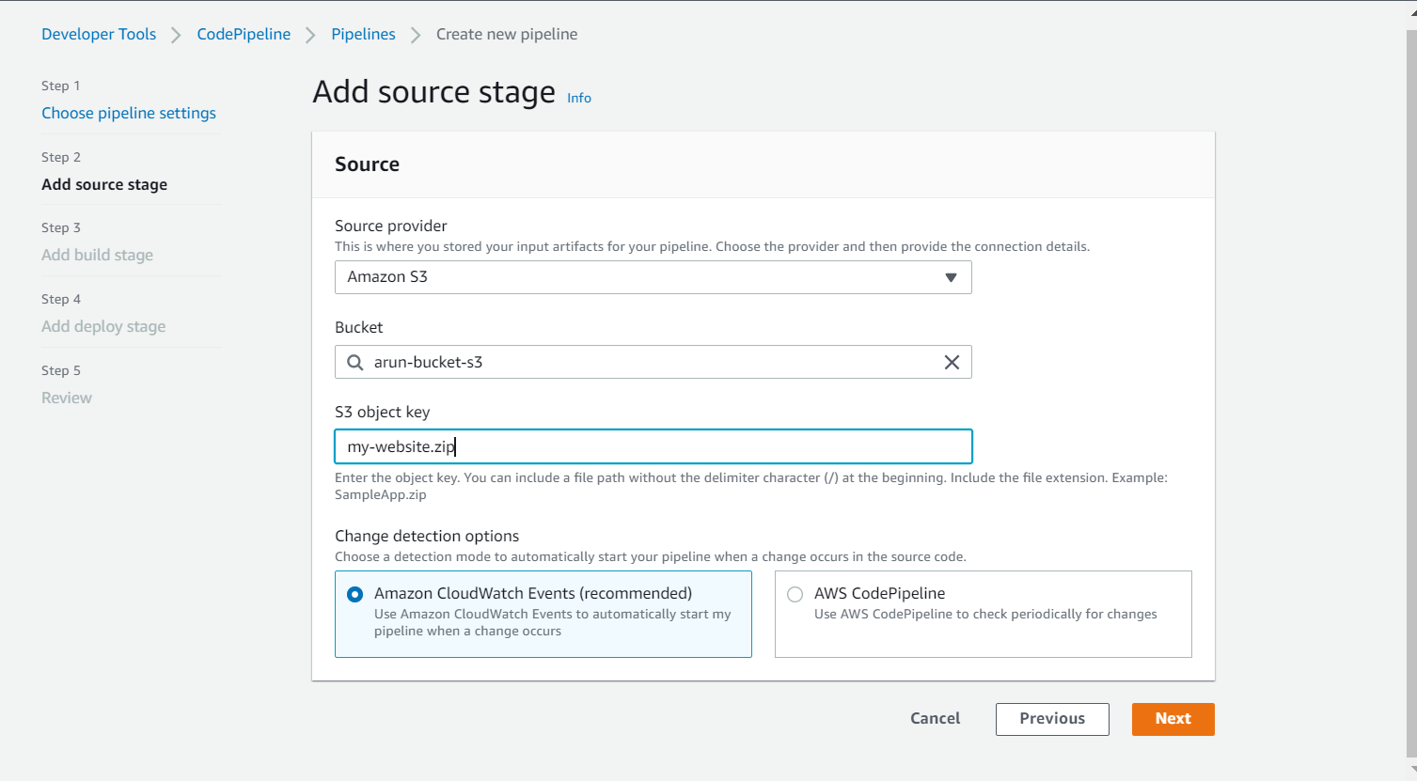

* Skip build stage for this example

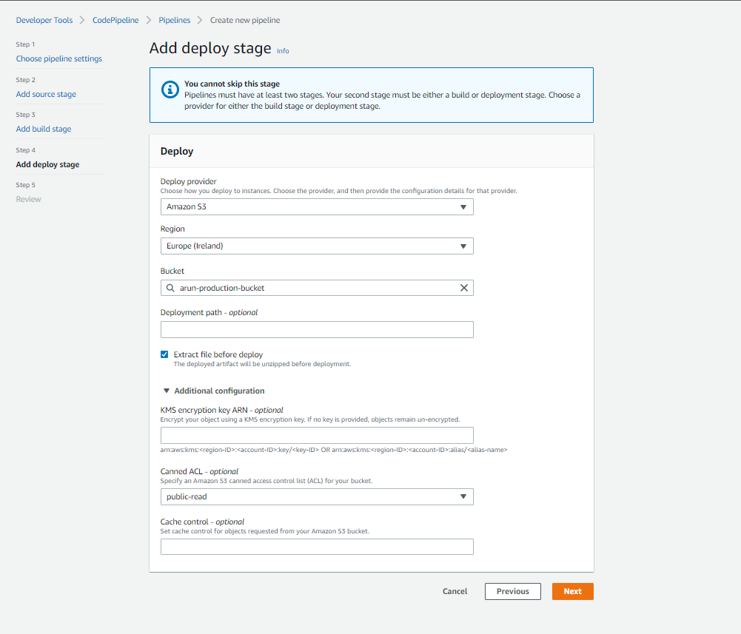

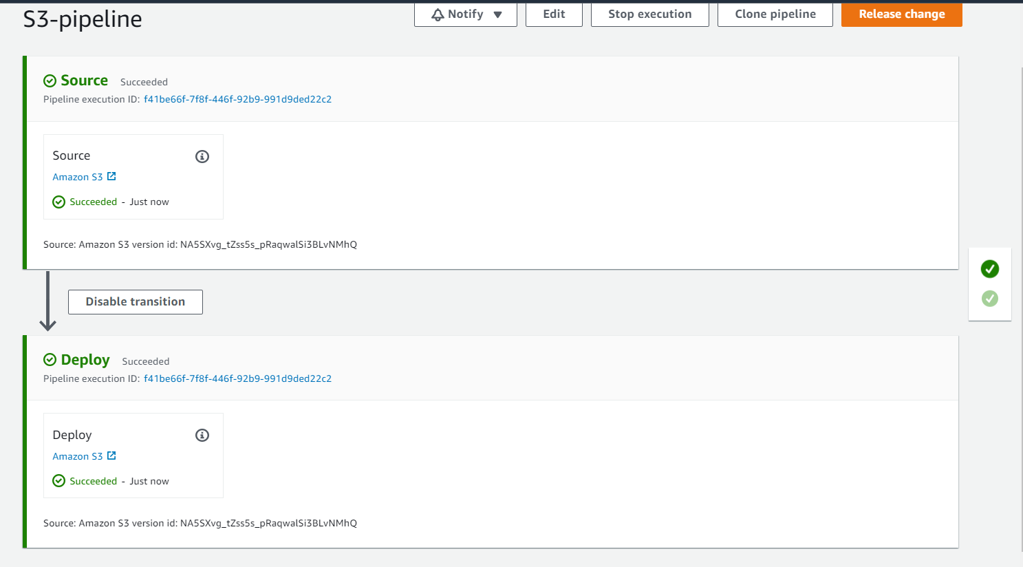

4)Now we can go to production S3 bucket properties and copy the URL under static website hosting and access it in browser.

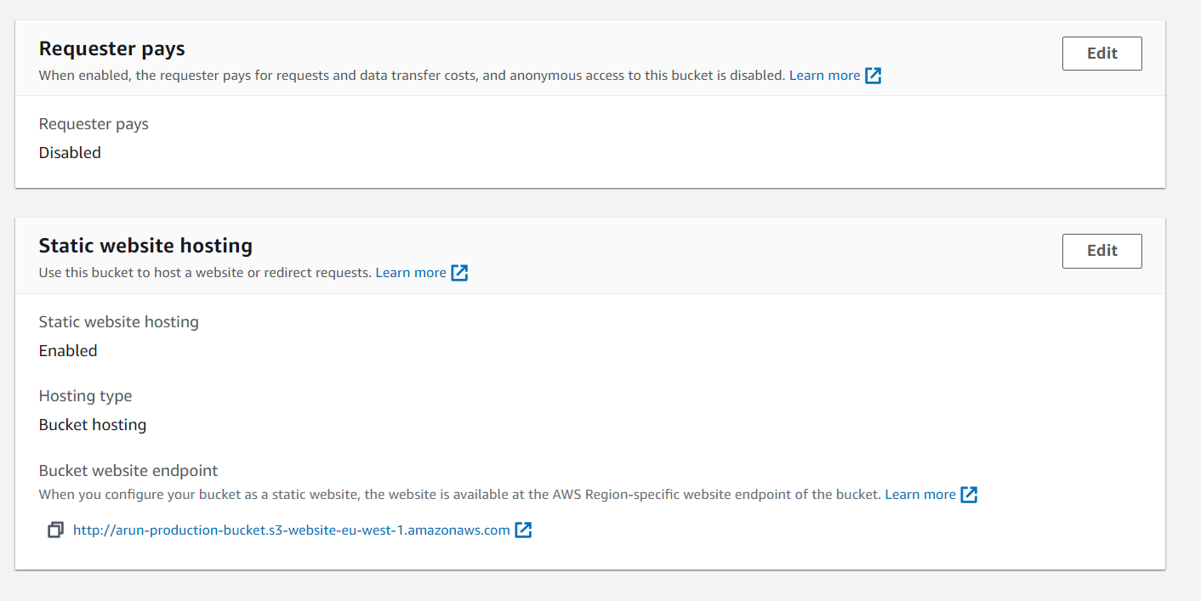

………………………………………………………………………………………………………………………………………………

**SECTION-2: AWS CODE COMMIT**

* AWS service for hosting private Git Repositories ,it’s a serverless service
* Highly available and scalable
* Parts of AWS Developer tools and can be integrated with other services
* Data at rest is encrypted with KMS Keys

Connecting to Code Commit repository from local machine

* Create an IAM user with full permission for Code pipeline ,Then login as that user in AWS console , then go to users tab and then select the user then go to security credentials .From their Generate HTTPS Git credentials for AWS code commit and save the username and password.
* Now open our source code in any of the local file editor (Visual studio) then do git commands, and then configure our code pipeline credentials ,then push our code.

Creating pipeline from Code commit Repository

1. Create an S3 bucket for production

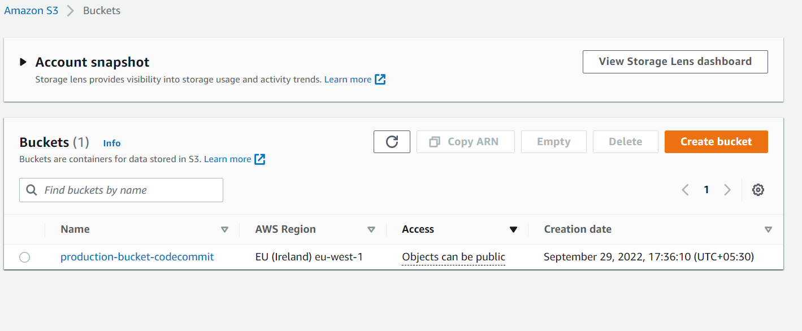

2)Now create a pipeline

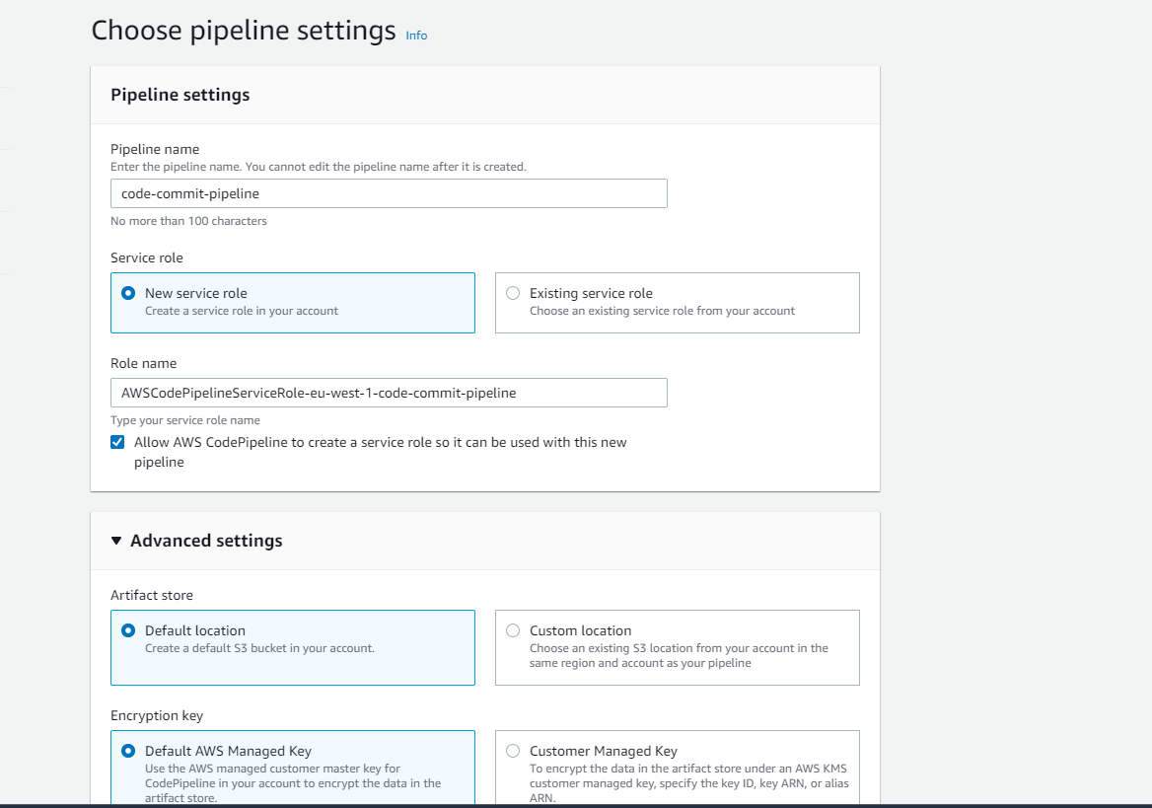

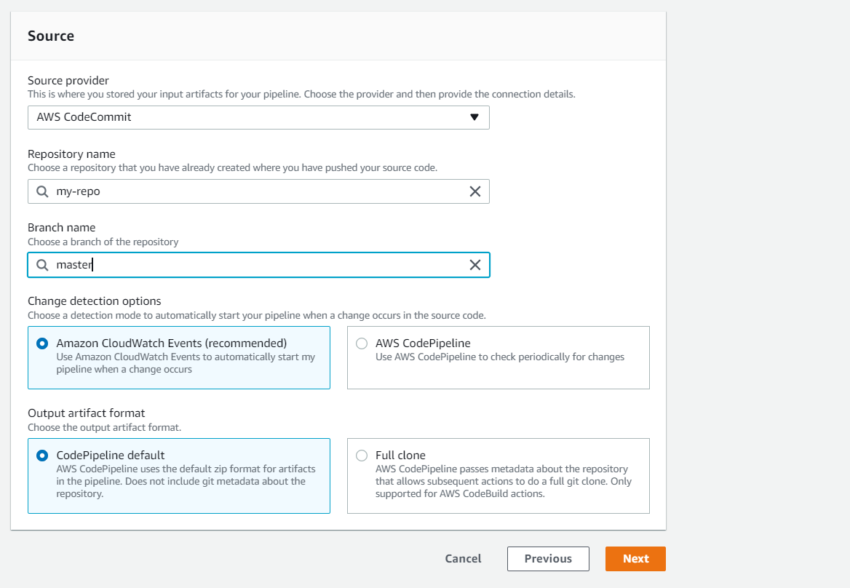

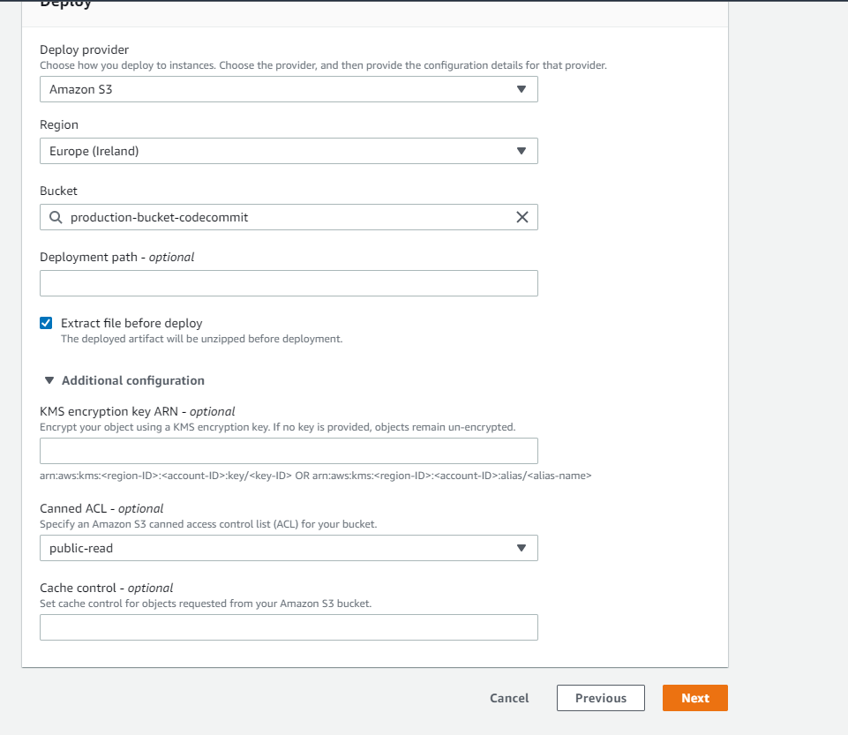

………………………………………………………………………………………………………………………………………………

**SECTION-3: AWS CODE BUILD**

* Build service in the AWS and part of AWS developer tools
* It acts as a command line in your pipelines
* It uses a docker containers to launch your build environments
* Buildspec: it is a YAML file containing your commands and runtime enviornments settings ,it can be provided as a file with source code

Creating a pipeline with Build Stage

1)Create a AWS code commit repo and push our code in to it

2)Create a S3 bucker for our production environment

3)Now go to pipeline ->Create a new pipeline -> Configure the source control stage -> Then go to build stage and create a new build pipeline

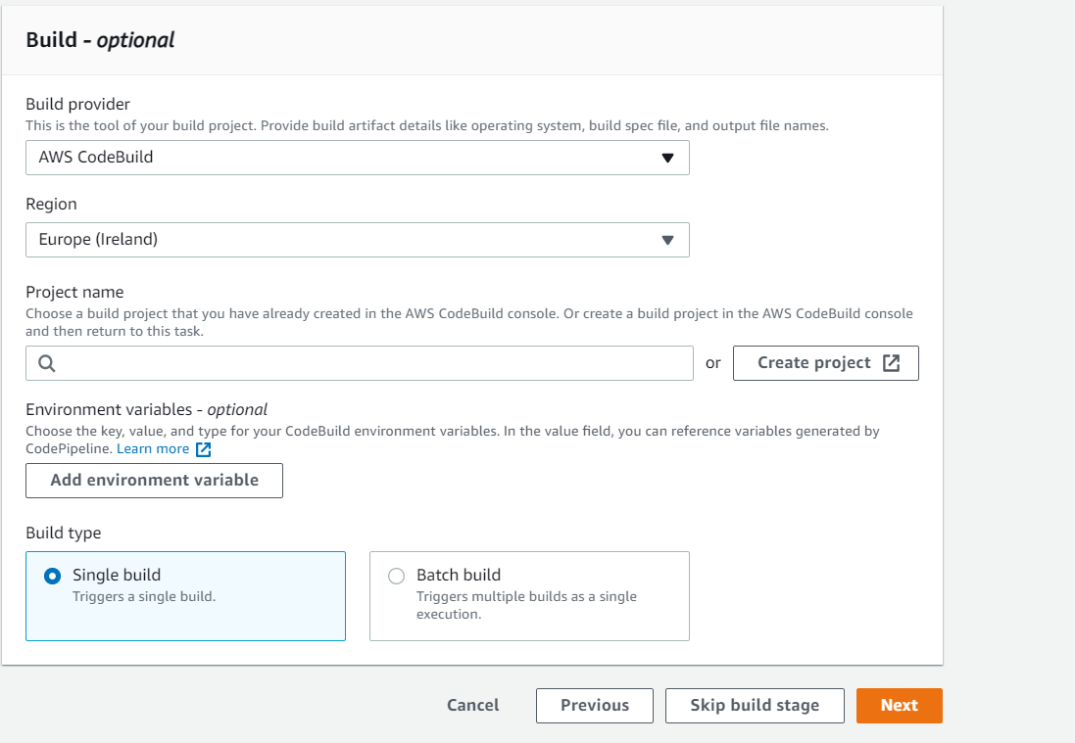

4)Now we need to create a project for build : for that click on create project tab in the same page

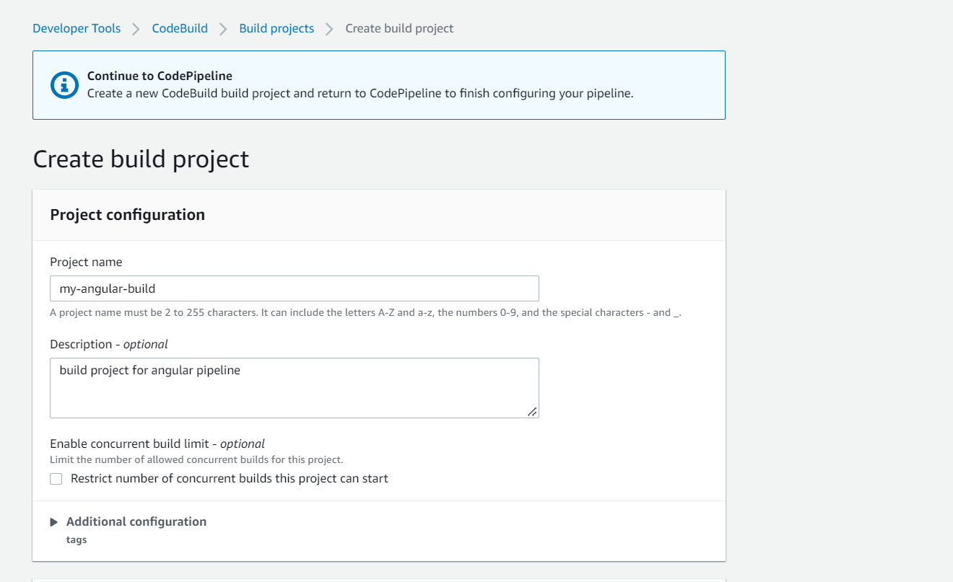

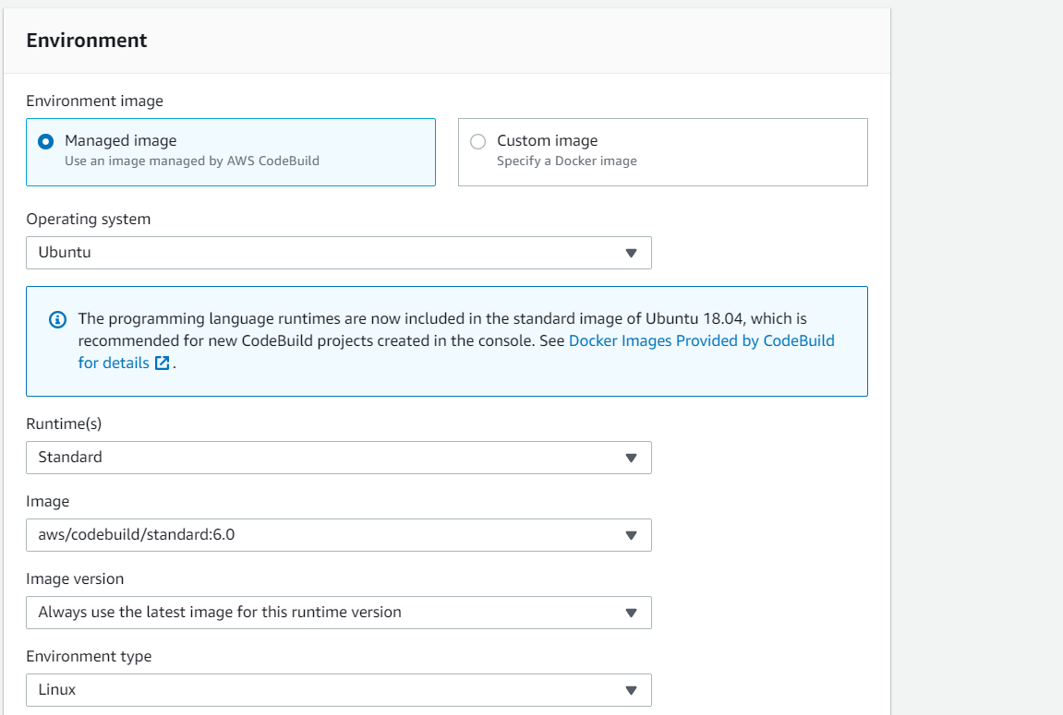

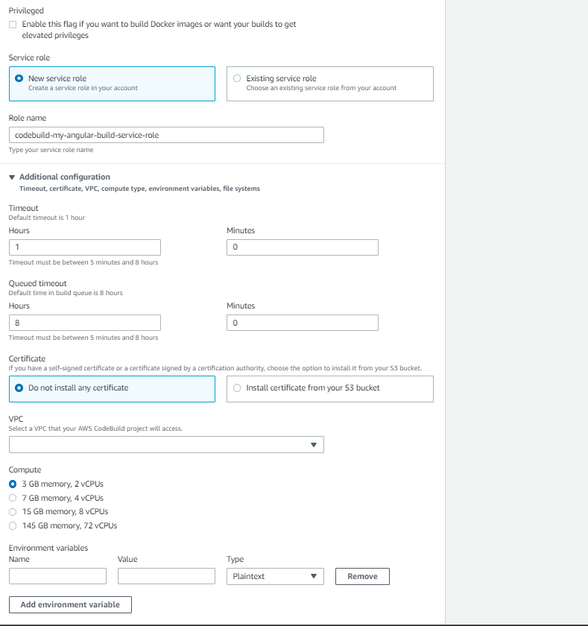

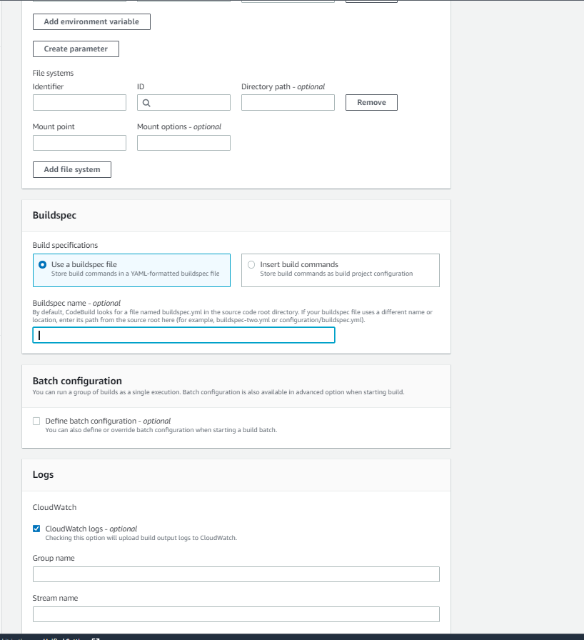

5)Now press continue to pipeline option , there we can see our project that we created.

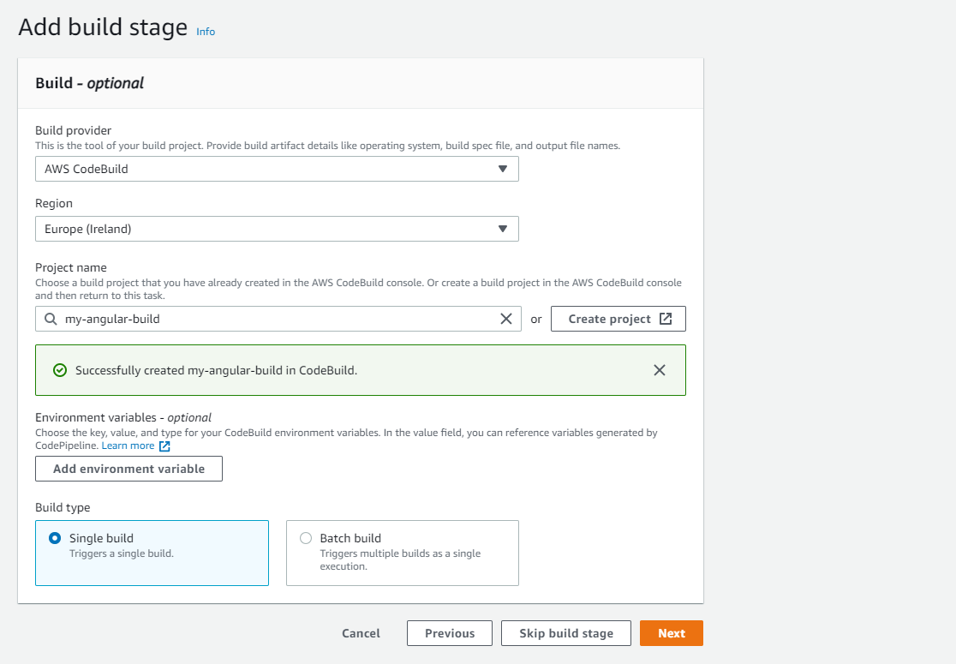

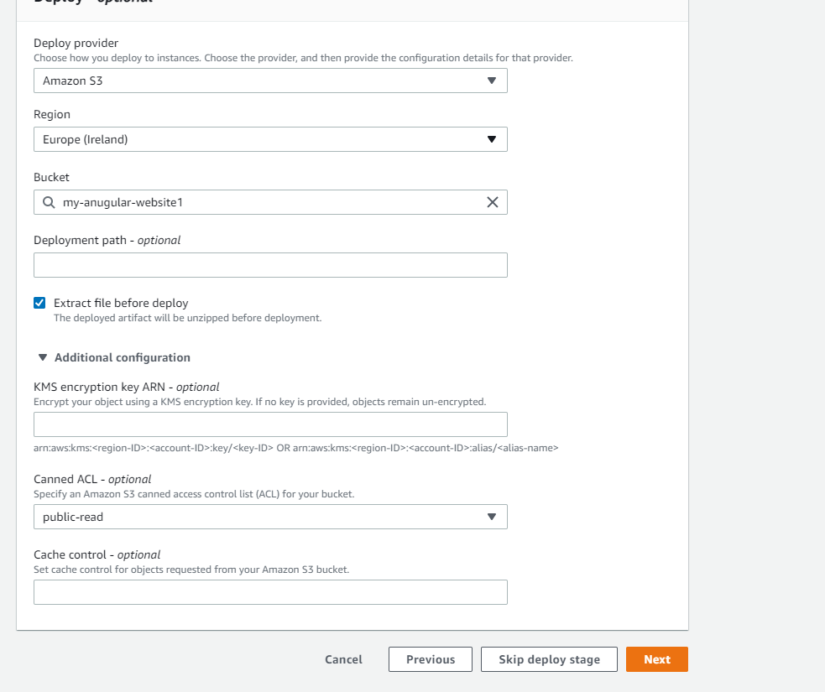

6)Now press next and create our pipeline

7)Now our pipeline will fail at the build stage : The reason is we didn’t add the Buildspec YAML file in the Build stage.

Creating Buildspec file for Our Build:

1)We need to create Buildspec file on the root of the Repository

Steps to create the buildspec.yml file

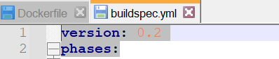

Buildspec phases:

Install:

* Commands during installation
* Use for installing packages in the build environment
* Runtime versions are also defined in this phase. If not specified ,default runtime in the build image are used

pre_build:

* Commands run before the build
* Use for installing dependencies like signing into ECR or docker hub etc..

build:

* Commands run during build.
* Use for running build and tests

post_build:

* Commands run after the build
* Use for your post build actions such as pushing docker images to ECR , Sending notification via SNS etc..

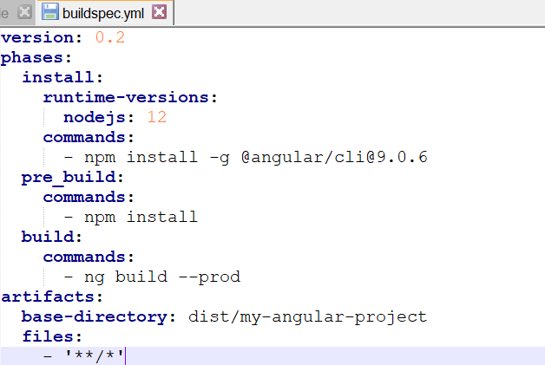

version: 0.2

phases:

install:

runtime-versions:

nodejs: 12

commands:

- npm install -g @angular/cli@9.0.6

pre_build:

commands:

- npm install

build:

commands:

- ng build --prod

artifacts:

base-directory: dist/my-angular-project

files:

- '**/*'

2)Now Save the buildspec file and push it into our Code commit repository , after adding this file pipeline automatically trigger and run pipeline and deploy it.

……………………………………………………………………………………………………………………………………………….

Adding a testing step for above created code build stage

* Firstly create another Yaml file in the same repository locally for our testing purpose(unit-test-buildspec.yml)

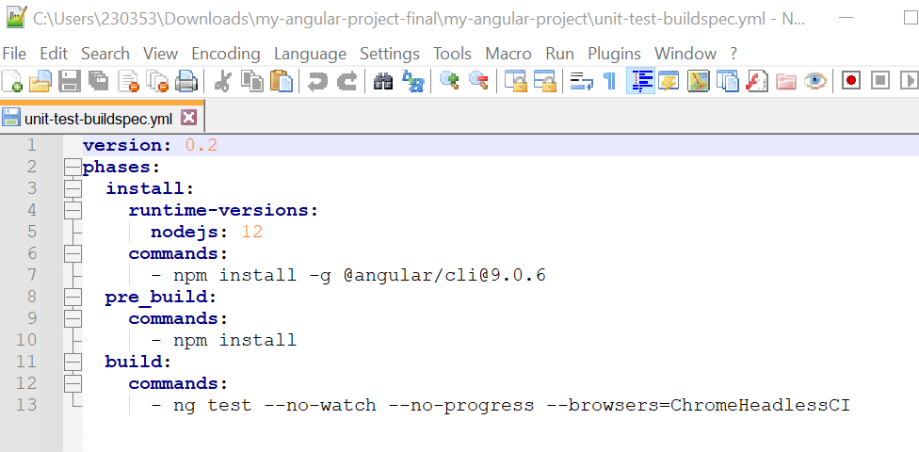

* Now go to AWS console and edit build stage -> Click add action group - > configure the first details -> and then go to build project ->create new build project->Then configure all details there as previous build ->then go to build spec session ->select choose a build spec file option -> Then their select the new Yaml file which we created for testing -> Then fill all the details and save our changes -> come back to our pipeline and save the pipeline.
* Now if we do any failure in the code, and push the code to AWS code commit ,Pipeline will pass the source stage and it will fail at the test stage that we added in the above step . This way we can add test step for our pipeline.

……………………………………………………………………………………………………………………………………………….

**SECTION-4: AWS CODE DEPLOY**

* AWS service to automate your application deployments
* You can deploy to one instance or thousands of instance
* Supported platform : EC2 , Lambda ,ECR ,On premises
* Code Deploy concepts:
* Deployment Group : A set of instances where the application deployed to.
* Revision: The version of your application containing your source code, Deployment scripts and deployment specification file
* Deployment: Execution of the deployment to the deployment group for a specific revision and deployment configuration
* Appspec : YAML or JSON file that defines the specifications of the code deploy deployment ,it similar as buildspec file in code build .Appspec file must be in the root of the source code

Configuring an EC2 instance for Code Deploy Deployments

1. Create an EC2 instance and install code-deploy agent and ngnix server inside it
2. Creatin an application and a Deployment group for EC2 instance

* For creating deployment, we need to create an application

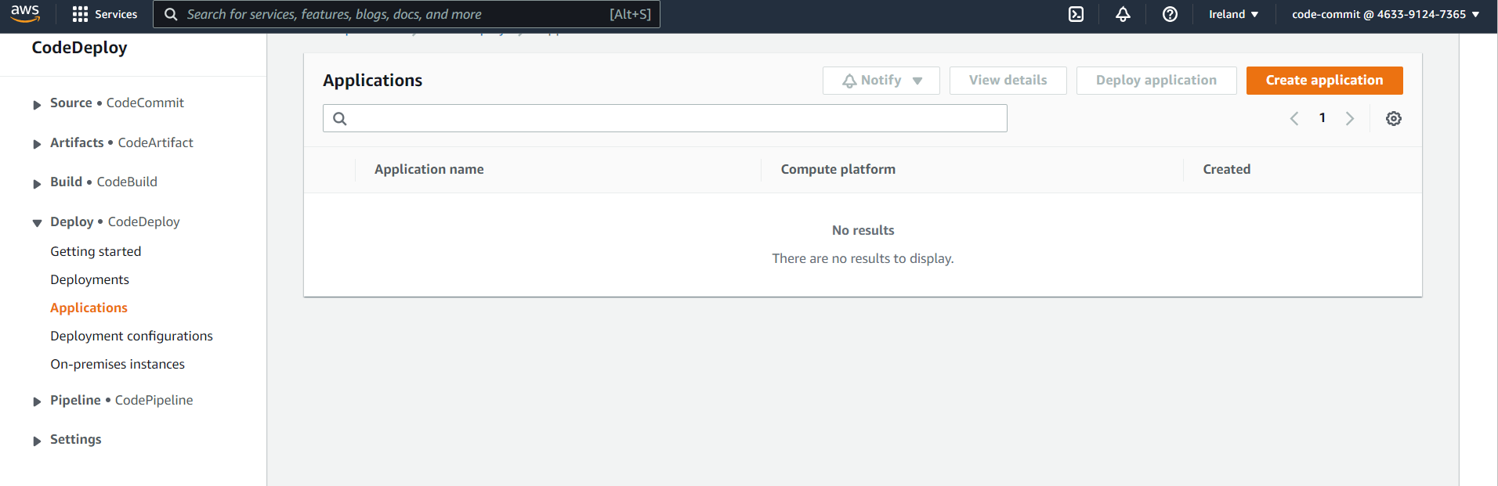

* Go to application inside code deploy->Create application

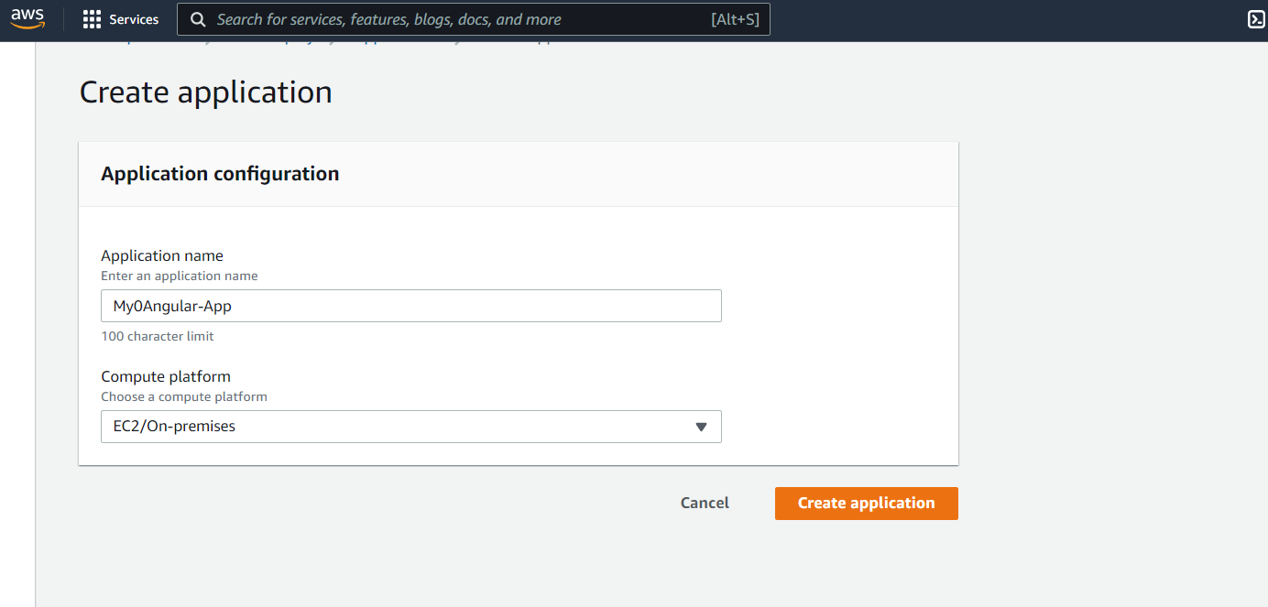

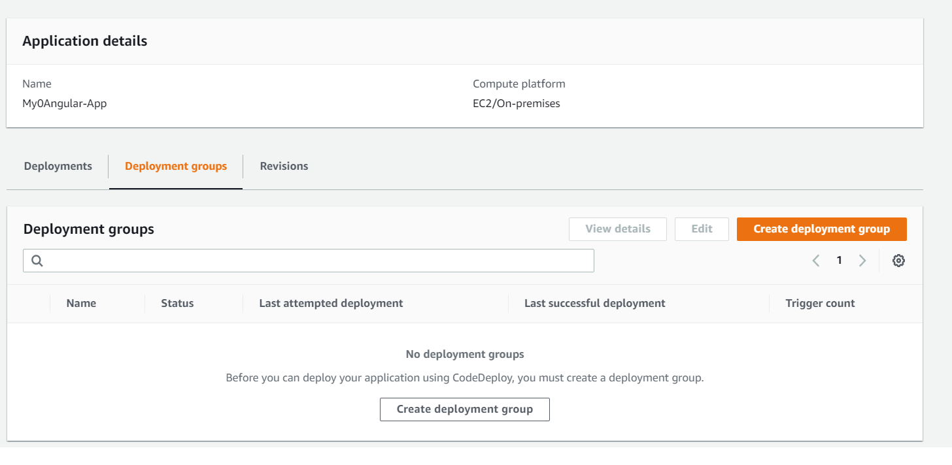

* Now Create a IAM Role for access the tags for EC2 instance

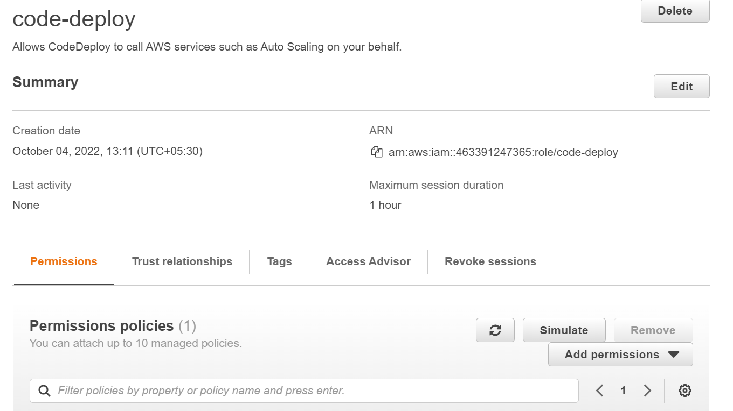

* Now go to Code deploy and create a deployment Group

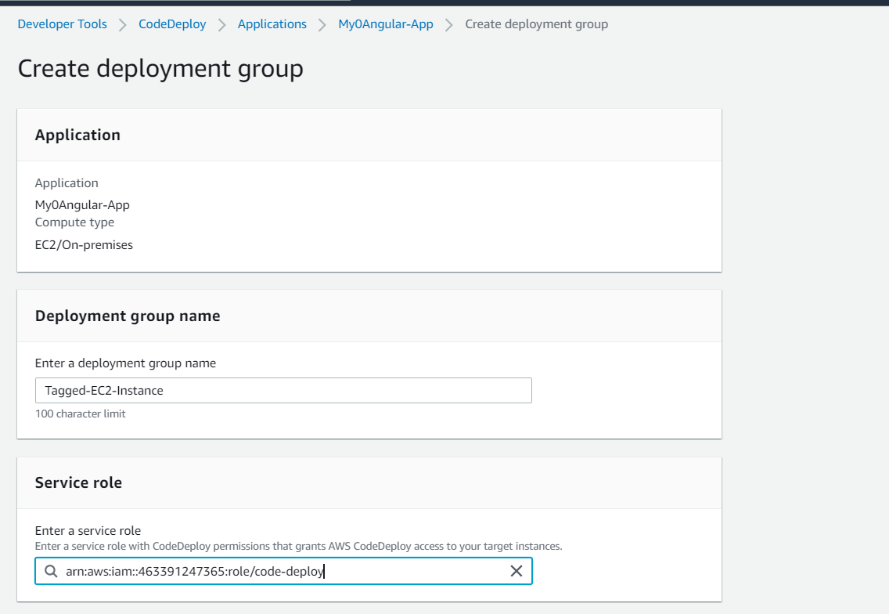

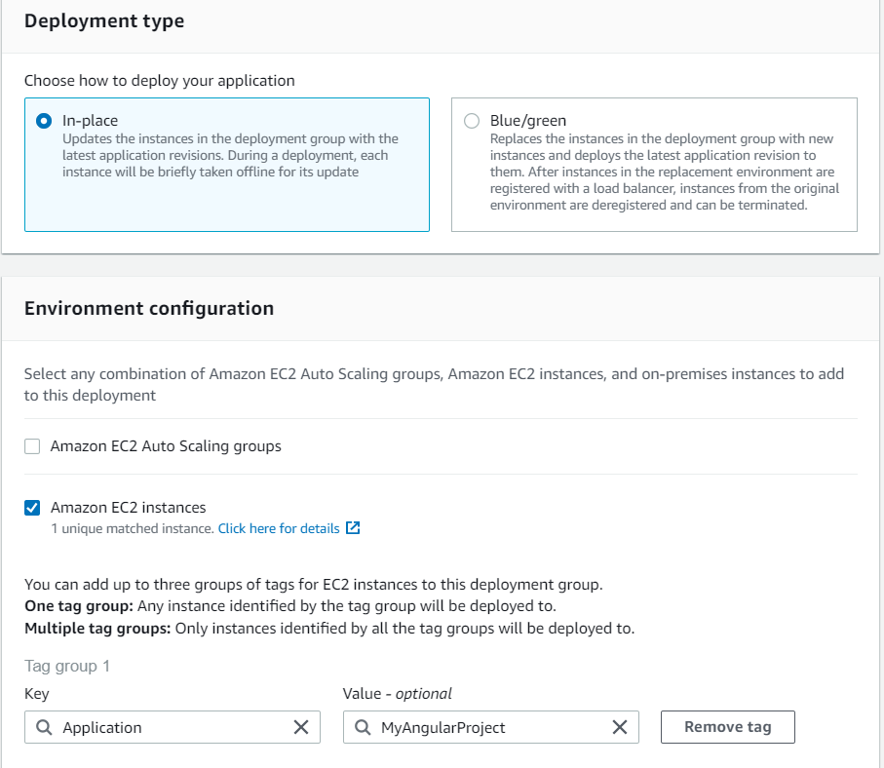

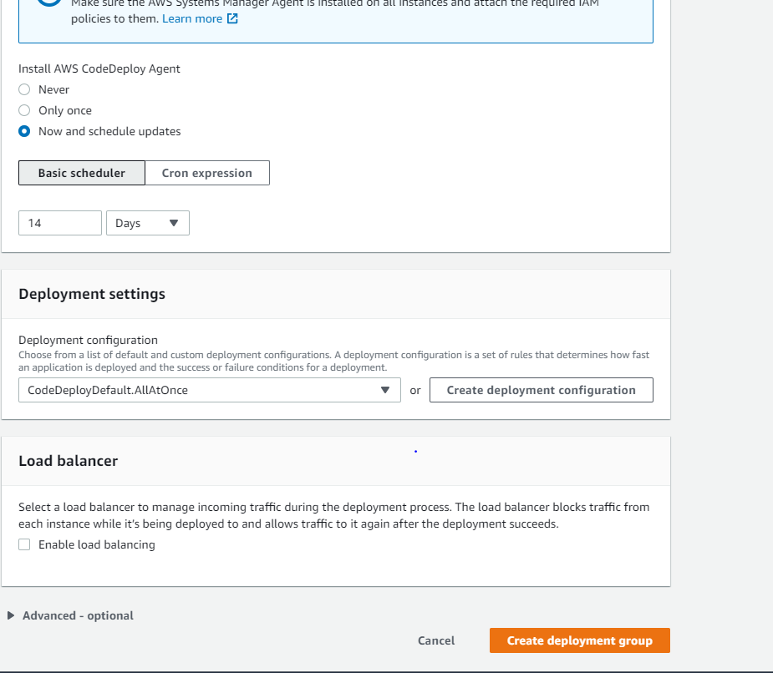

3)Adding a Code Deploy Deploy action to your pipeline

* We edit the previously created pipeline for this

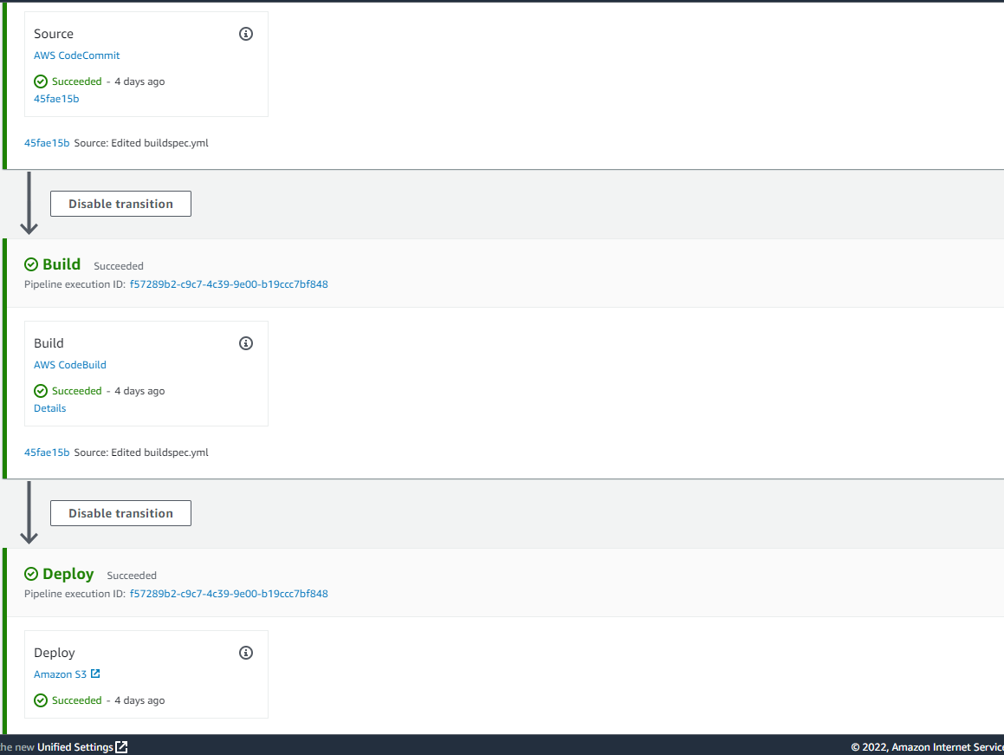

* Edit the pipeline as follow
* Delete the existing Deploy stage and add a new Action group as follow

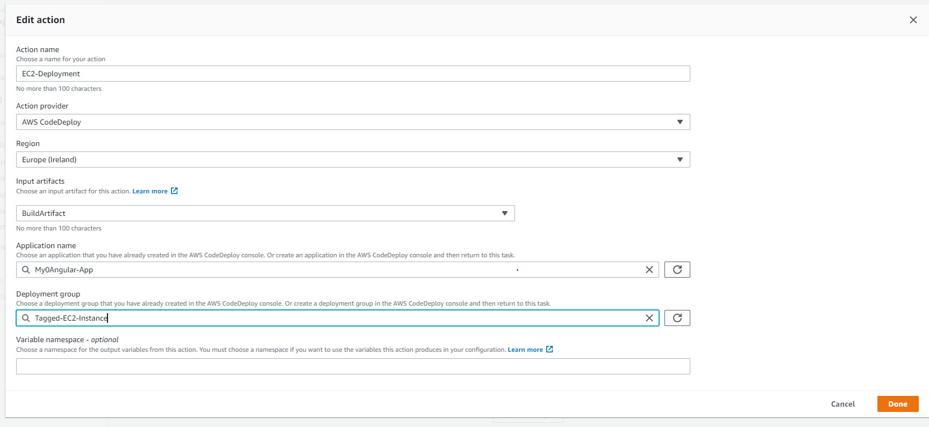

* Now save our pipeline

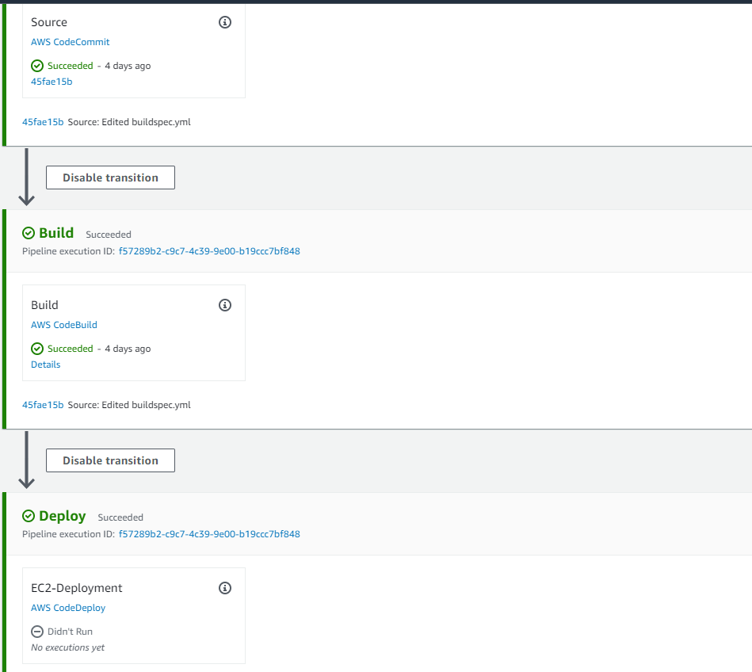

4)Creating an appspec file for Deployments to EC2 instances

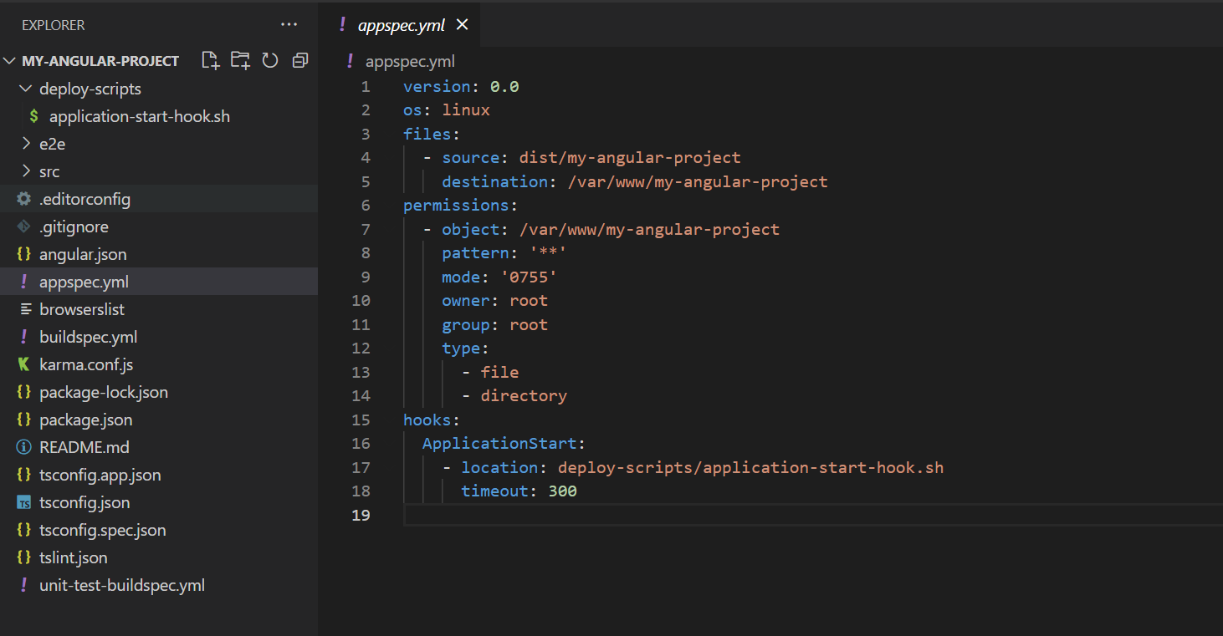

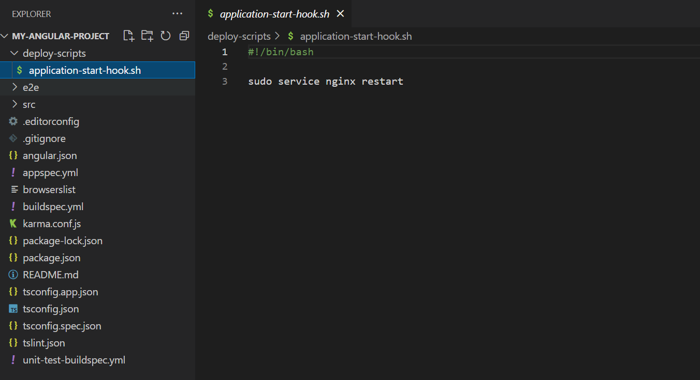

* Push this code to Code commit and our pipeline will trigger and it will push the application into our EC2 instance.

……………………………………………………………………………………………………………………………………………

Streaming Deployment logs to CloudWatch Logs

* Add a new CloudWatch policy for our previously created EC2 instance
* Download the unified CloudWatch agent

wget <https://s3.amazonaws.com/amazoncloudwatch-agent/amazon_linux/amd64/latest/amazon-cloudwatch-agent.rpm>

* Install the package

sudo rpm -U ./amazon-cloudwatch-agent.rpm

* Create configuration file using CloudWatch agent wizard

sudo /opt/aws/amazon-cloudwatch-agent/bin/amazon-cloudwatch-agent-config-wizard

* Configure all the details which is asking in the terminal
* Log file path

/opt/codedeploy-agent/deployment-root/deployment-logs/codedeploy-agent-deployments.log

* The configuration wizard creates the configuration file at /opt/aws/amazon-cloudwatch-agent/bin/config.json
* Edit the config file

sudo nano /opt/aws/amazon-cloudwatch-agent/bin/config.json

* "timestamp_format": "[%Y-%m-%d %H:%M:%S.%f]"

Ctrl+X to exit nano, press Y to save changes, press Enter to approve.

* Start CloudWatch agent

sudo /opt/aws/amazon-cloudwatch-agent/bin/amazon-cloudwatch-agent-ctl -a fetch-config -m ec2 -c file:/opt/aws/amazon-cloudwatch-agent/bin/config.json -s

* Stop CloudWatch agent

sudo /opt/aws/amazon-cloudwatch-agent/bin/amazon-cloudwatch-agent-ctl -m ec2 -a stop

* Check CloudWatch agent status

sudo /opt/aws/amazon-cloudwatch-agent/bin/amazon-cloudwatch-agent-ctl -m ec2 -a status

……………………………………………………………………………………………………………………………………………….

**SECTION-5: Cloud Formation Deploy actions ,Manual approvals and Notifications**

* For Manual Approvals, we need a second environment other than production called Staging environment.

Adding cloud formation Deploy action to pipeline

1)Attach the Cloud formation YAML file in the root of local repository

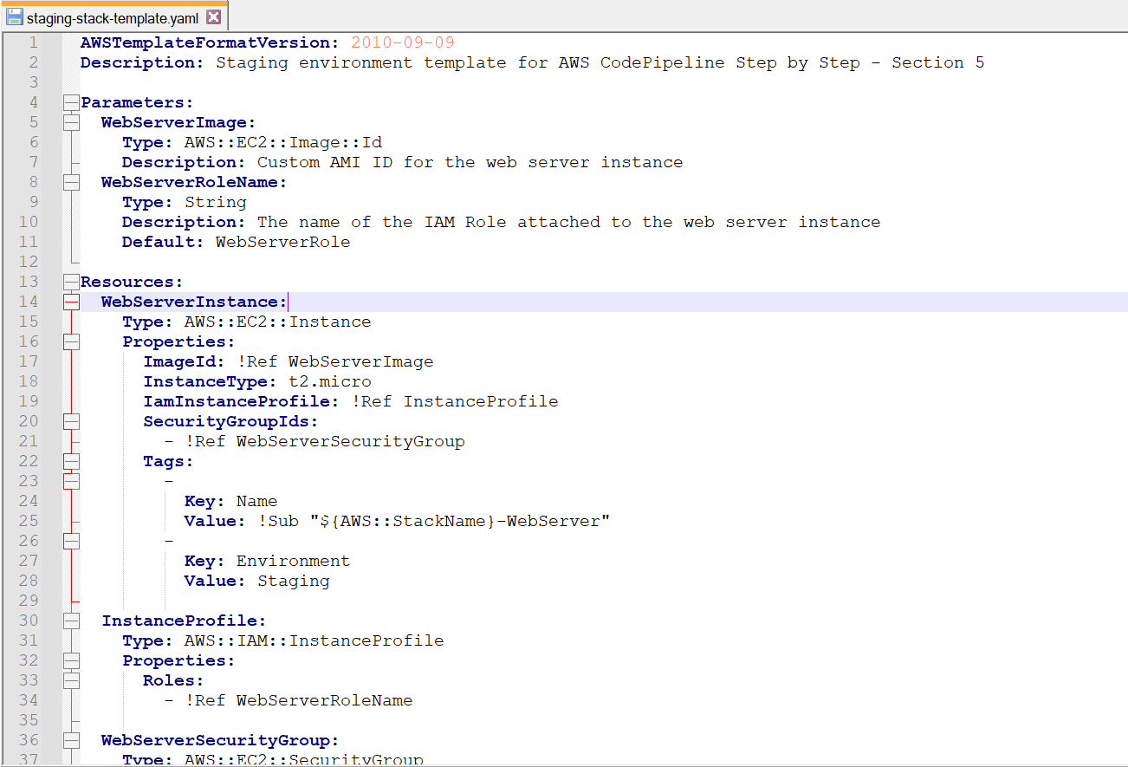

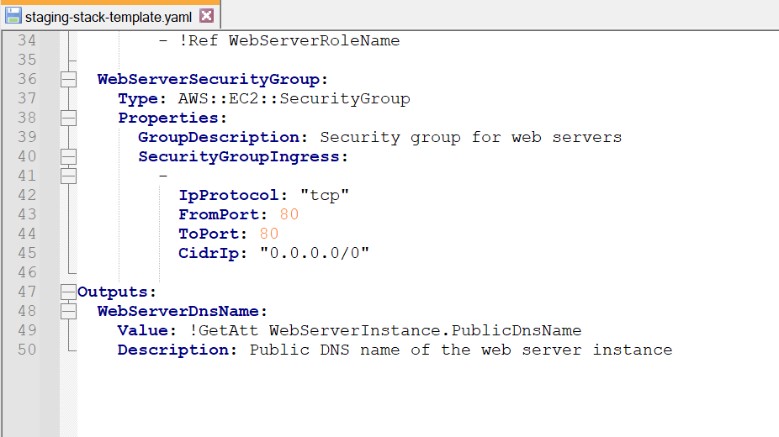

2)As we created IAM role for Code Build and Code Deploy ,We need to create IA M role for Cloud formation

3)Now go to pipeline which we created previously and edit the pipeline for adding another stage : staging between build and Deploy stage

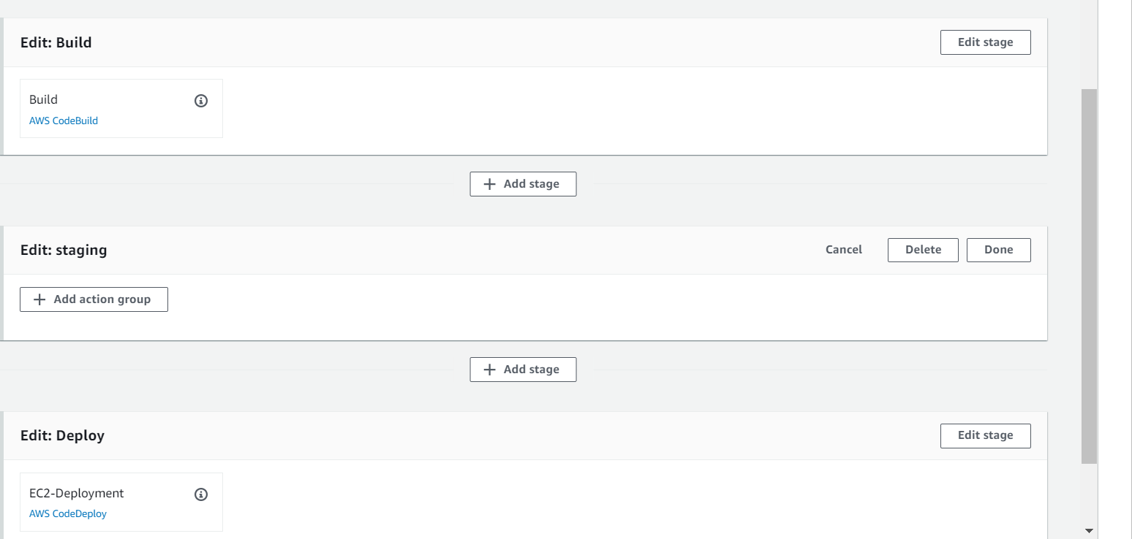

5)Click on add action group ->Configure the action name and action provider

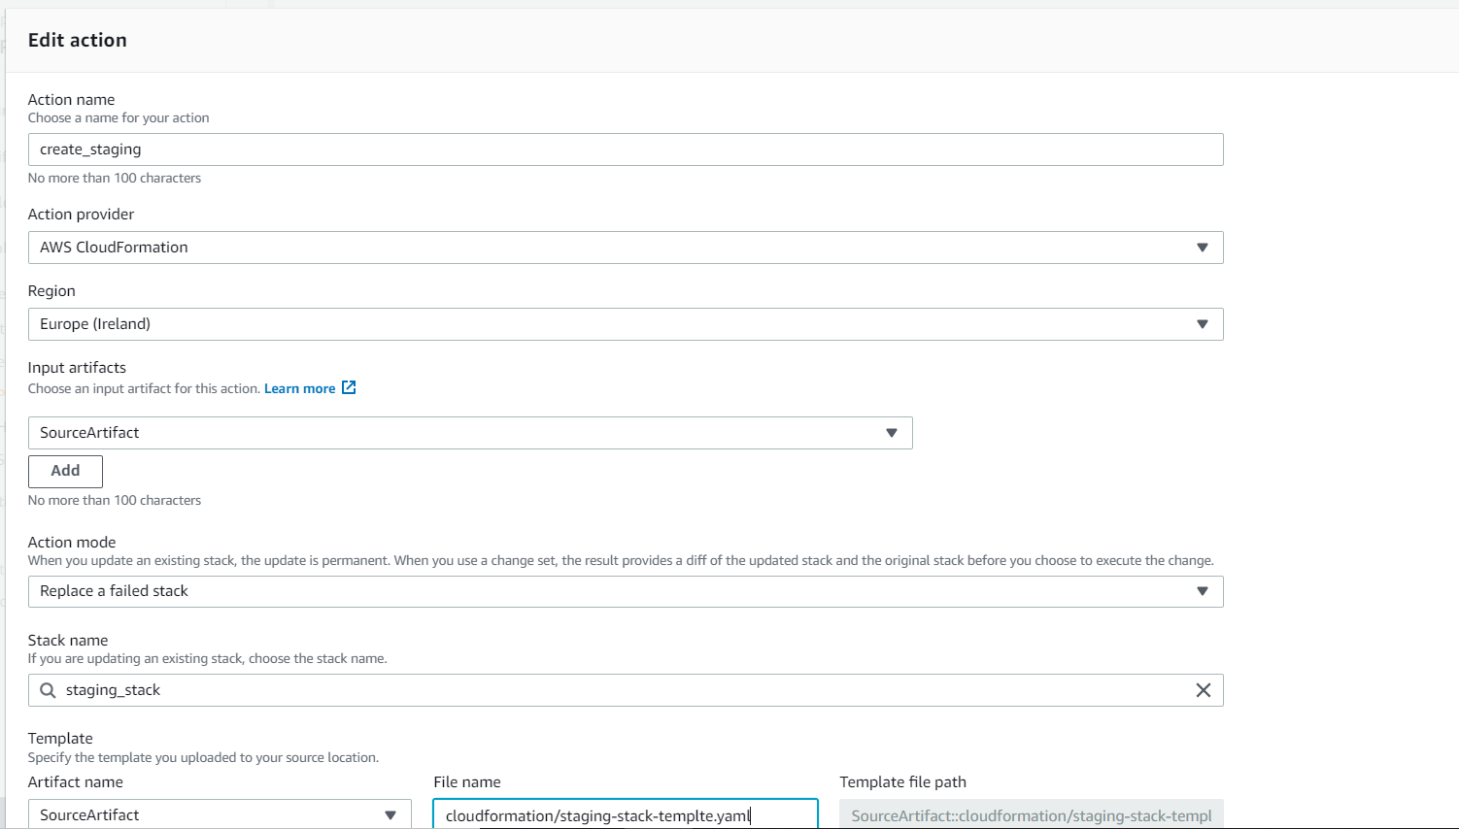

The filename which is given in the above screenshot is our Yaml file which we created on our local repository

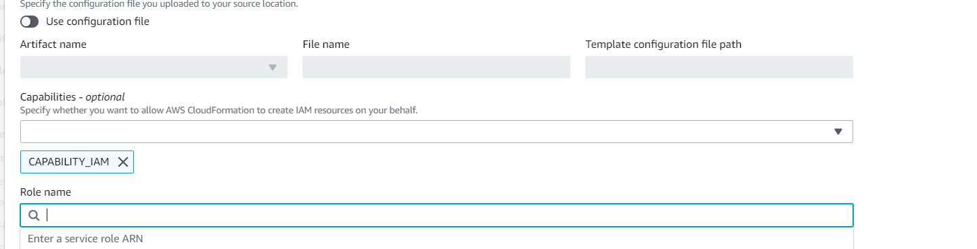

-We need to select the option CAPABILITY_IAM which helps cloud formation to create IAM roles and in the role name field we need to select the IAM role which is created for Cloud Formation in the 2nd step

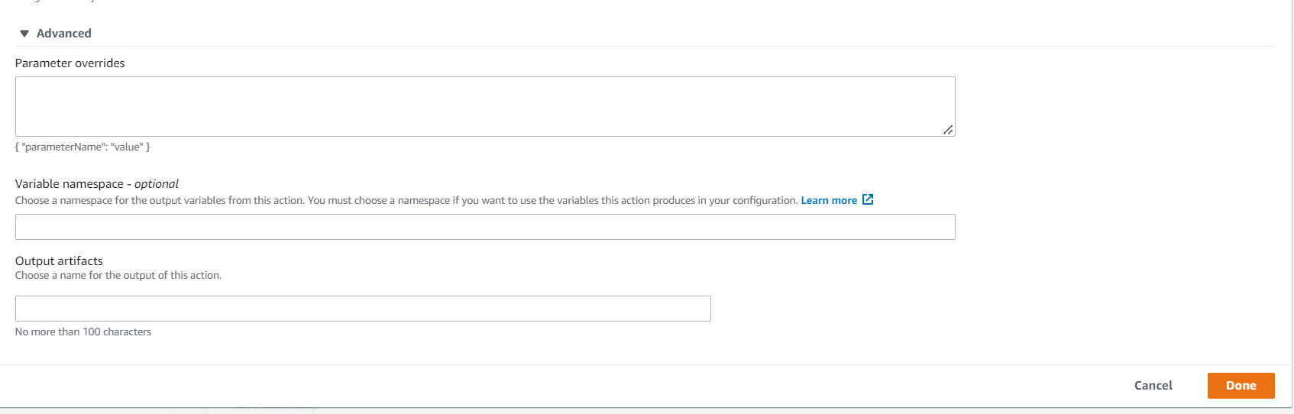

-In the advanced section we can set parameters and its value which we are using inside our cloud formation template(YAML file)

4)Now save the changes and save pipeline.

Adding a Code Deploy Deploy action for the staging stage created previously

1)First we need to create a deployment group for the staging stage

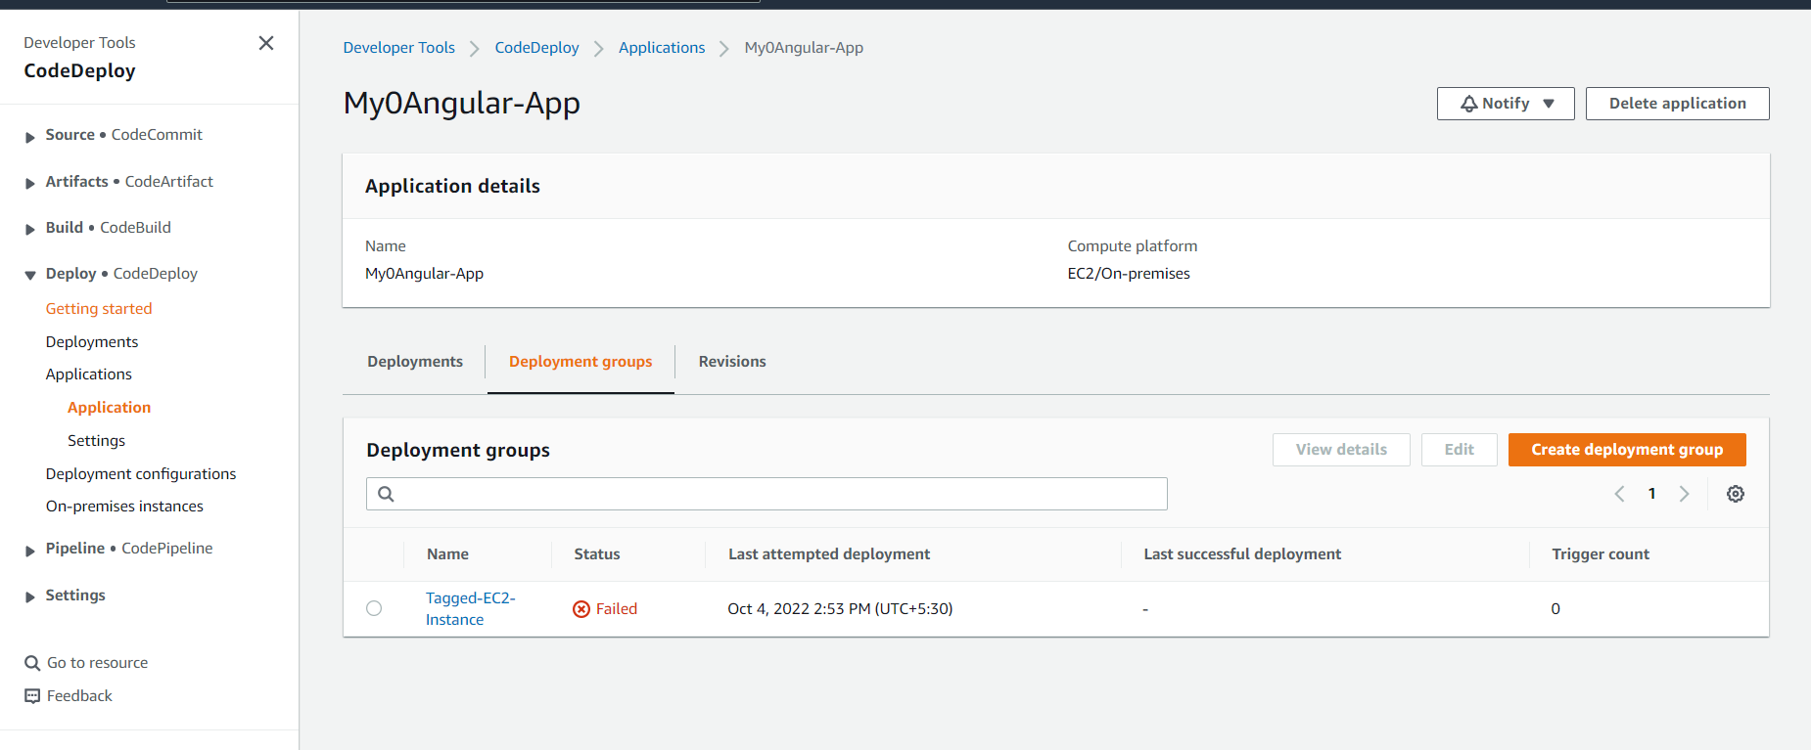

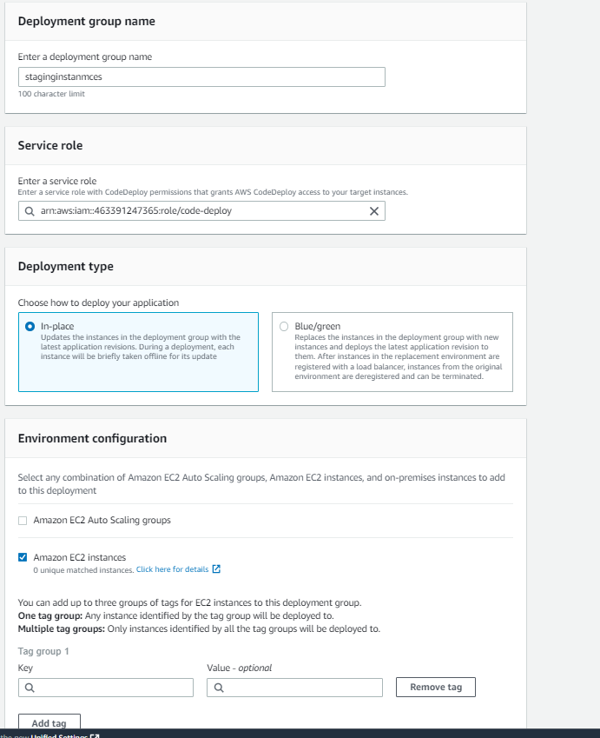

-Select the IAM role for our Code Deploy

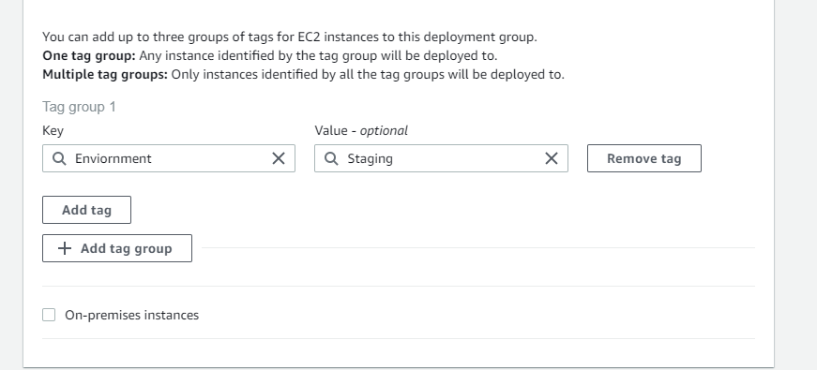

-This tag is we added in our cloud formation Yaml File

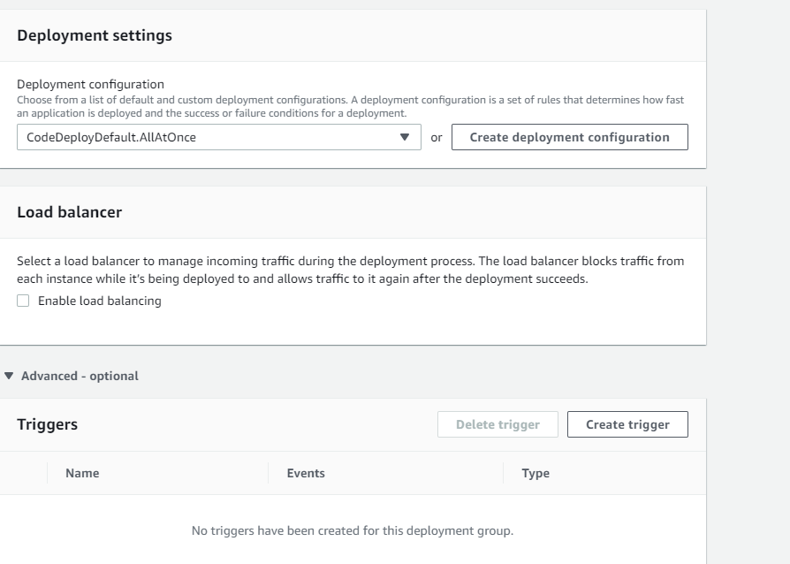

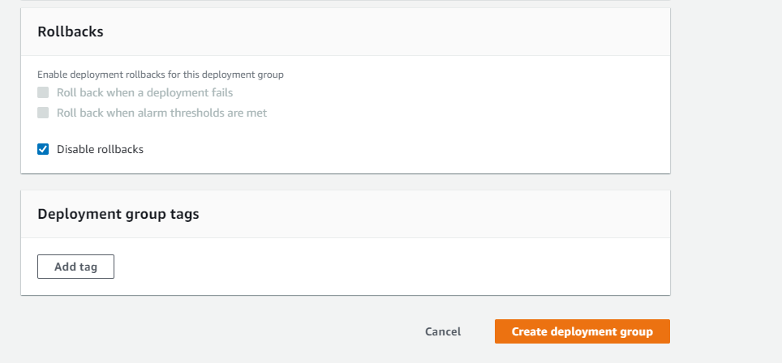

-Now create deployment Group

2)Now go to our pipeline and edit our pipline

3)Edit the Staging job -> click on add action group ->

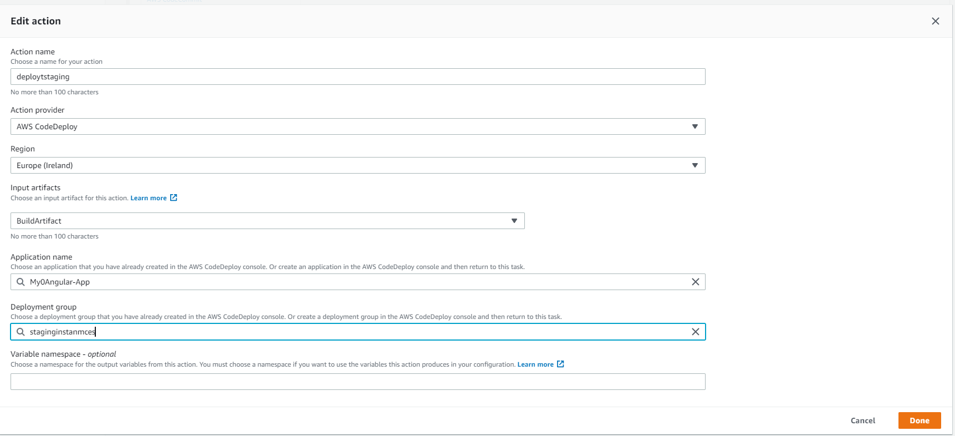

-Click done and goto pipeline and save our changes

4)now go to our local repository ,change source code to new version and push the change to remote repository -> it will trigger the pipeline and staging stage , and we can see our application in staging DNS URL.

Adding a manual approval between Staging and Deploy Stage

1)Create an Amazon SNS topic for our manual approval action

Go to SNS ->

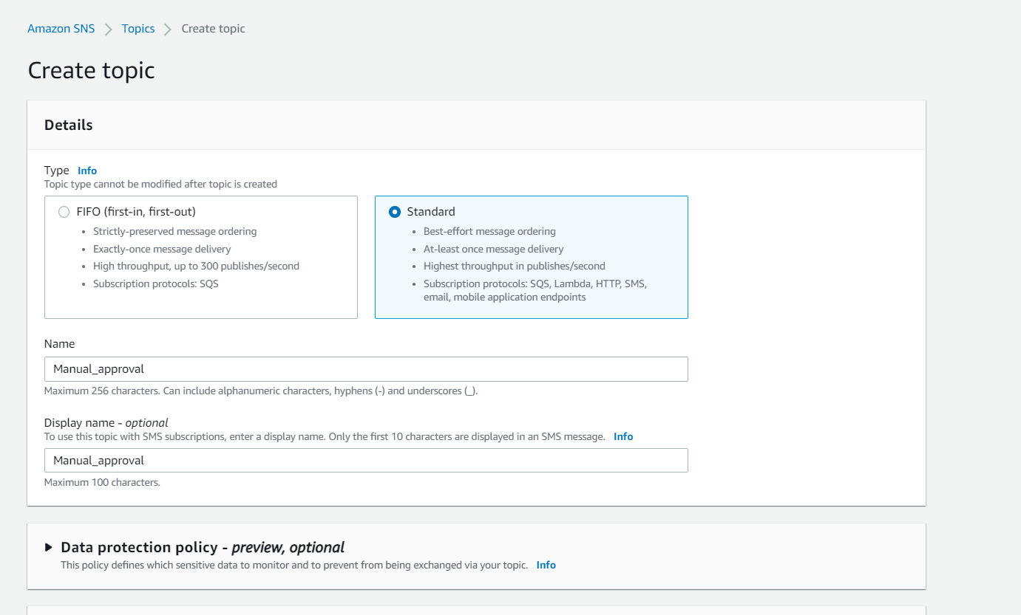

->Create topic.

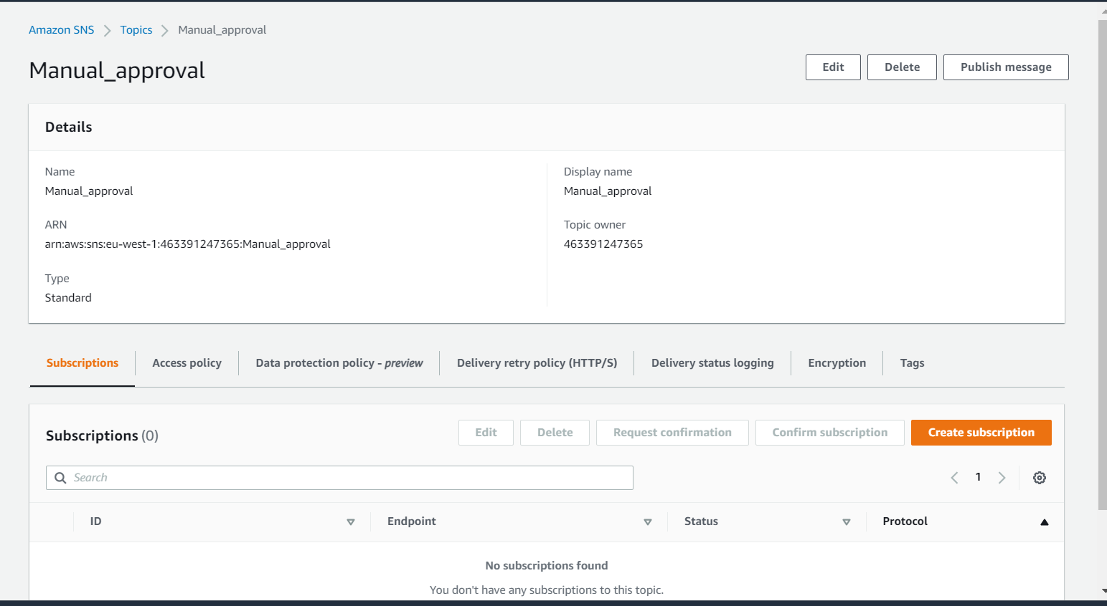

-Next to receive notification Email we need to subscribe our emails to this topic

For that -> Create subscription->Select Email protocol -> type your email id

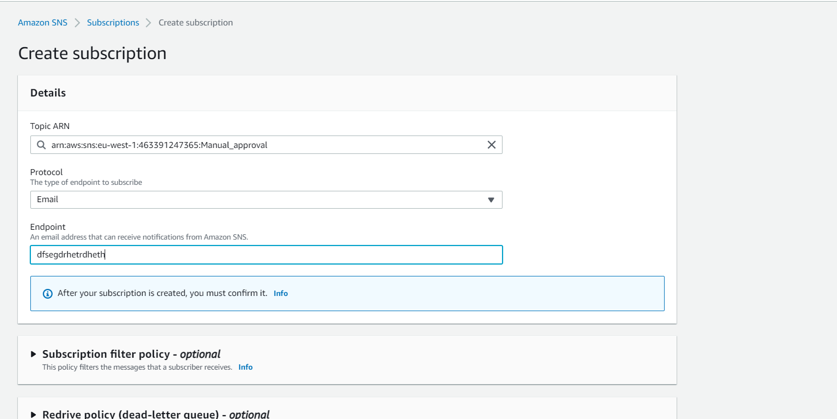

2)now go back to pipeline and configure manual approval

->Edit pipeline ->Edit staging stage ->add another action group inside staging stage

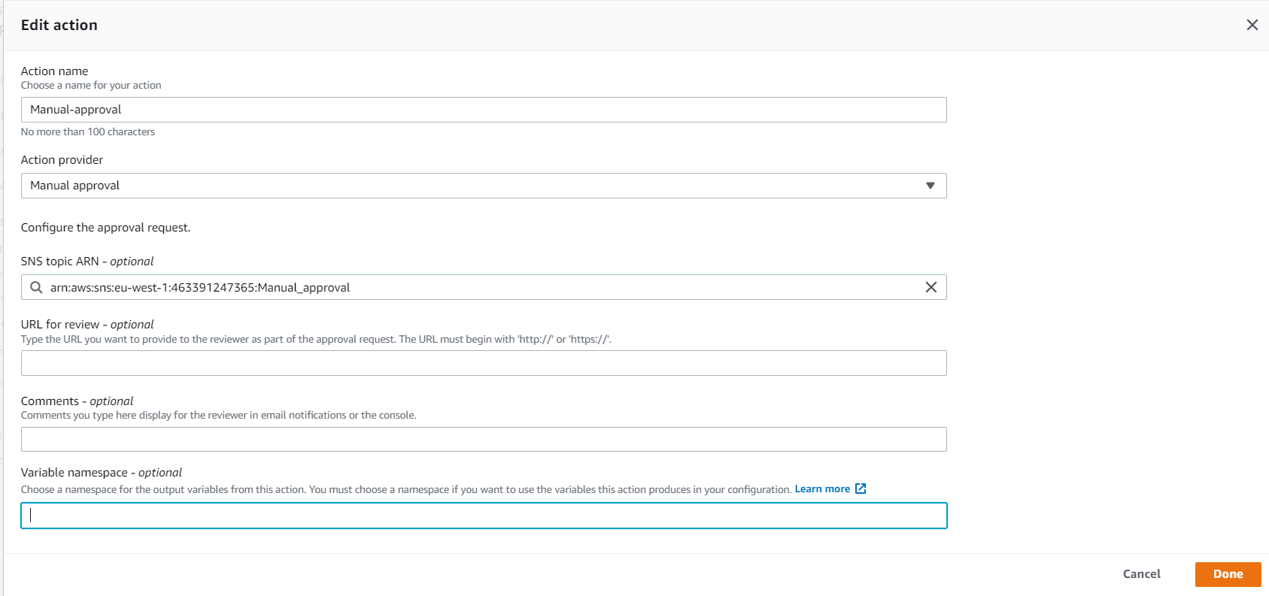

-in the SNS topic select the SNS topic that we created

3)Now save our changes and save our pipeline , now we can see the manual approval option in the pipeline

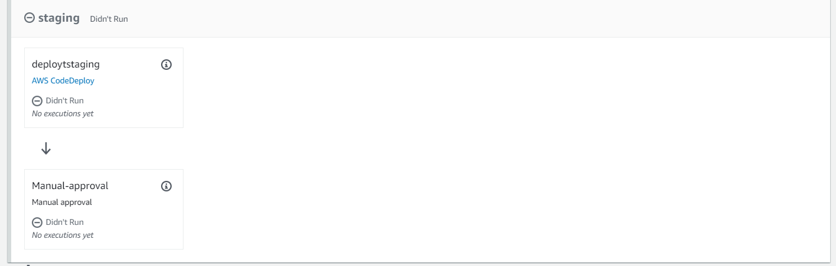

Adding Cloud formation Delete stack action to your pipeline

In our previous steps we have created staging environment using cloud formation.

After the staging stage the pipeline will move to deploy stage ,so we don’t need the staging stage and stack(the things which is created with Staging stage) . we will be able to delete the Stack using CloudFormation by below steps:

1)Edit pipeline and then go to edit staging stage

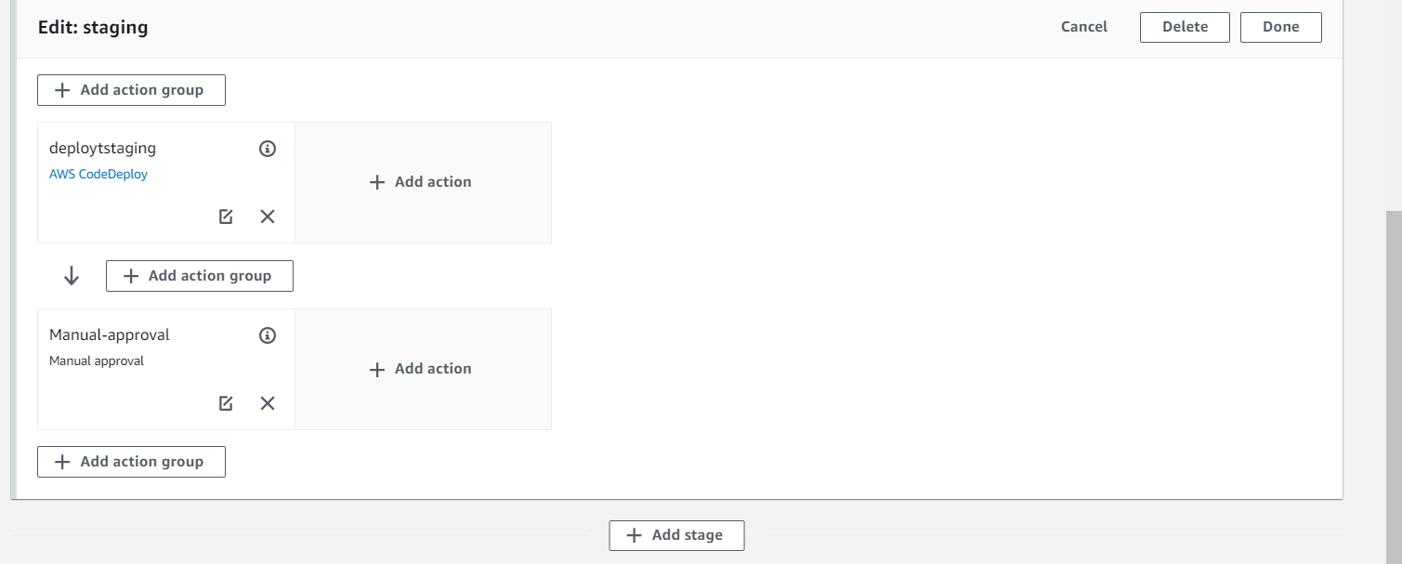

2)Add another action group below manual-approval

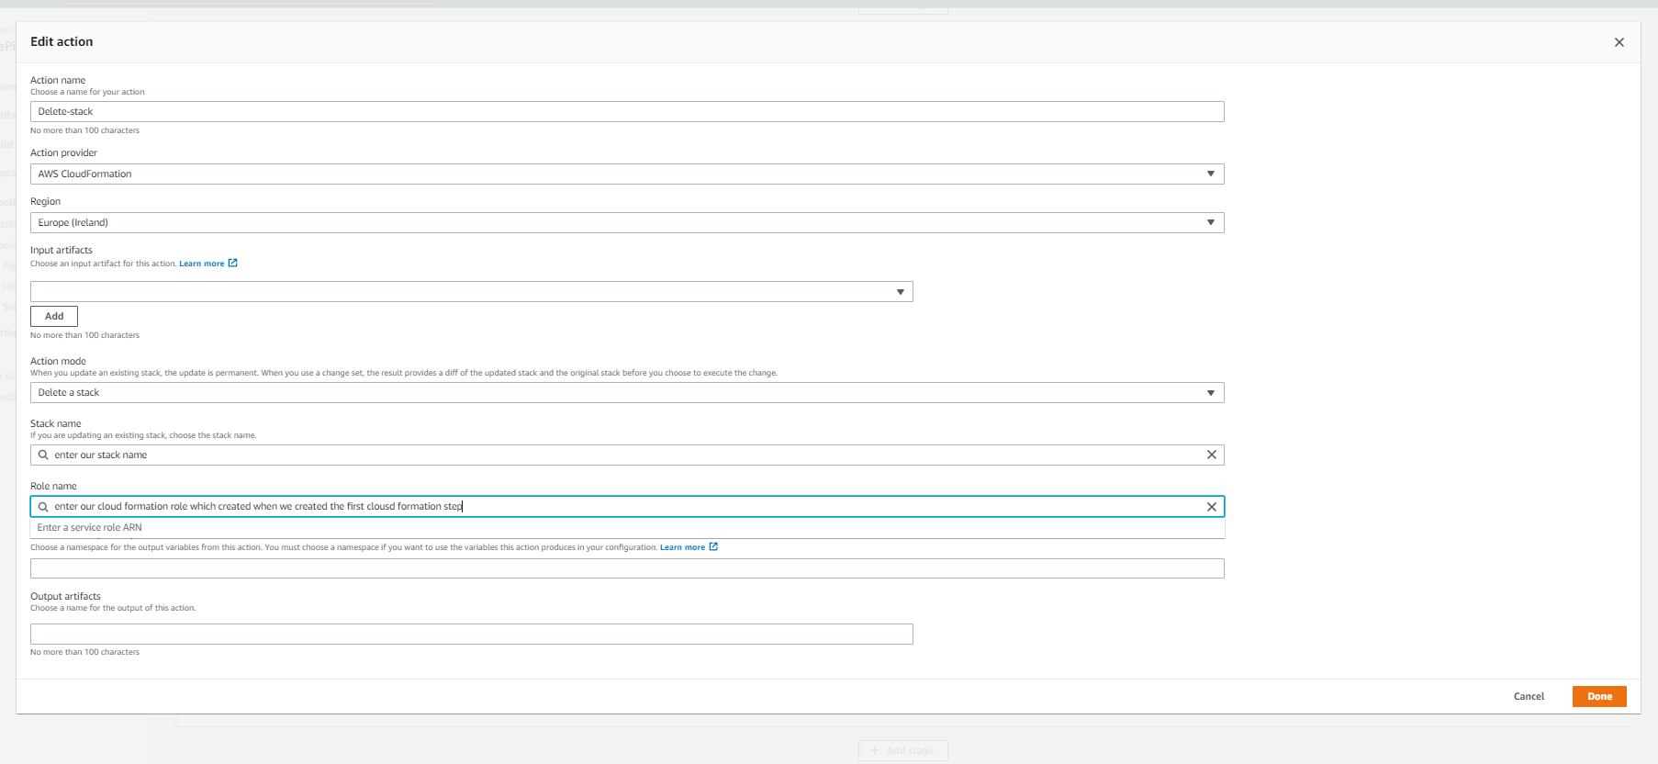

-Now save it and save pipeline

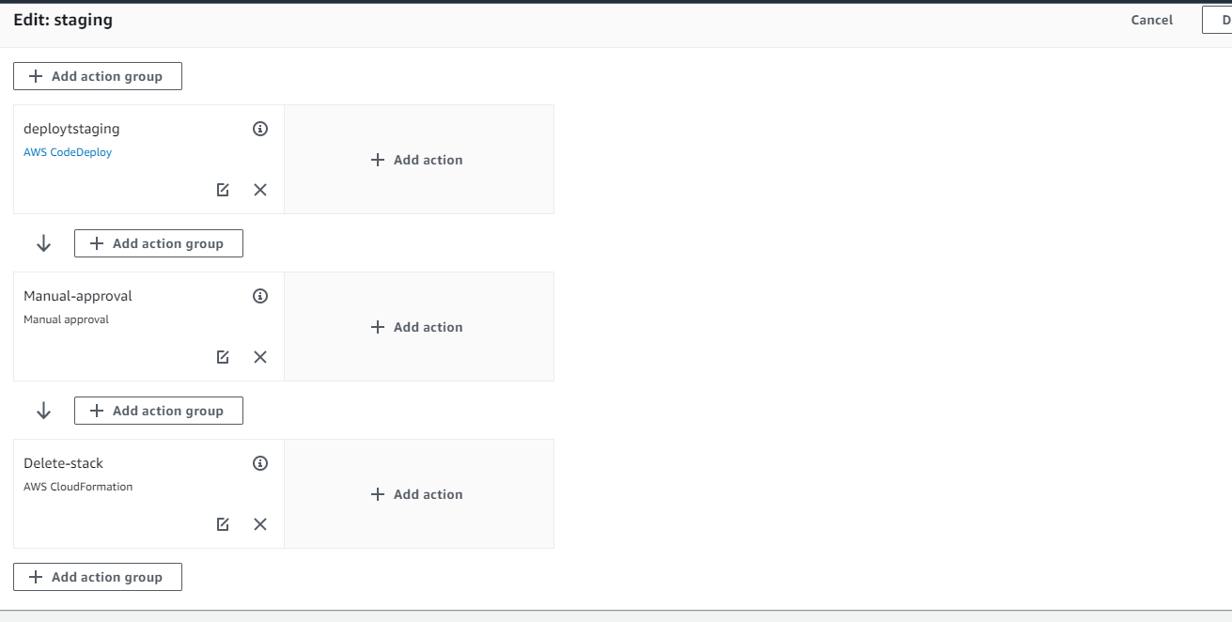

-Now after starting the Deploy stage the pipeline automatically delete the Staging stage and its stack.

Creating notification rules on the pipeline

1. Go to pipeline settings -> Notification->Create notification rule

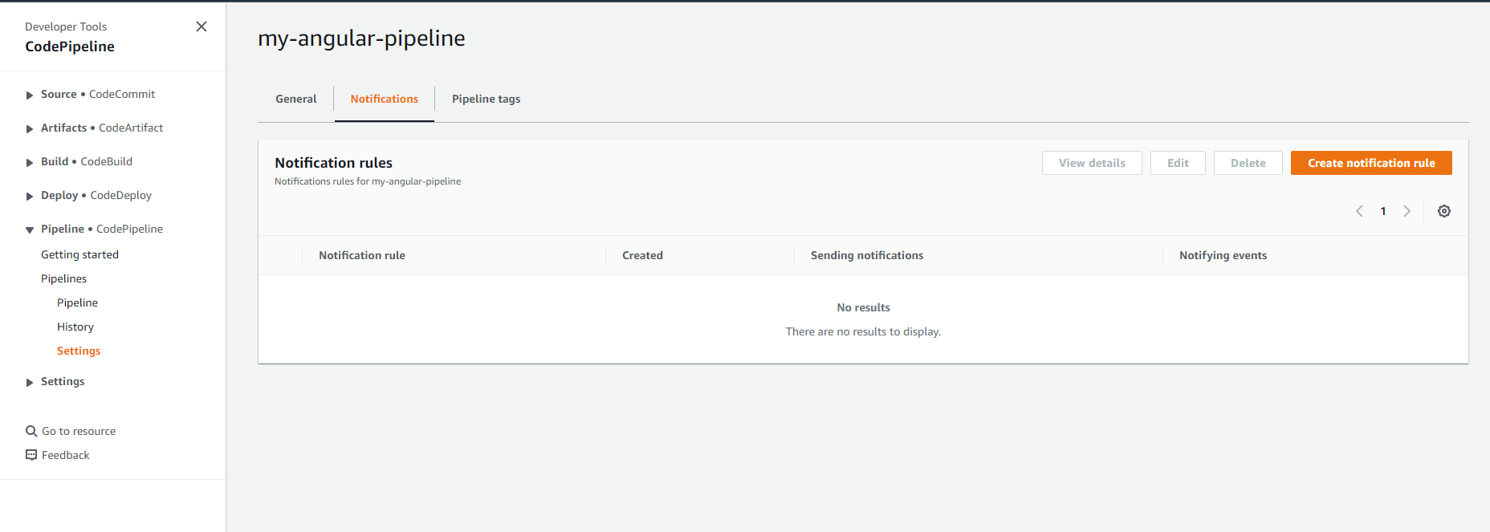

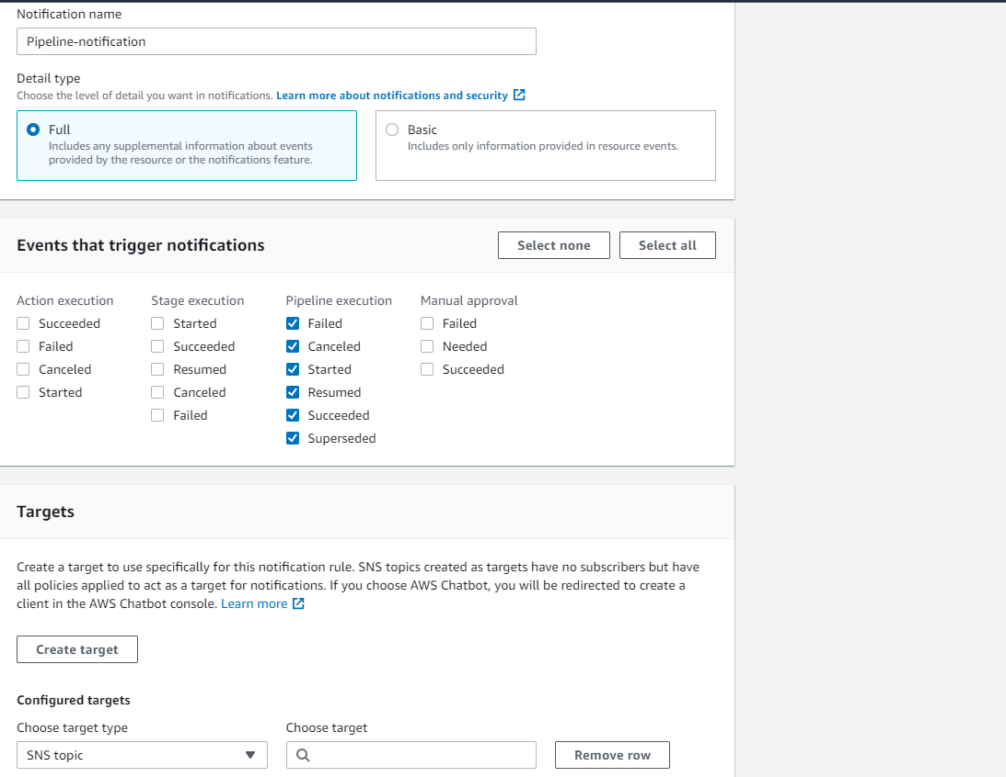

2)Now Create a target

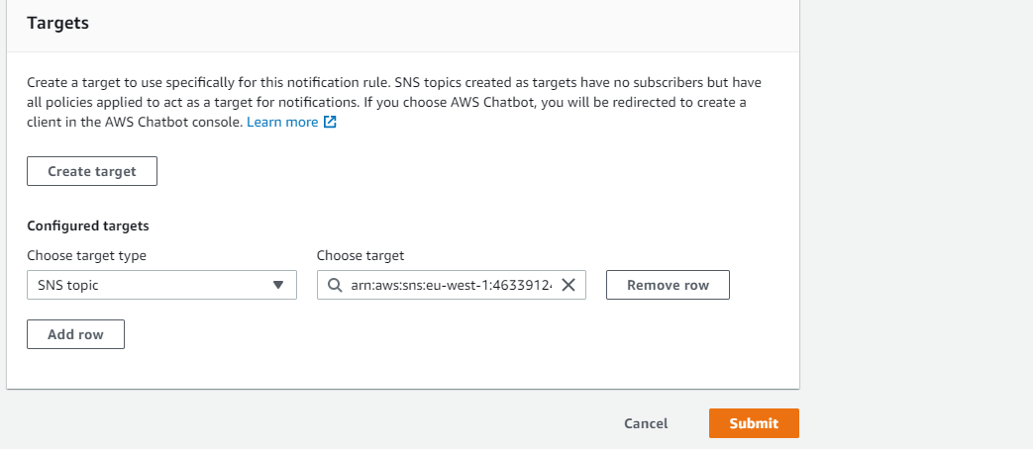

3)AWS Developer tools use Code star for sending notifications , so we need to edit access policy of our SNS topic to allow AWS code-star to publish

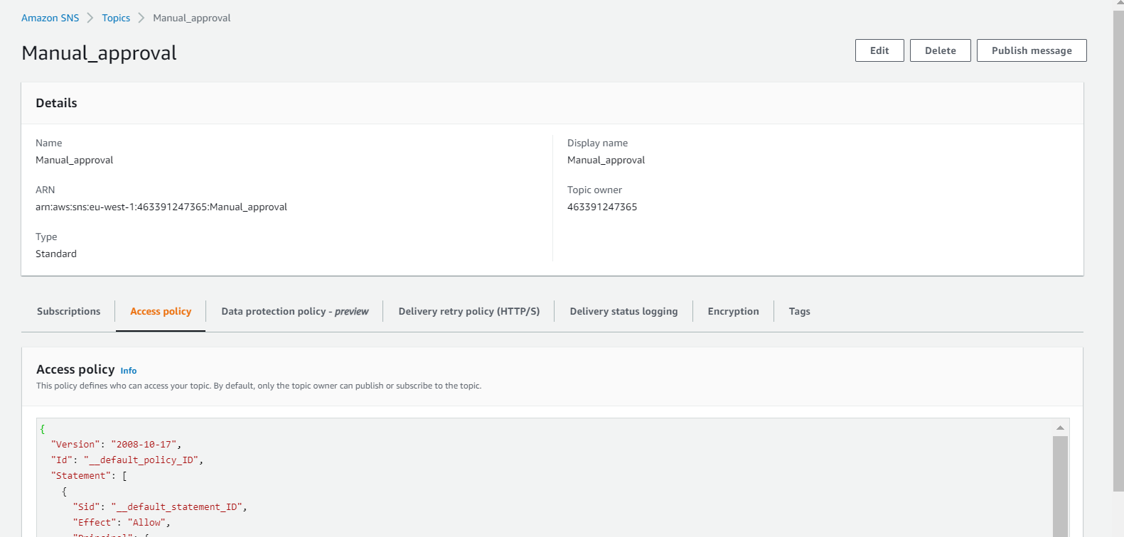

-For edit the access policy

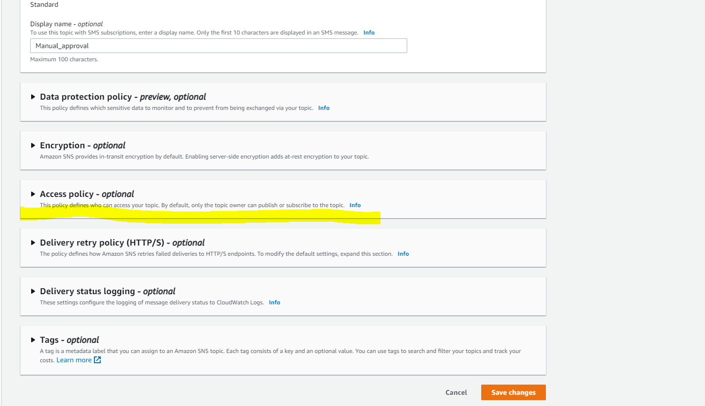

-Edit the policy as below

{

"Version": "2008-10-17",

"Id": "__default_policy_ID",

"Statement": [

{

"Sid": "__default_statement_ID",

"Effect": "Allow",

"Principal": {

"AWS": "*"

},

"Action": [

"SNS:GetTopicAttributes",

"SNS:SetTopicAttributes",

"SNS:AddPermission",

"SNS:RemovePermission",

"SNS:DeleteTopic",

"SNS:Subscribe",

"SNS:ListSubscriptionsByTopic",

"SNS:Publish"

],

"Resource": "arn:aws:sns:eu-west-1:463391247365:Manual_approval",

"Condition": {

"StringEquals": {

"AWS:SourceOwner": "463391247365"

}

}

},

{

"Sid": "AWSCodeStarNotifications_publish",

"Effect": "Allow",

"Principal": {

"Service": [

"codestar-notifications.amazonaws.com"

]

},

"Action": "SNS:Publish",

"Resource": "arn:aws:sns:us-east-2:123456789012:codestar-notifications-MyTopicForNotificationRules",

"Condition": {

"StringEquals": {

"aws:SourceAccount": "123456789012"

}

}

}

]

}

4)Now save changes , from now onwards we will receive the notification for each stage in our pipeline.

**SECTION 6:Building Docker images and ECS Rolling Deployments with Code Pipeline**

1)Creating code build buildspec file for docker builds

* Docker file for the project

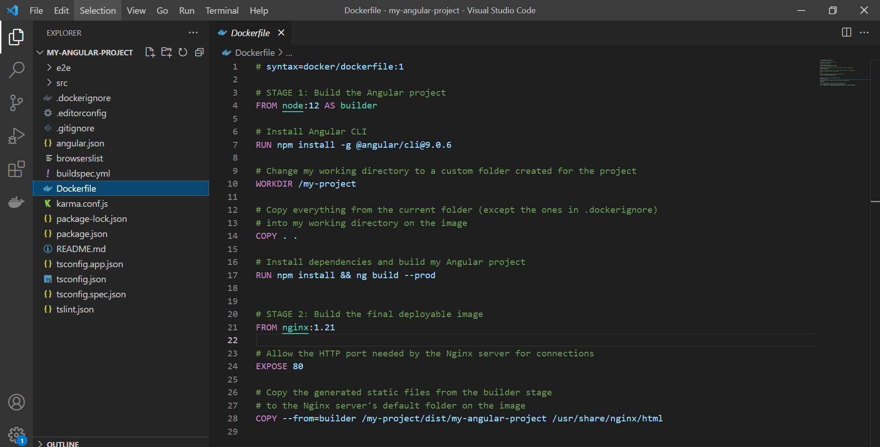

* Creating buildspec file

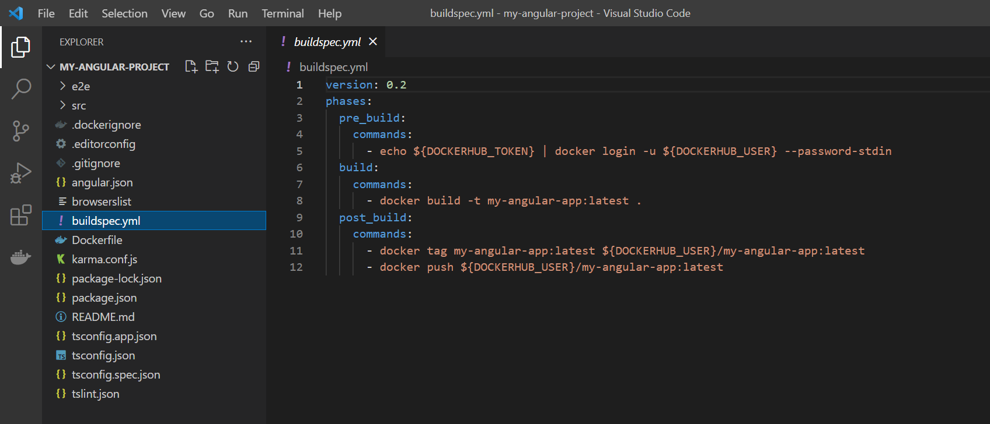

version: 0.2

phases:

  pre_build:

    commands:

      - echo ${DOCKERHUB_TOKEN} | docker login -u ${DOCKERHUB_USER} --password-stdin

  build:

    commands:

      - docker build -t my-angular-app:latest .

  post_build:

    commands:

      - docker tag my-angular-app:latest ${DOCKERHUB_USER}/my-angular-app:latest

      - docker push ${DOCKERHUB_USER}/my-angular-app:latest

* Now Create a repo in code commit

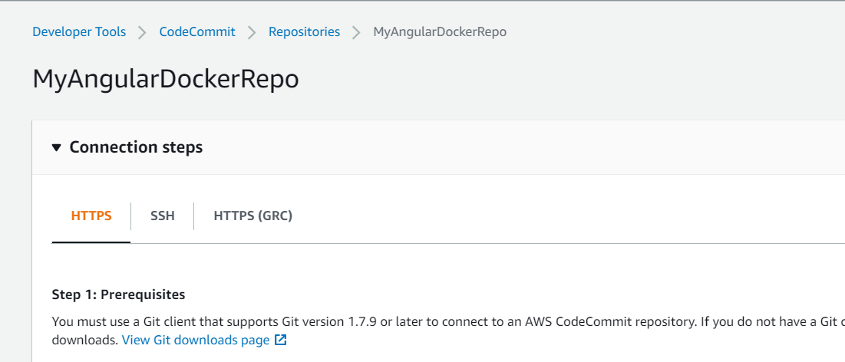

* Push the code and files to remote repository

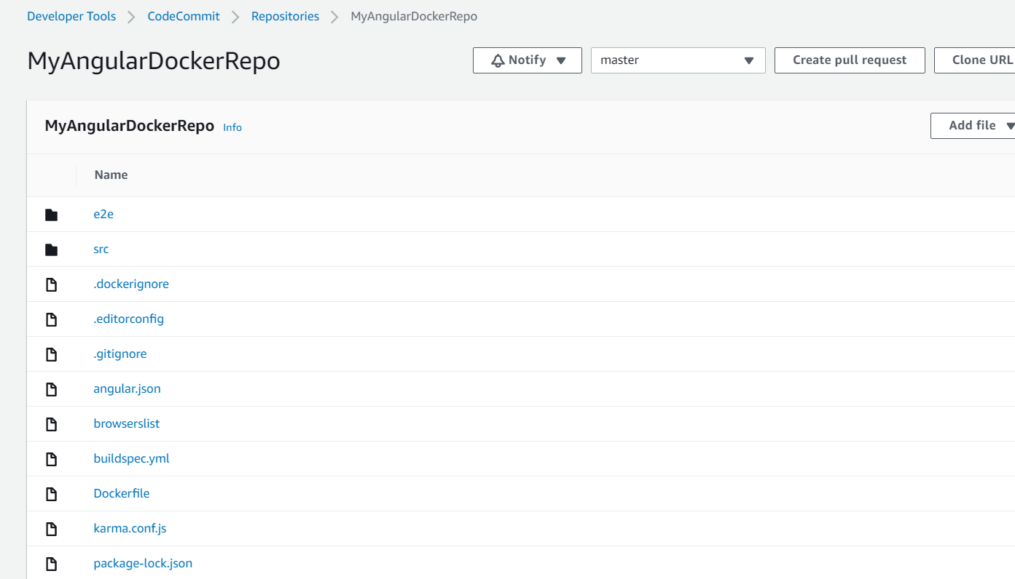

2)Creating pipeline for Build the Docker image

* Create a new pipeline

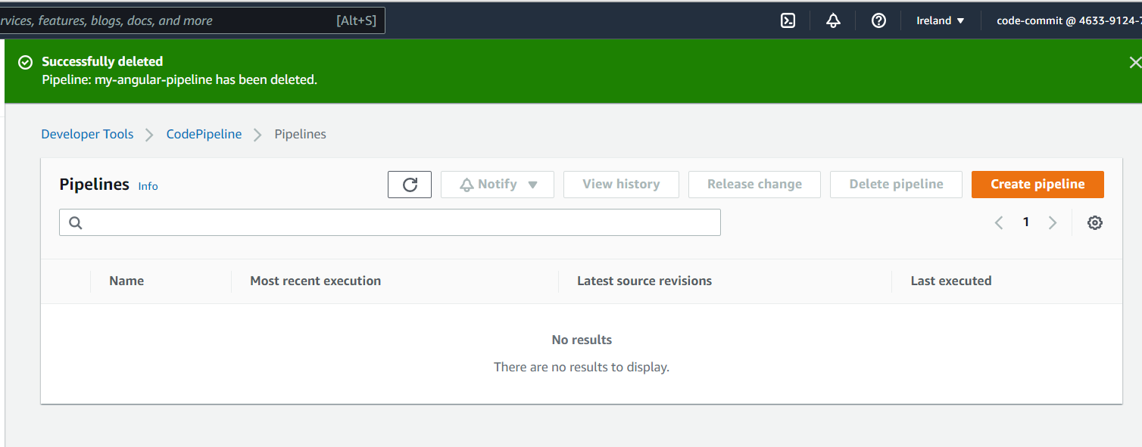

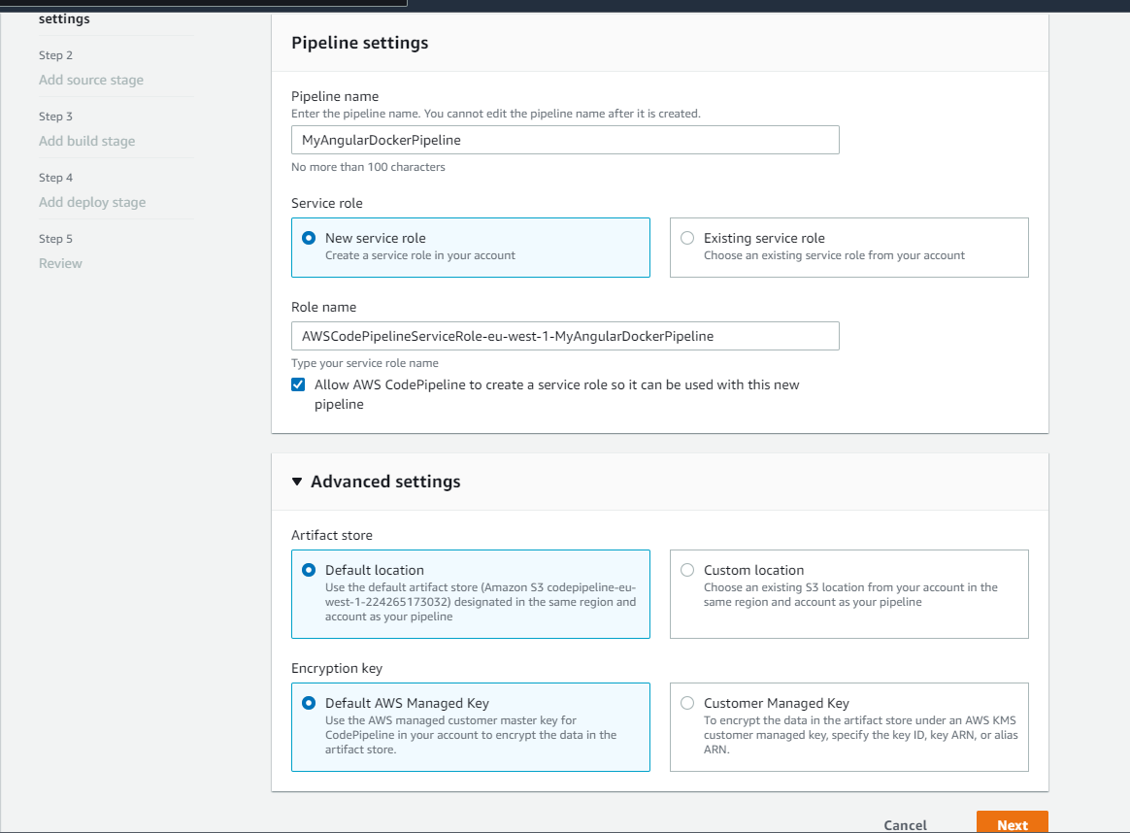

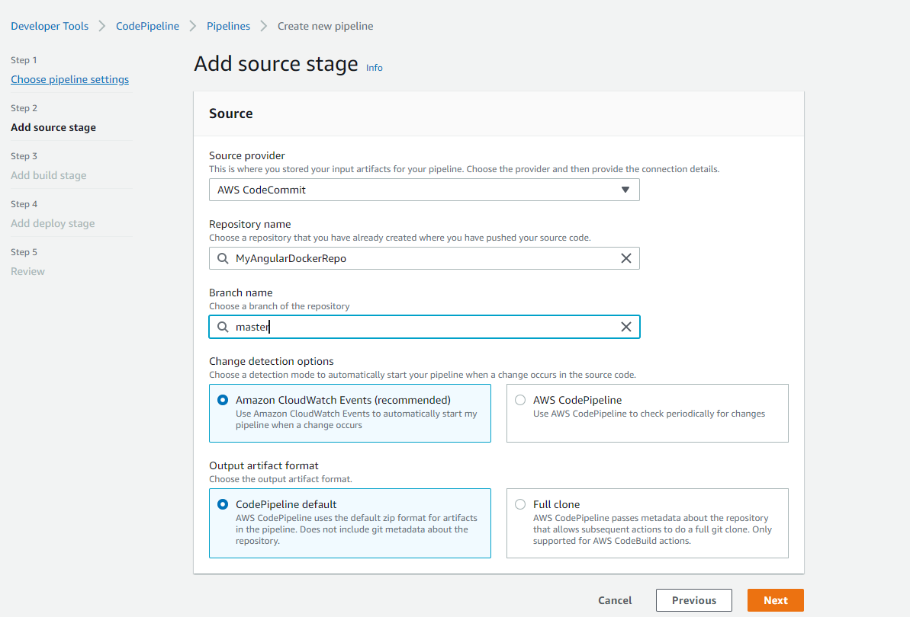

* Create a project for the build stage

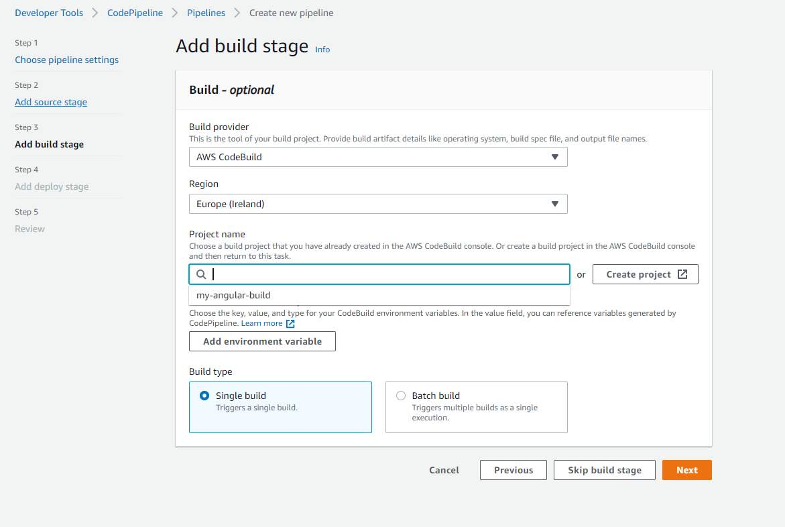

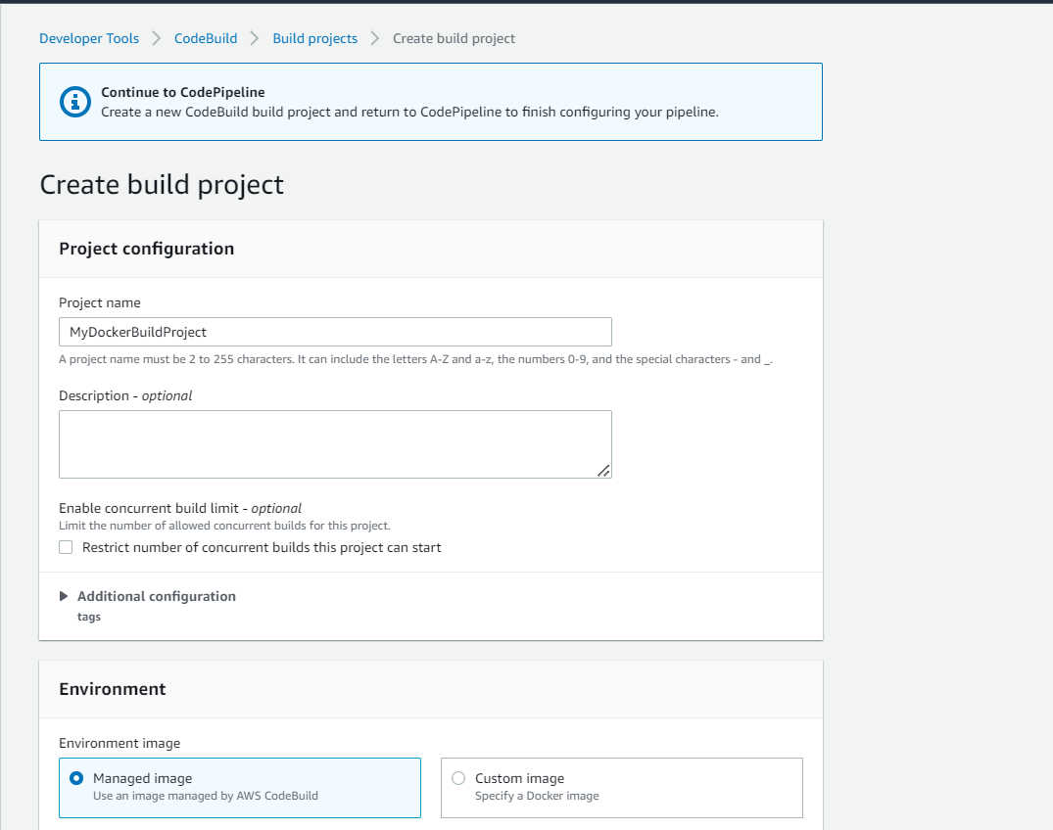

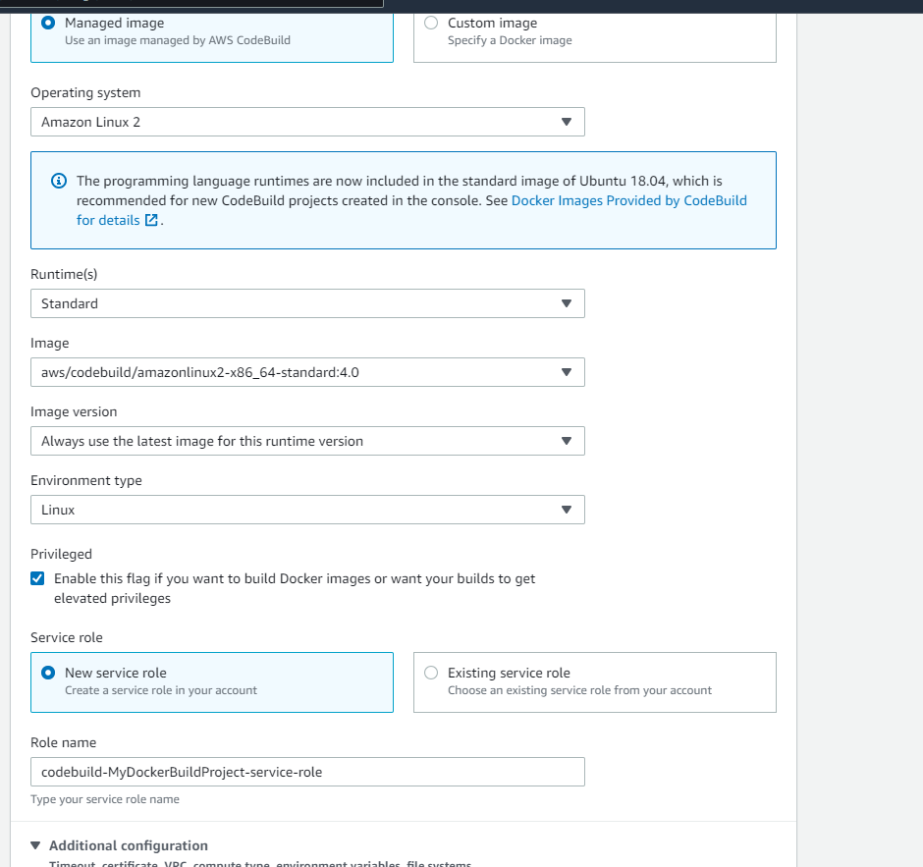

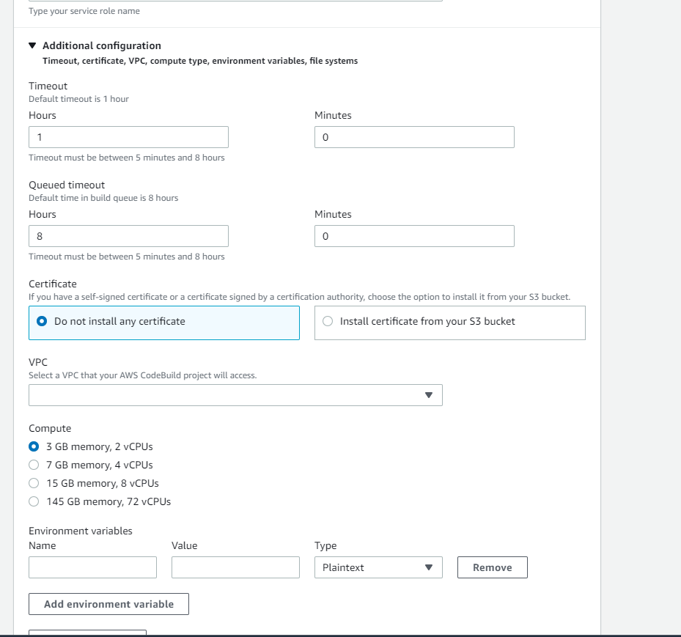

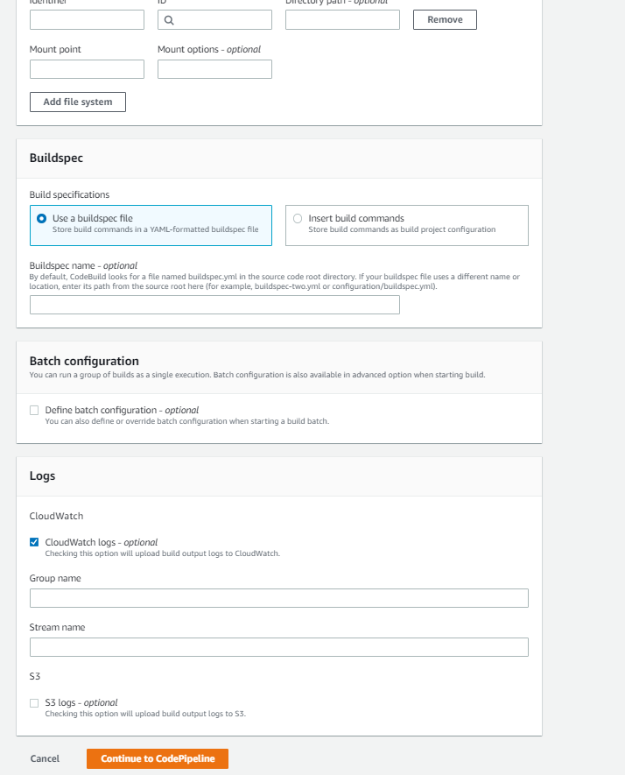

Now Define the environment variable (add environment variable option)which is mentioned in buildspec file

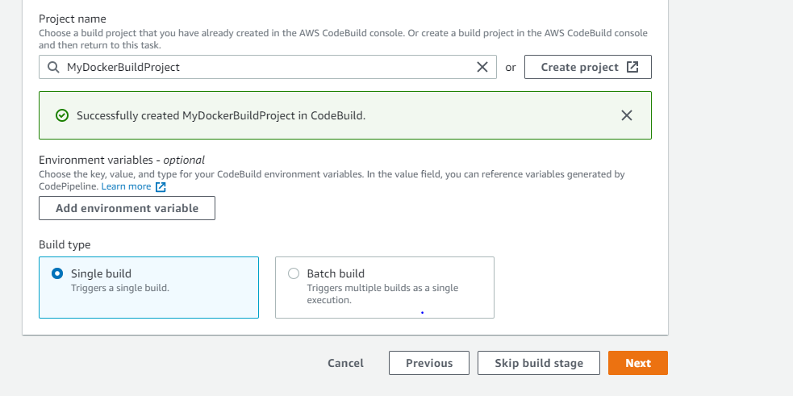

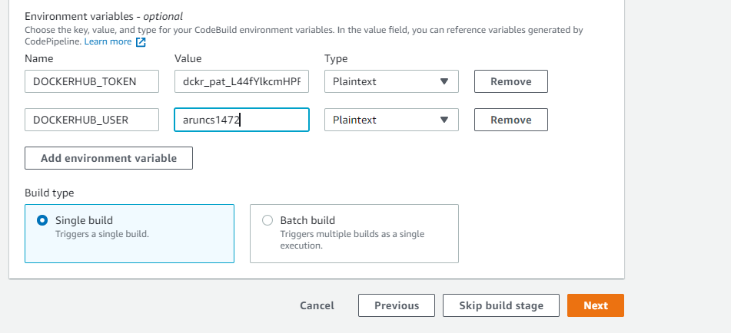

* The value we given here is Docker hub secret access token and Docker hub

Username

* Skip the deploy stage

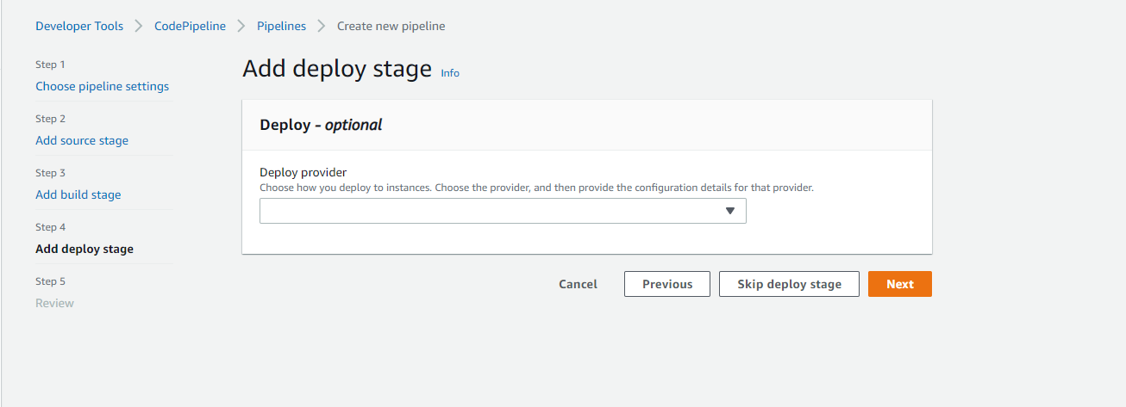

* Then Review and create pipeline

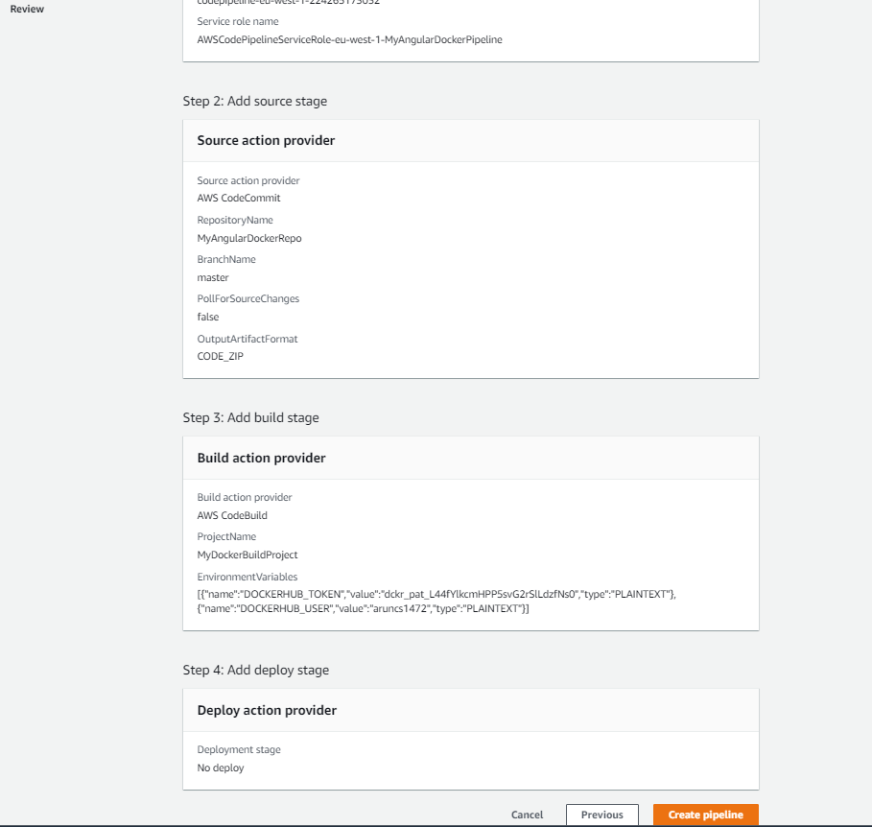

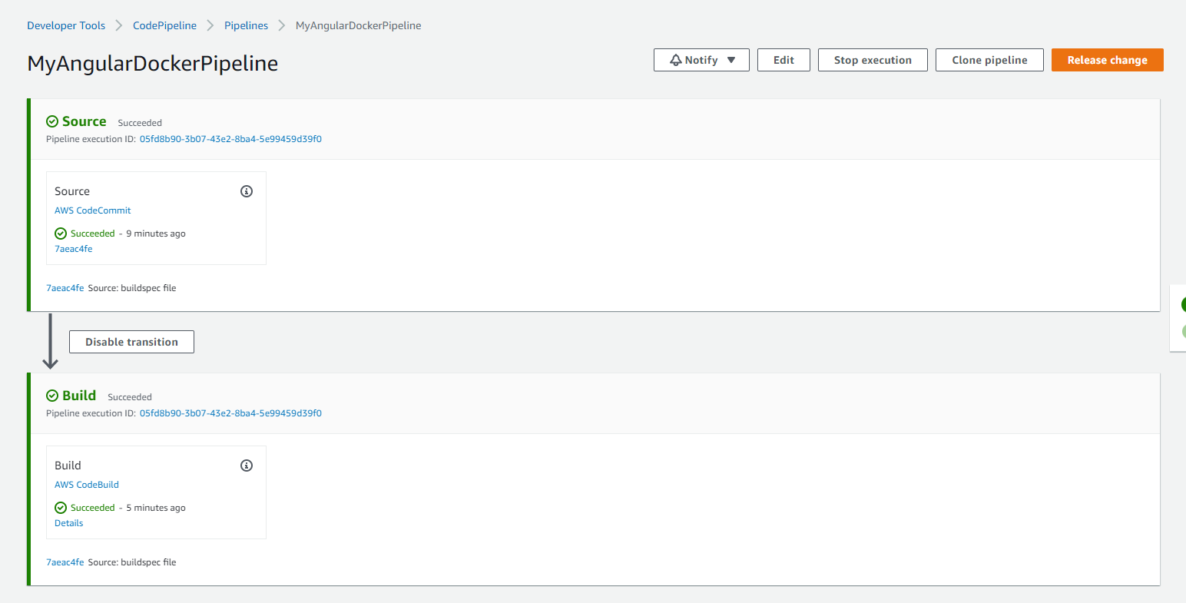

* Now We can see the image created and pushed to the Docker hub.

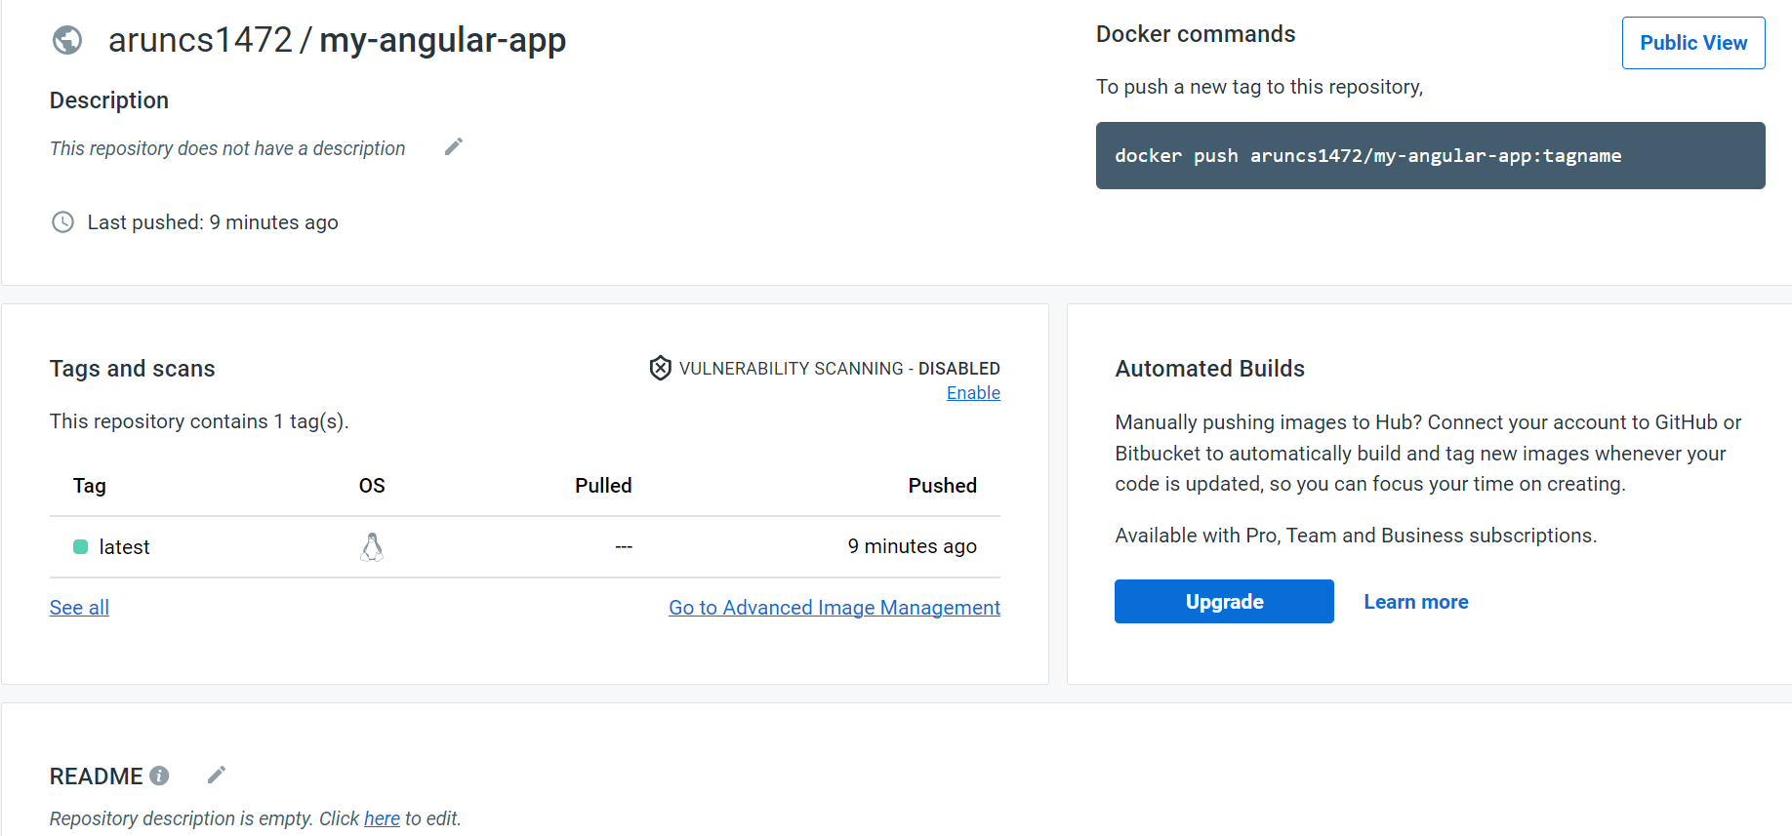

3)Secrets Manager Environment variable on AWS Code build

Type of environment variables in code Build

* Plaintext
* AWS System manager parameter store (Supports encrypted and unencrypted)
* AWS Secrets manager : Not free

AWS Secret manager -> Create new secret -> other secret

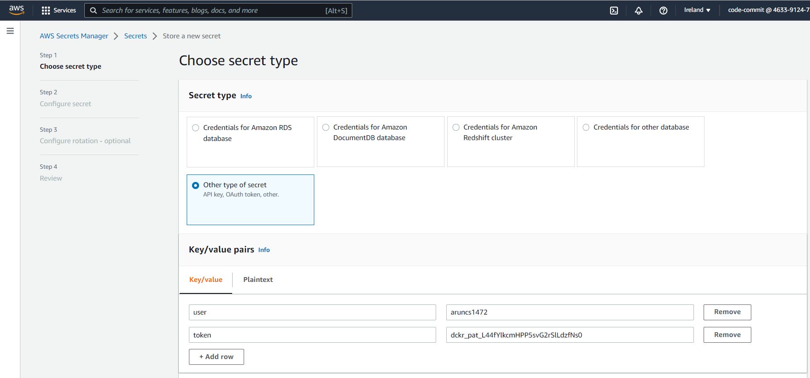

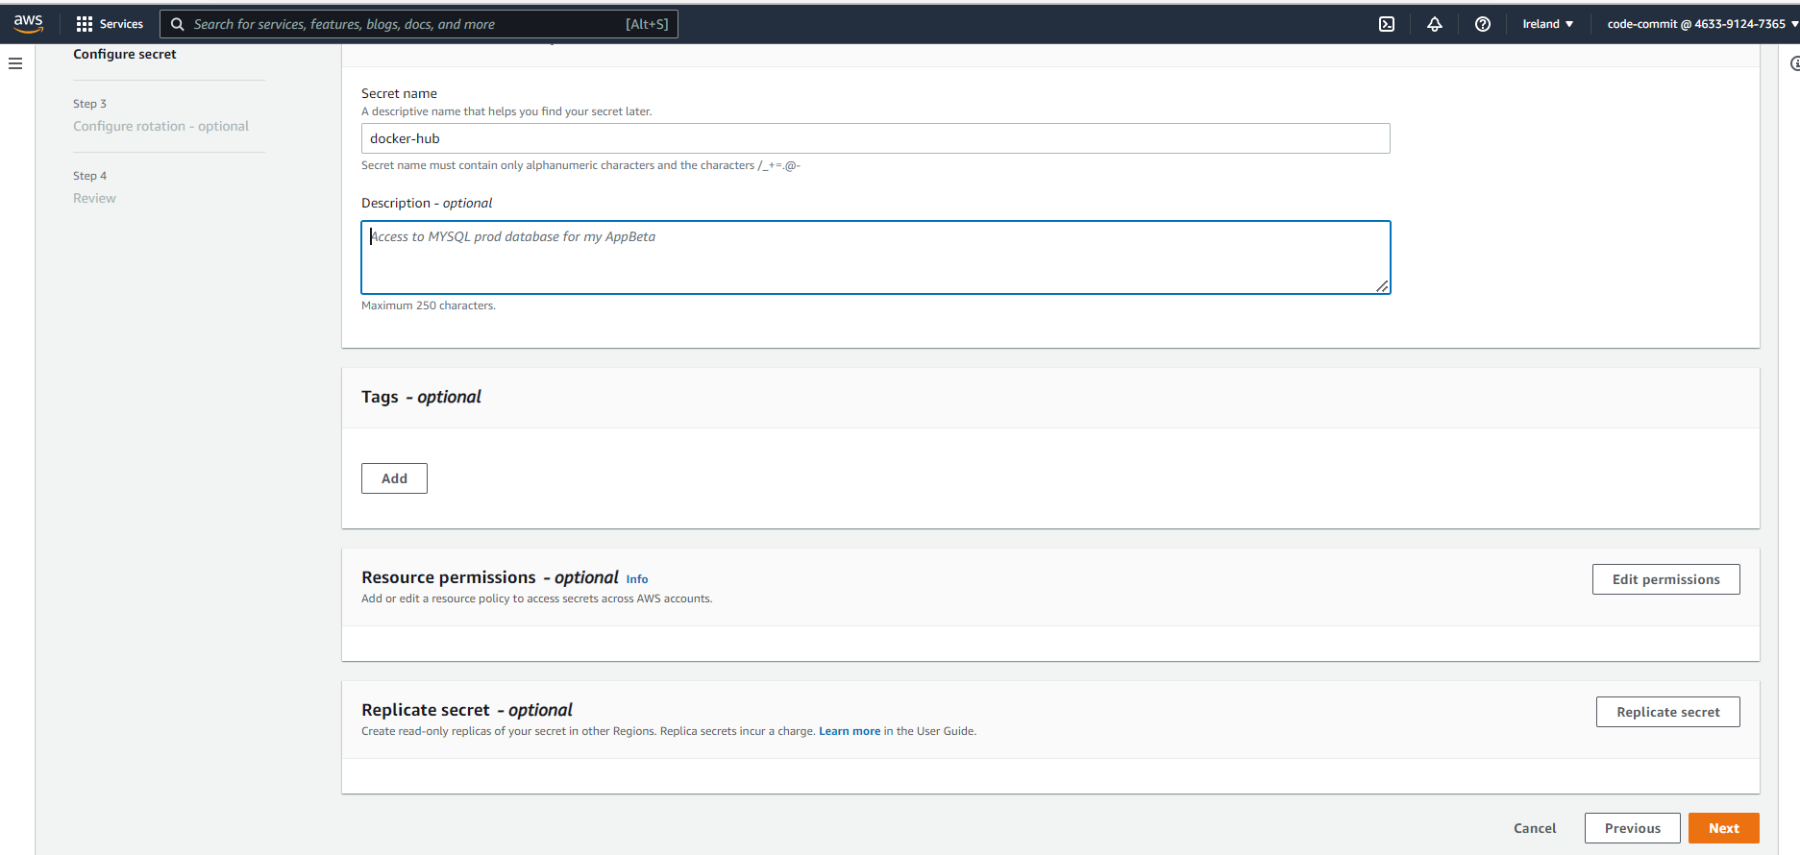

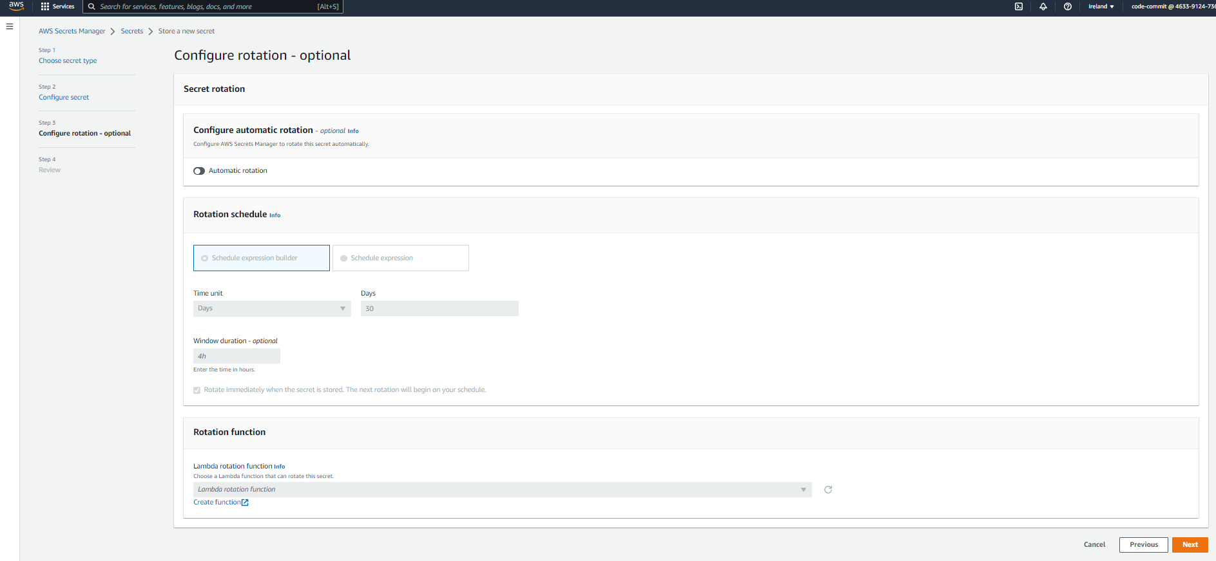

4)system manager Parameter store environment variable on AWS Code Build

* System manager is an AWS service that helps to centralize operational data and automate tasks across your AWS services.

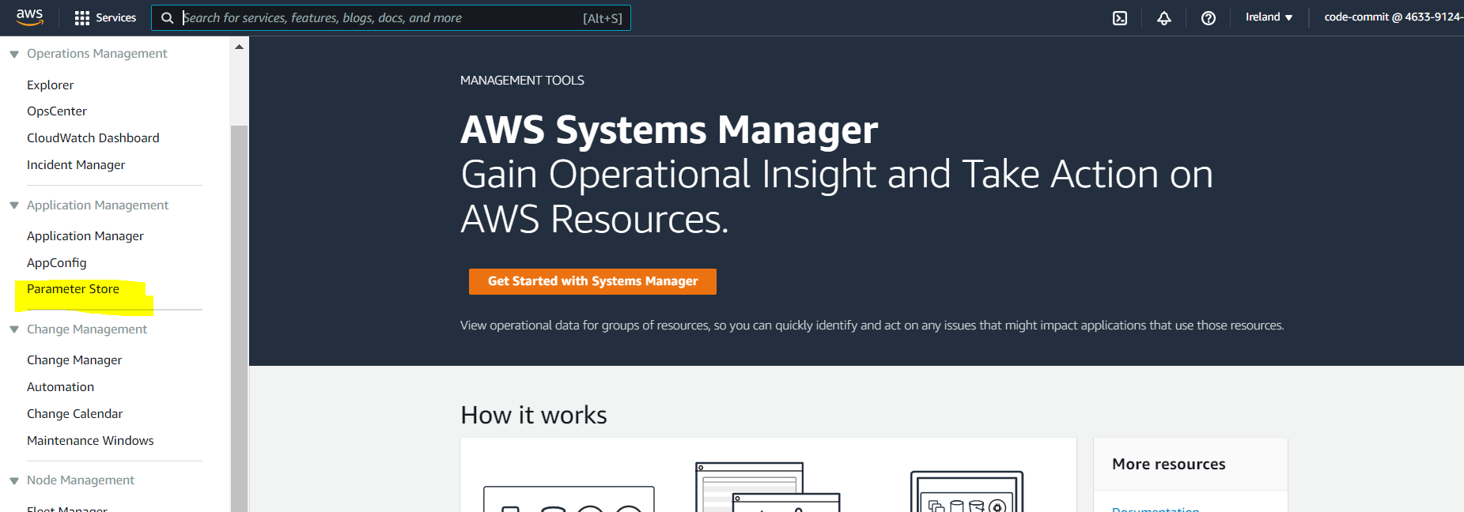

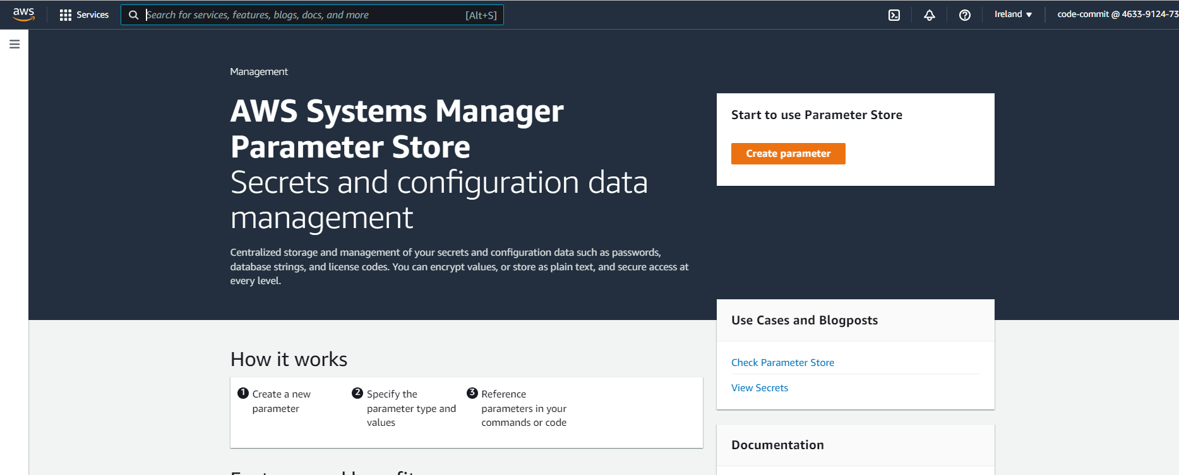

Parameter store -> Create parameter

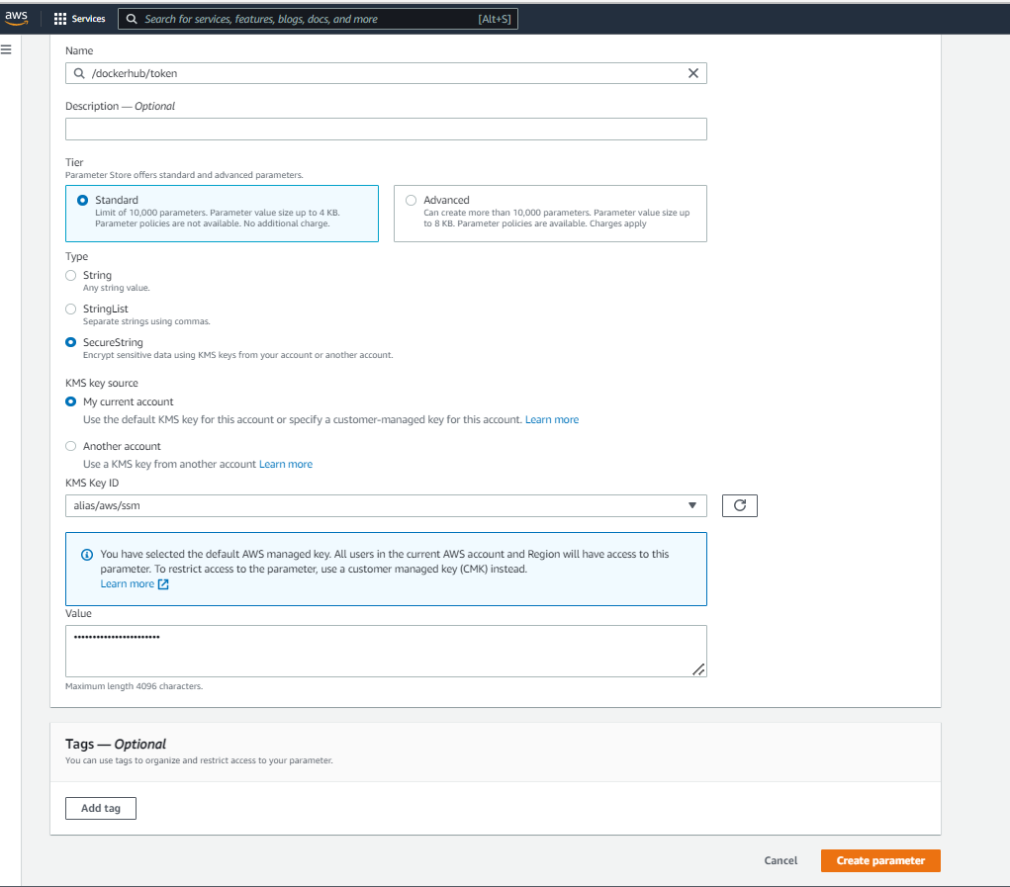

5)Pushing Docker images to Amazon ECR with AWS Code Build

* Go To Amazon ECR and create a repository

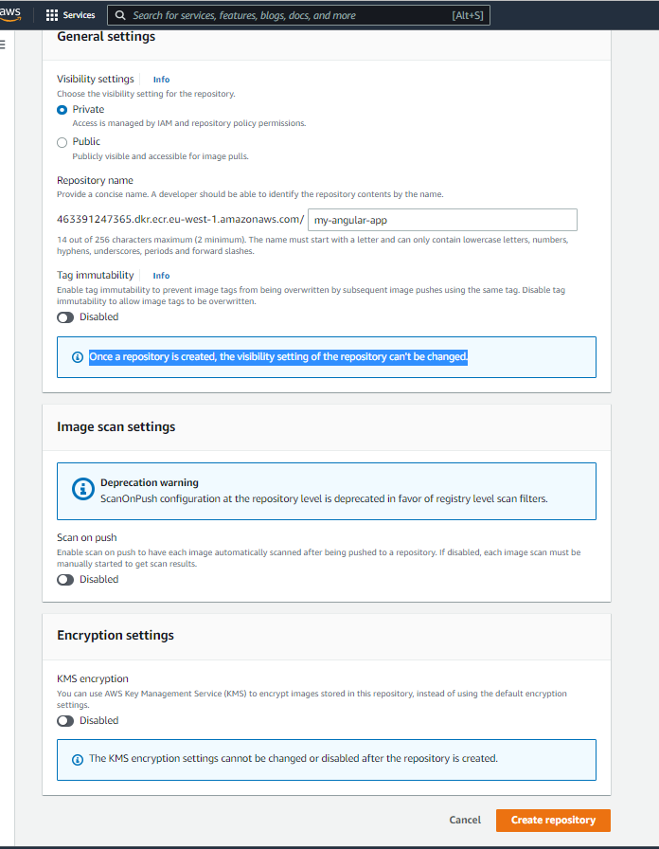

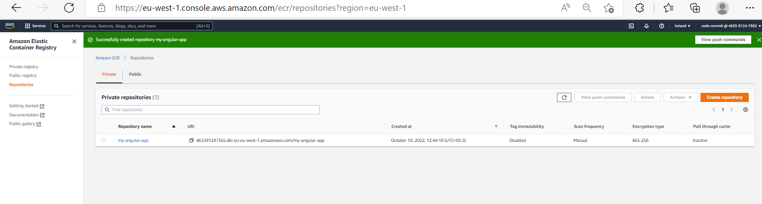

We can see the below commands by selecting option ”view push commands”

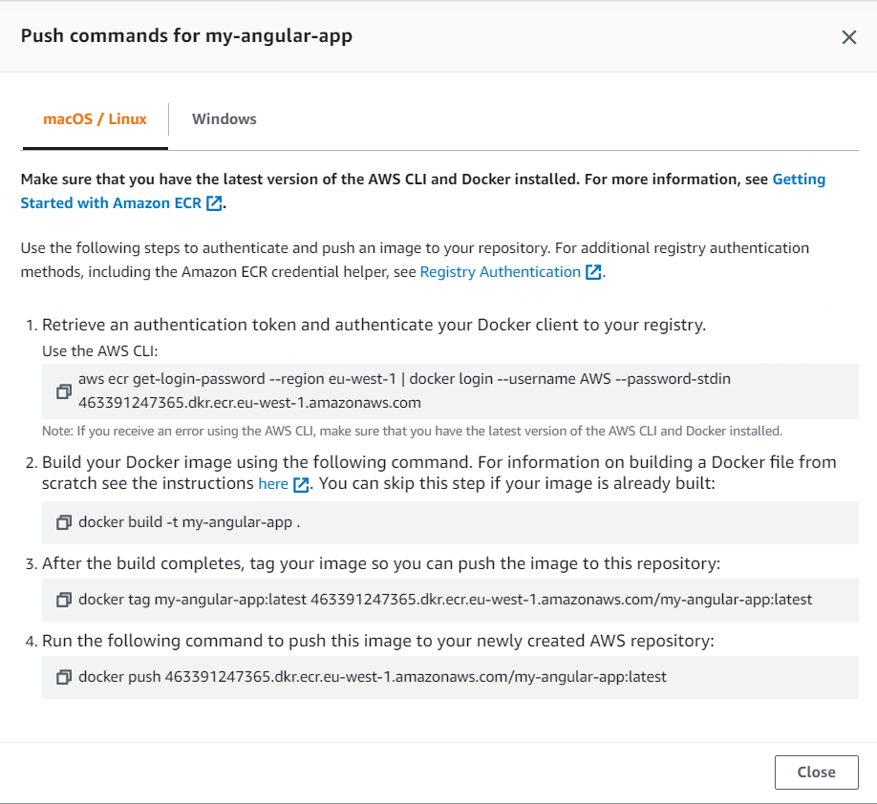

* Add permission for code build for login to ECR (We can configure it by adding IAM role for the Code Build)

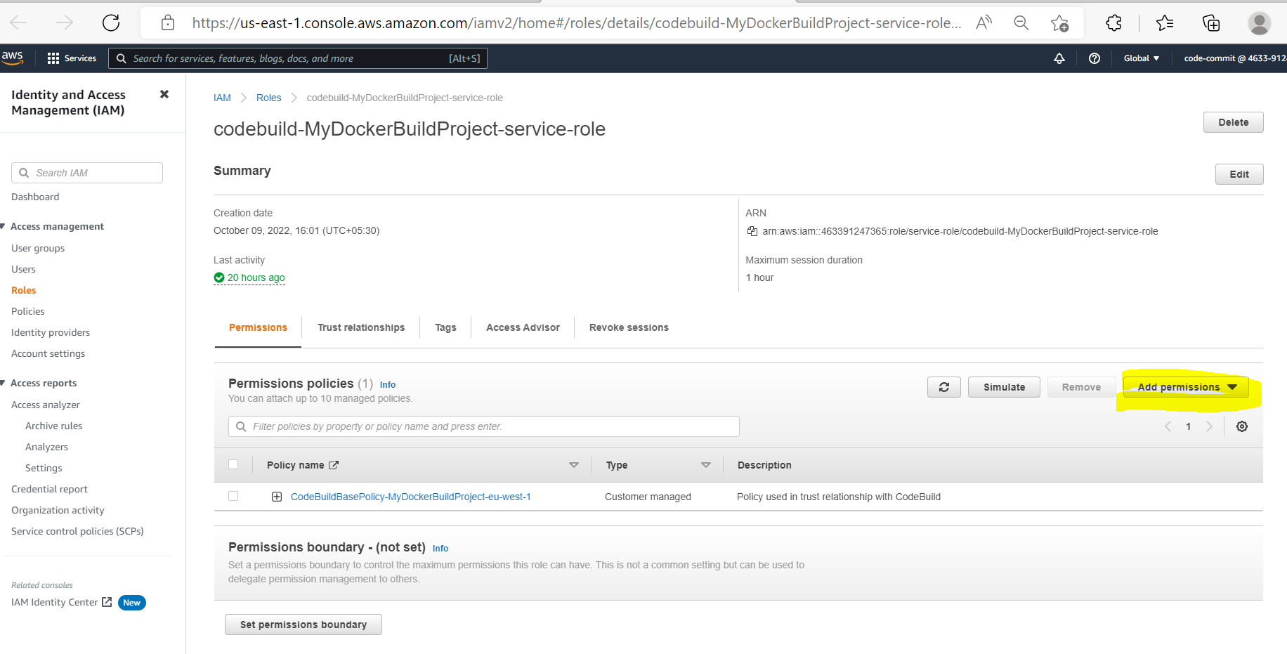

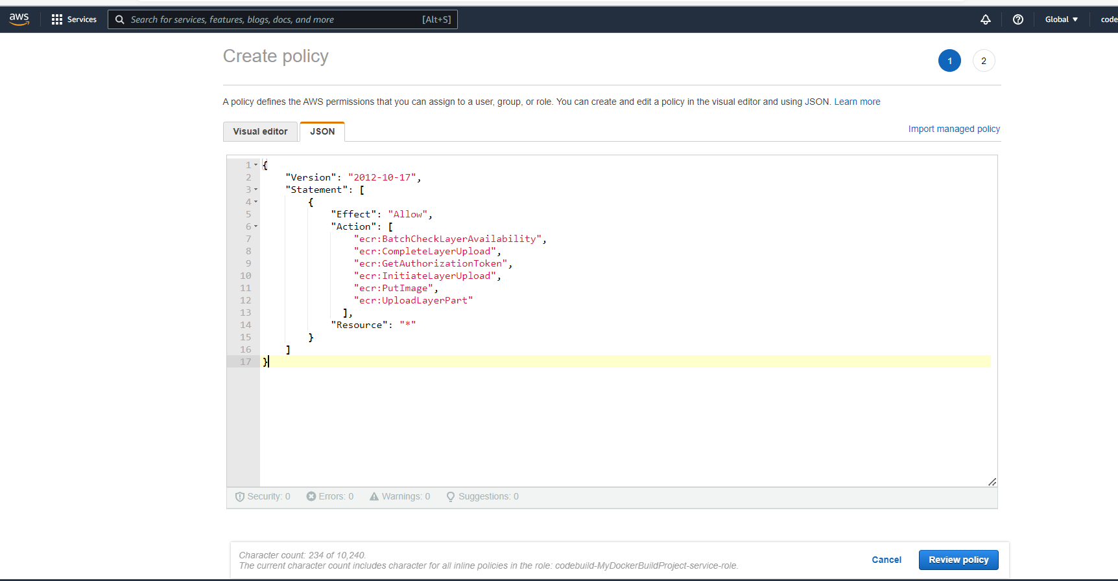

{

"Version": "2012-10-17",

"Statement": [

{

"Effect": "Allow",

"Action": [

"ecr:BatchCheckLayerAvailability",

"ecr:CompleteLayerUpload",

"ecr:GetAuthorizationToken",

"ecr:InitiateLayerUpload",

"ecr:PutImage",

"ecr:UploadLayerPart"

],

"Resource": "*"

}

]

}

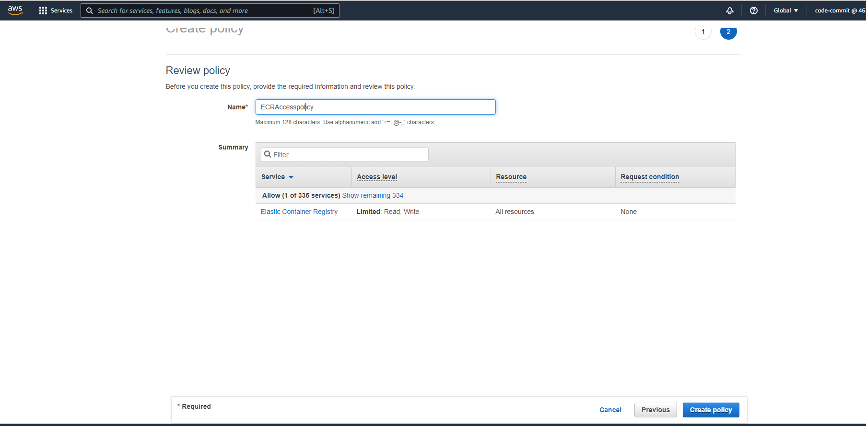

Now we have created policy for ECR access.

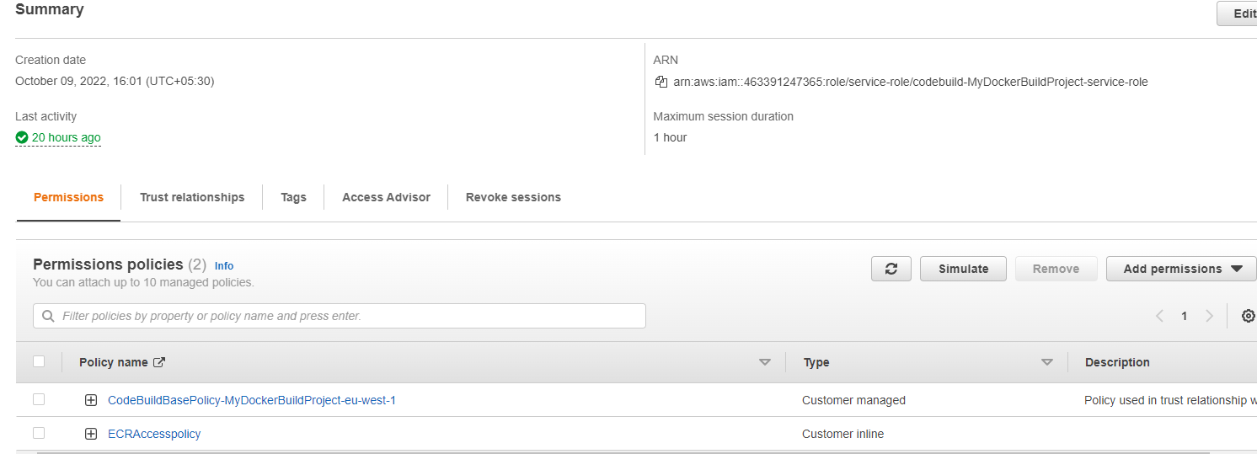

* Now edit the buildspec file for configuring Amazon ECR

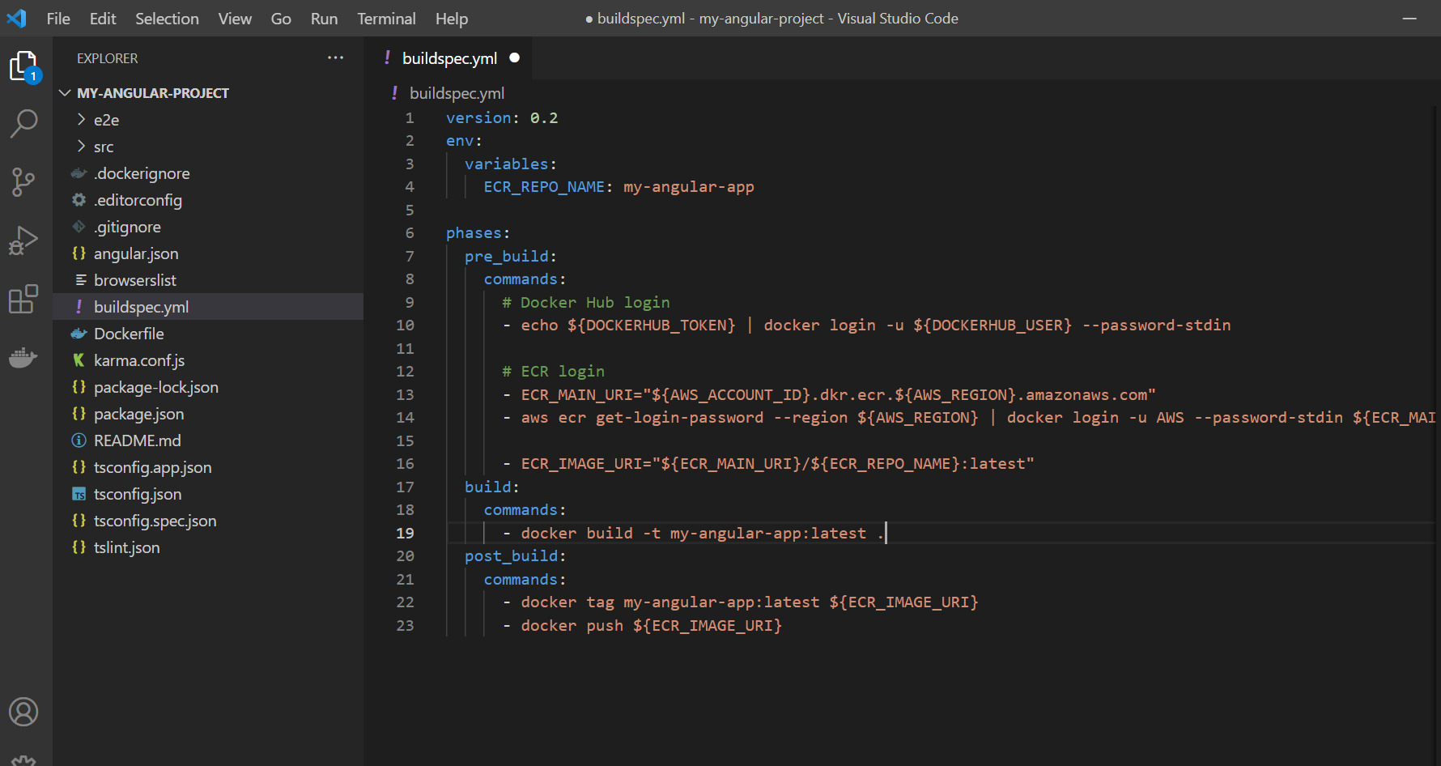

version: 0.2

env:

  variables:

    ECR_REPO_NAME: my-angular-app

phases:

  pre_build:

    commands:

      # Docker Hub login

      - echo ${DOCKERHUB_TOKEN} | docker login -u ${DOCKERHUB_USER} --password-stdin

      # ECR login

      - ECR_MAIN_URI="${AWS_ACCOUNT_ID}.dkr.ecr.${AWS_REGION}.amazonaws.com"

      - aws ecr get-login-password --region ${AWS_REGION} | docker login -u AWS --password-stdin ${ECR_MAIN_URI}

      - ECR_IMAGE_URI="${ECR_MAIN_URI}/${ECR_REPO_NAME}:latest"

  build:

    commands:

      - docker build -t my-angular-app:latest .

  post_build:

    commands:

      - docker tag my-angular-app:latest ${ECR_IMAGE_URI}

      - docker push ${ECR_IMAGE_URI}

* Now go to our pipeline and add environment variable

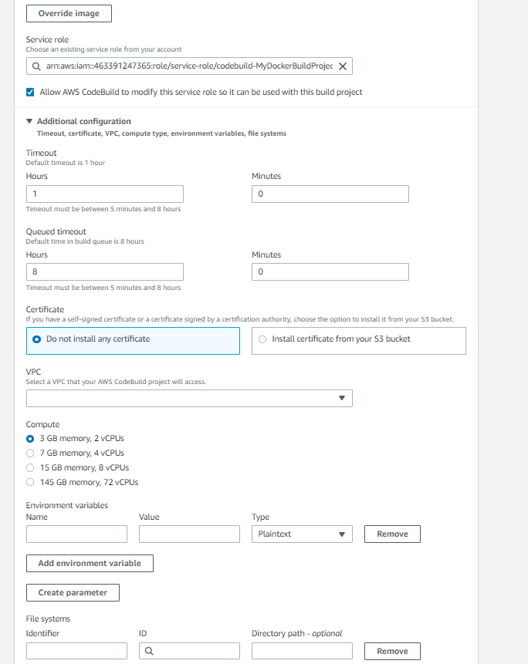

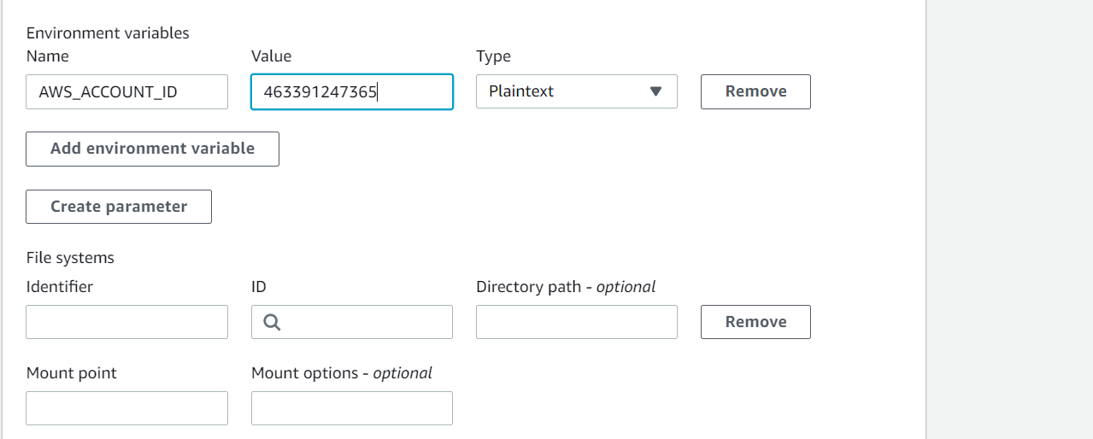

Now update environment and save it.

* Now save our code and buildspec file and push it to code commit repository and it will trigger our pipeline

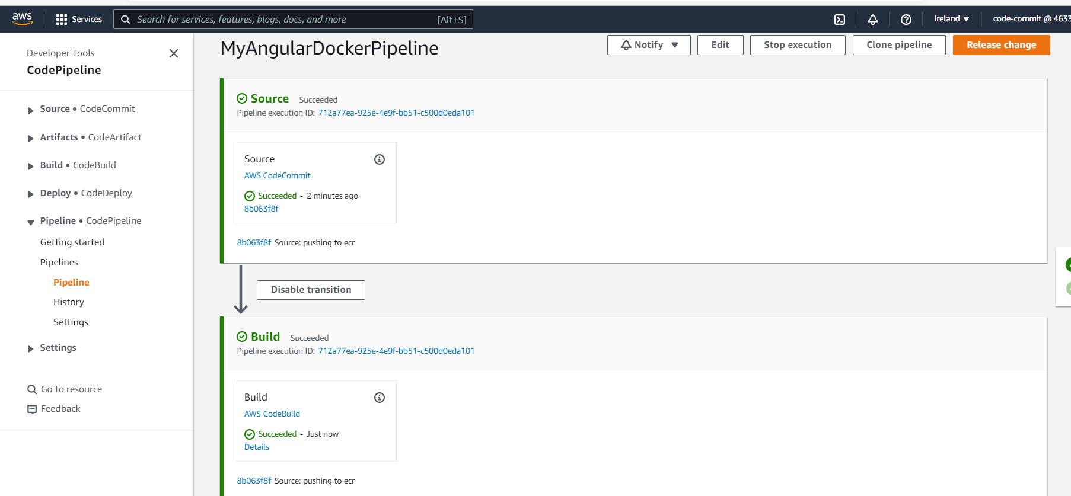

Now we can see image in our ECR repository

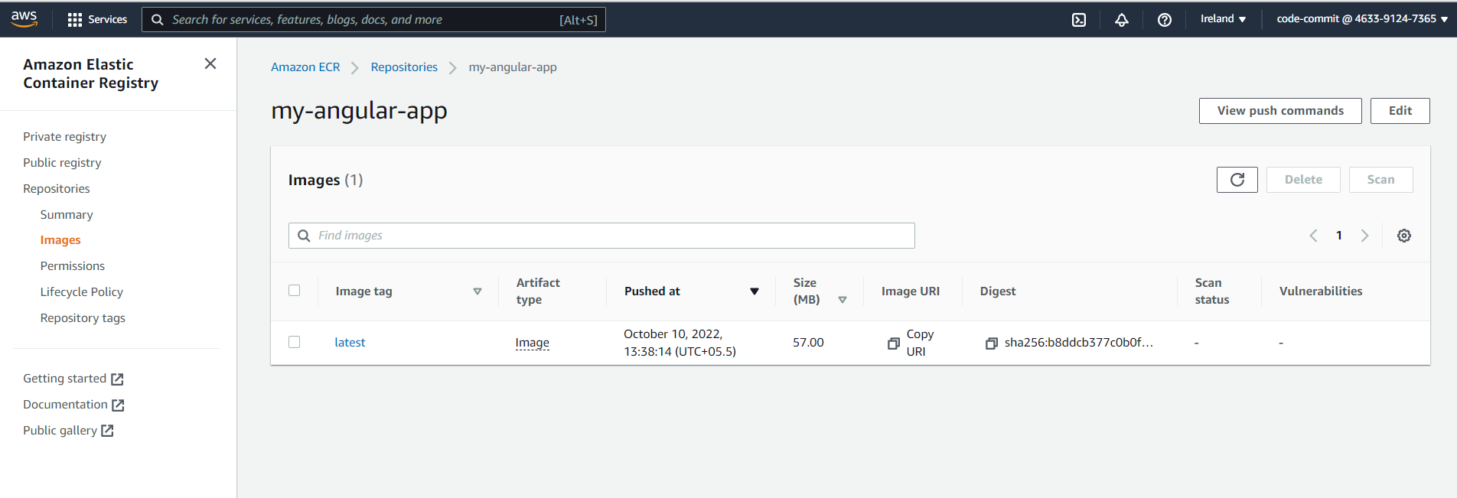

Part 2 : Configuring ECS

6)Creating Task Definition for our docker image

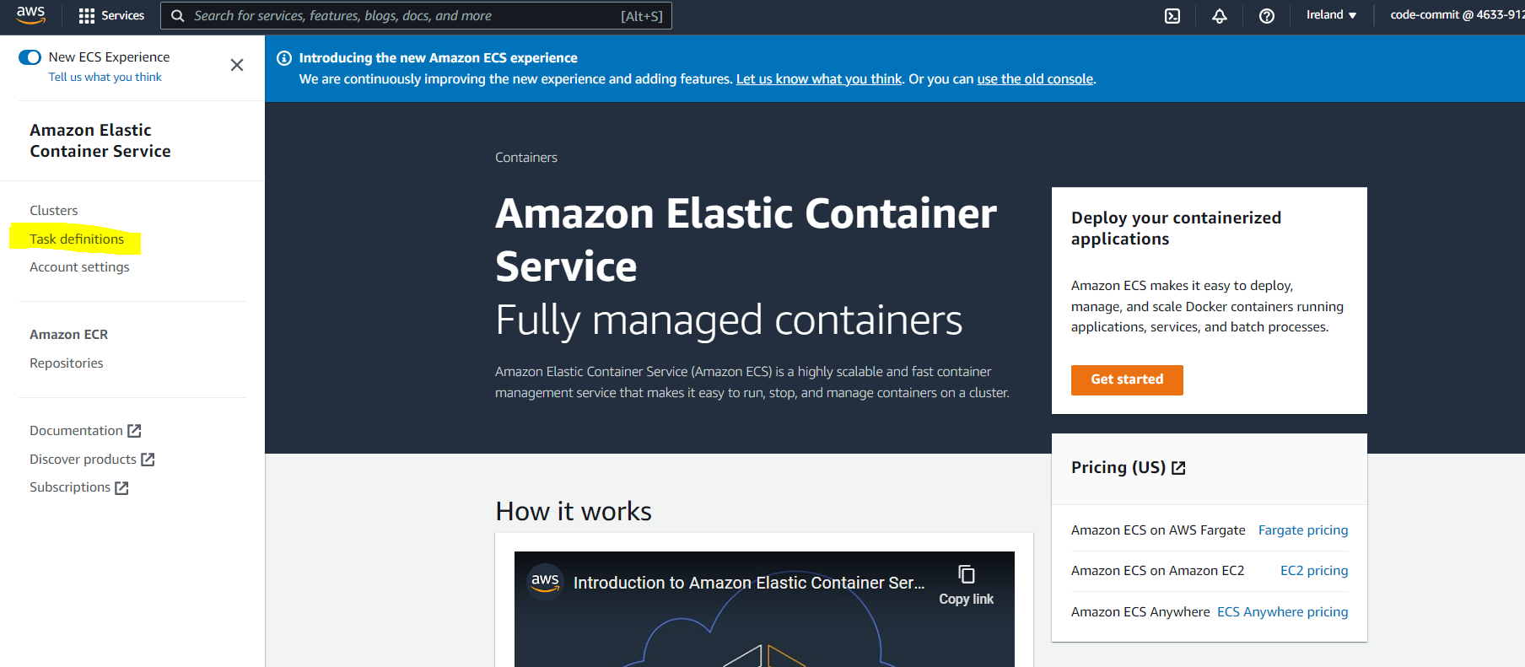

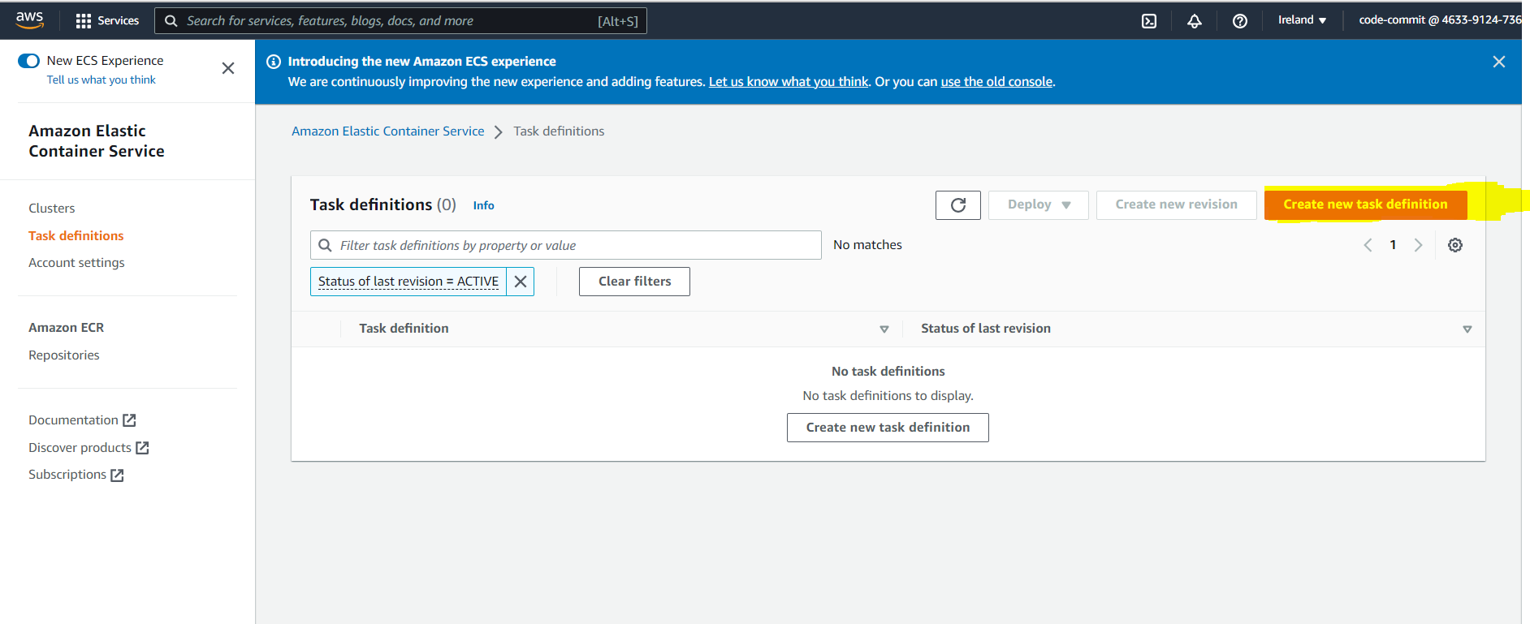

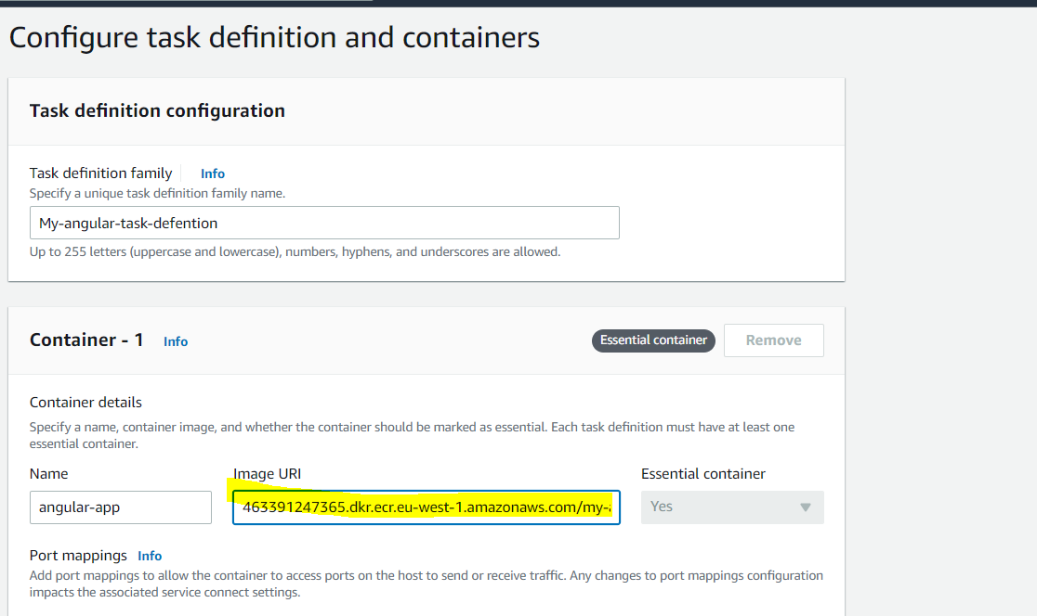

* Image Uri is the URI of the image which we pushed to ECR previously

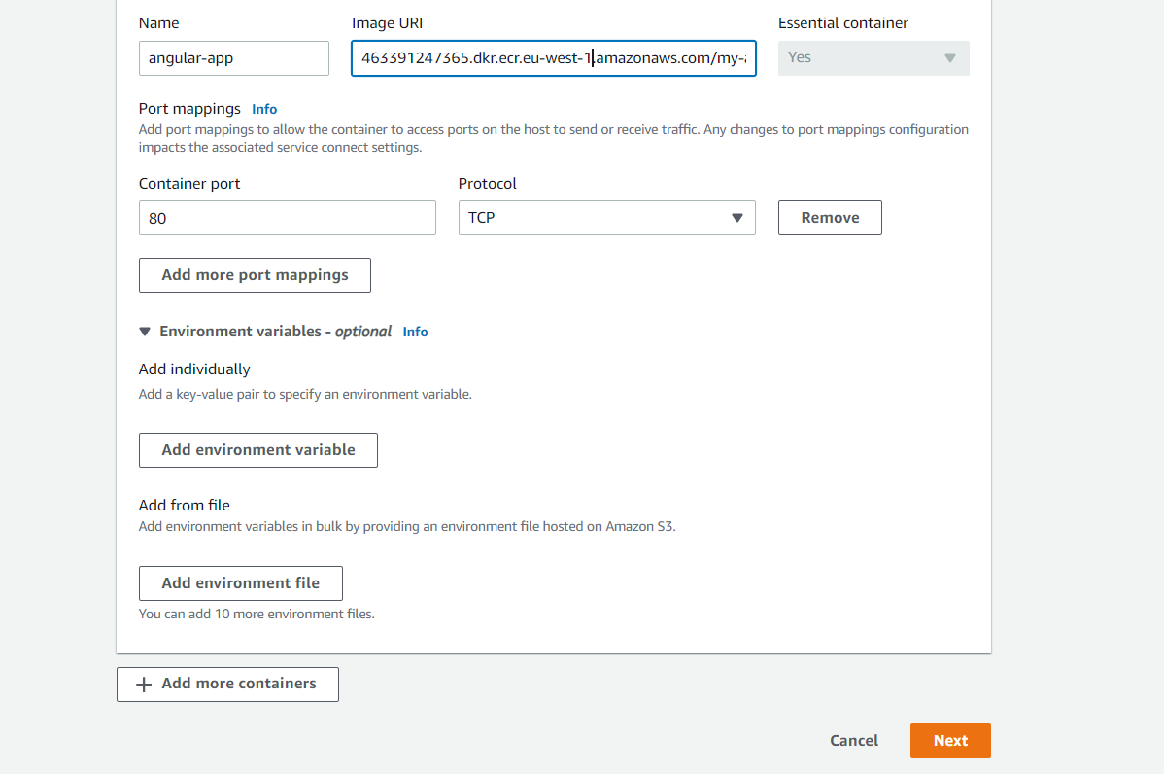

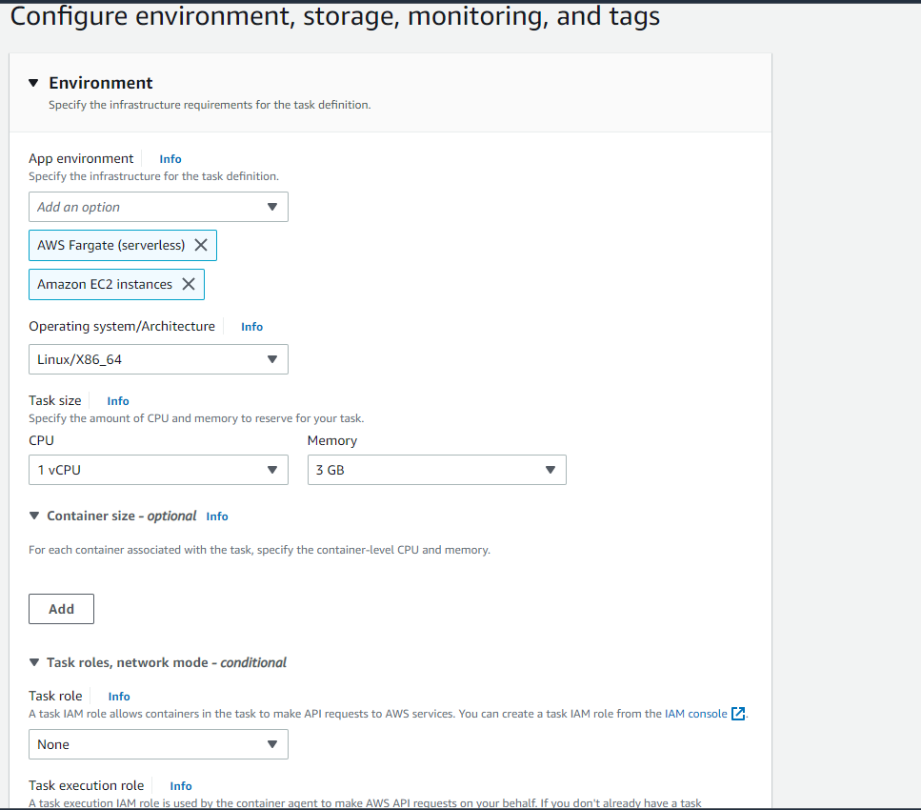

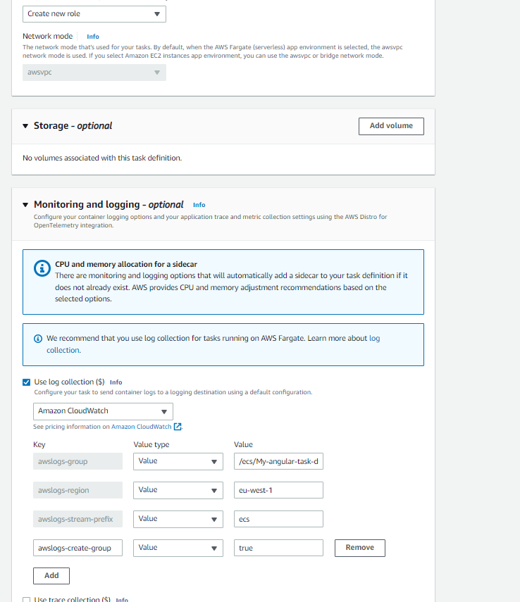

* Now Review the details and create it.

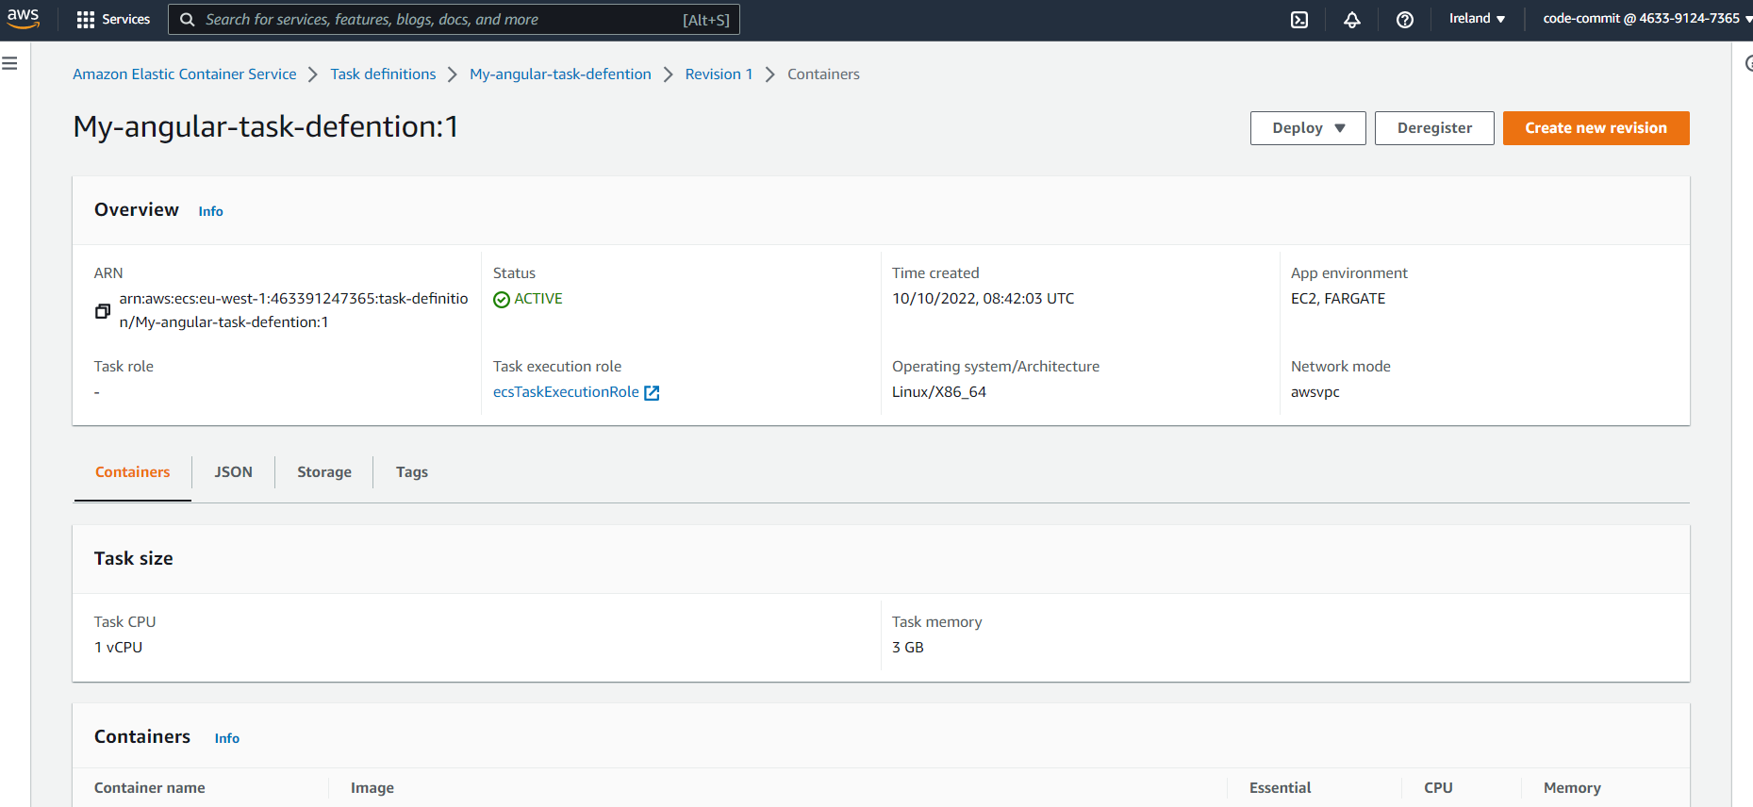

7)Creating an ECS Cluster For your services

* We cant create ECS Service without an ECS Cluster

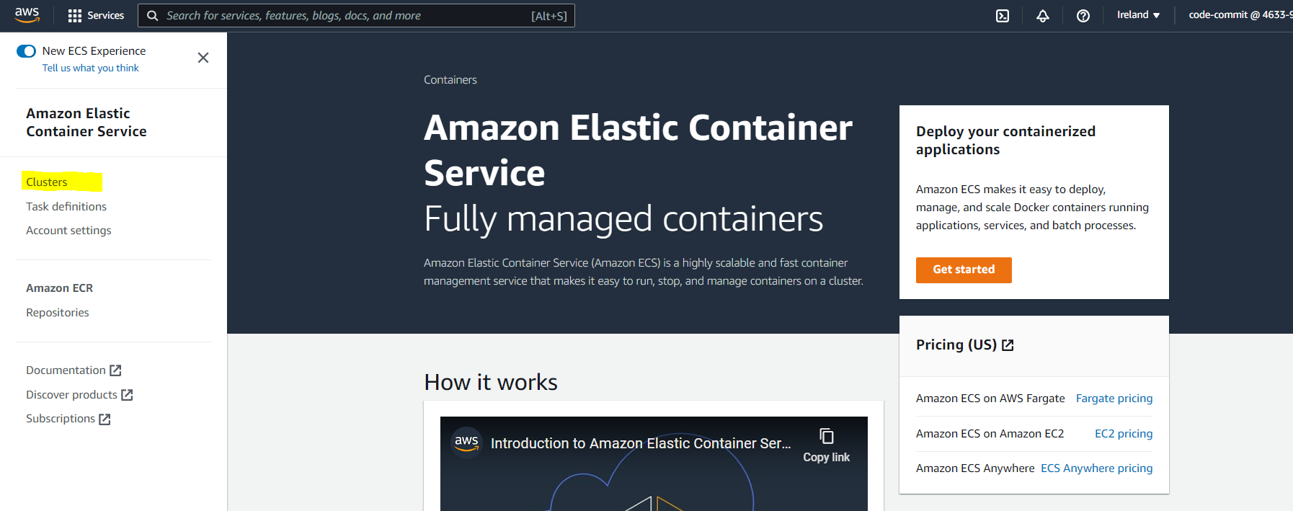

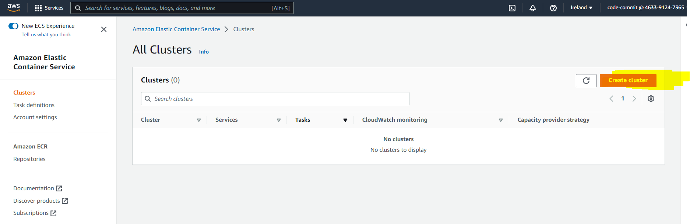

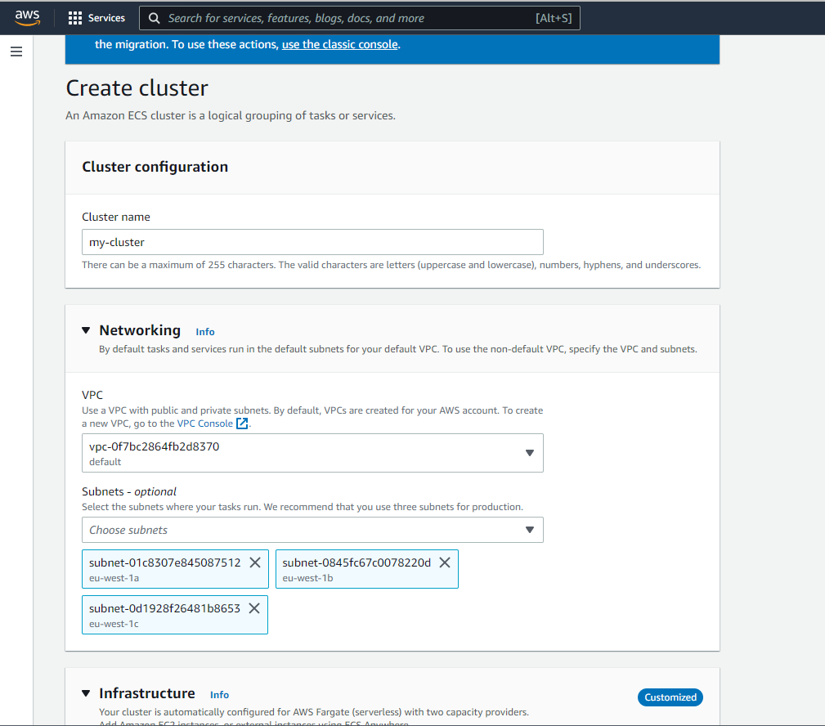

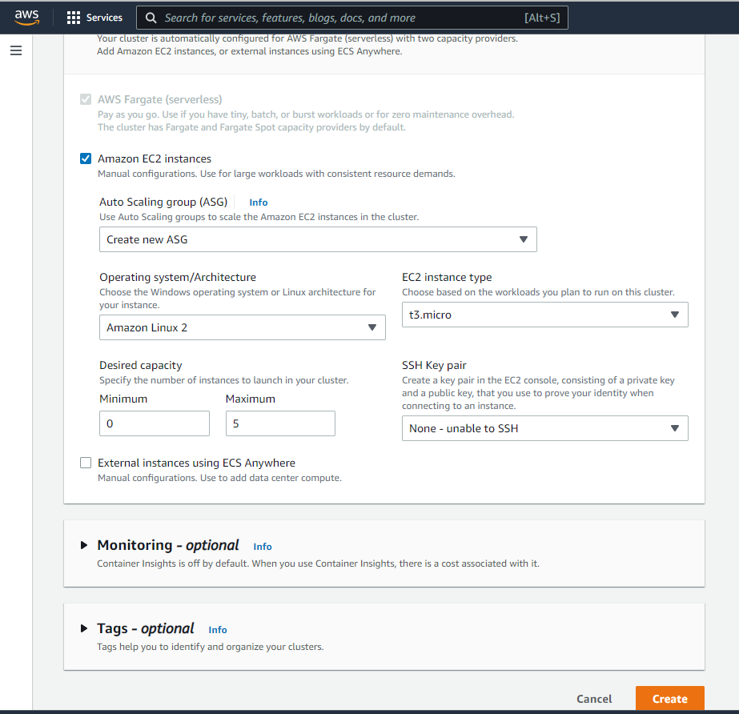

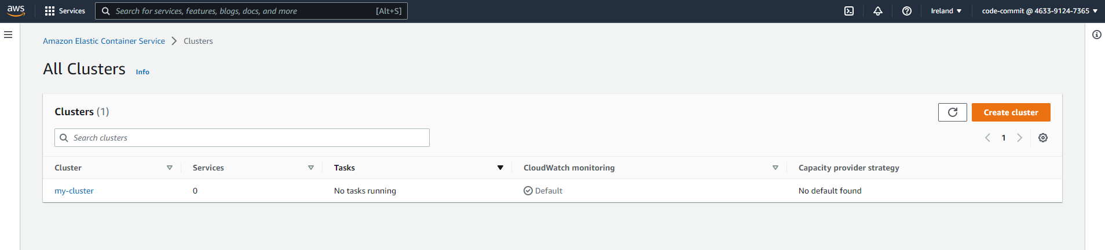

8)Creating an ECS service on Fargate for rolling Deployments

Go to services tab inside our cluster and click Deploy tab

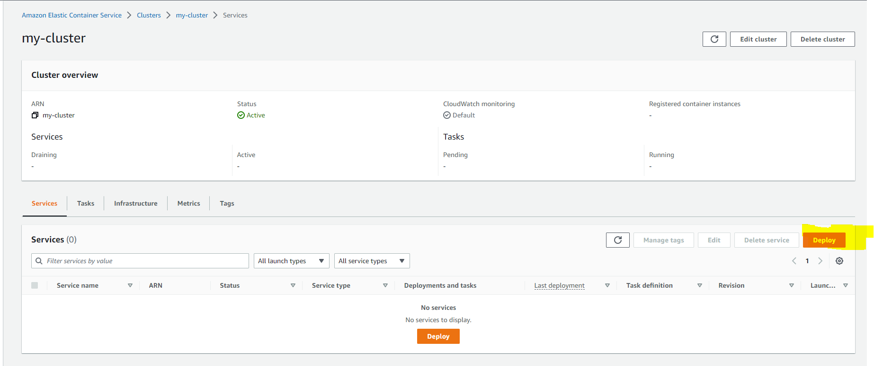

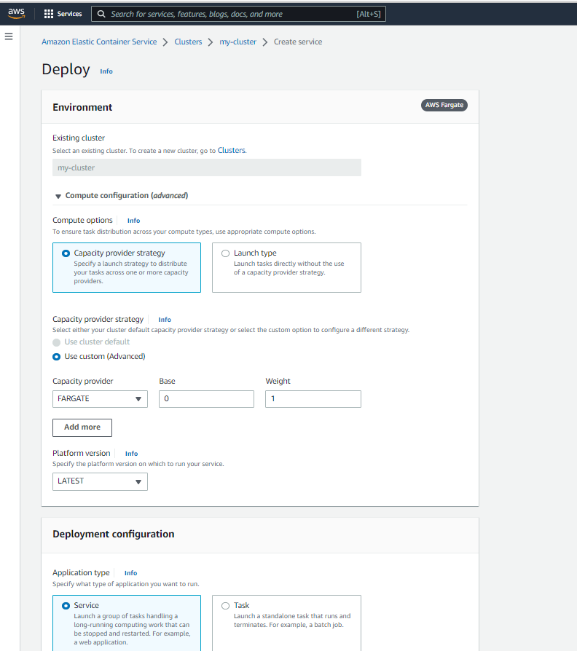

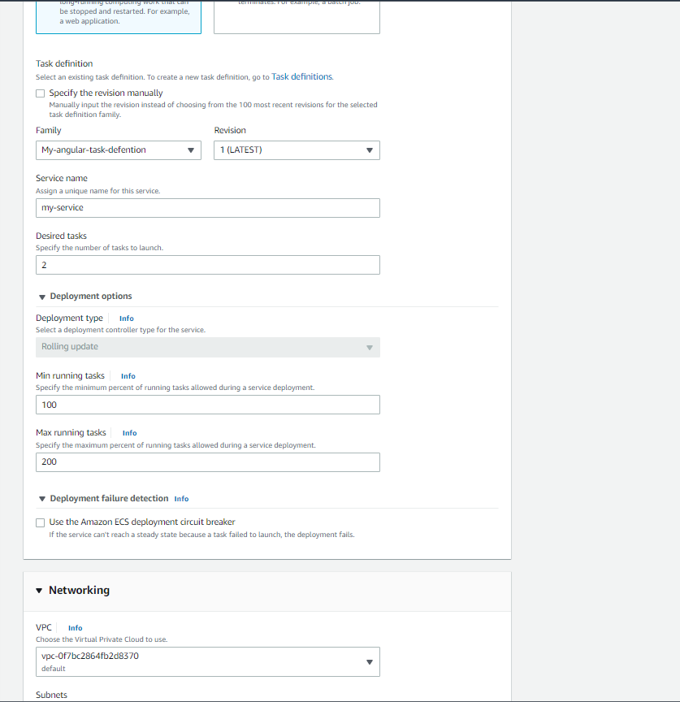

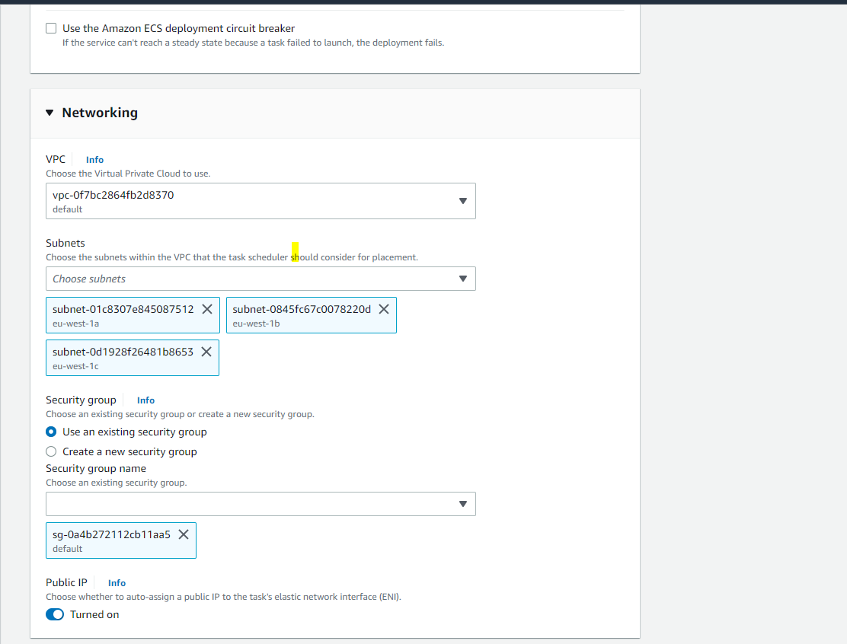

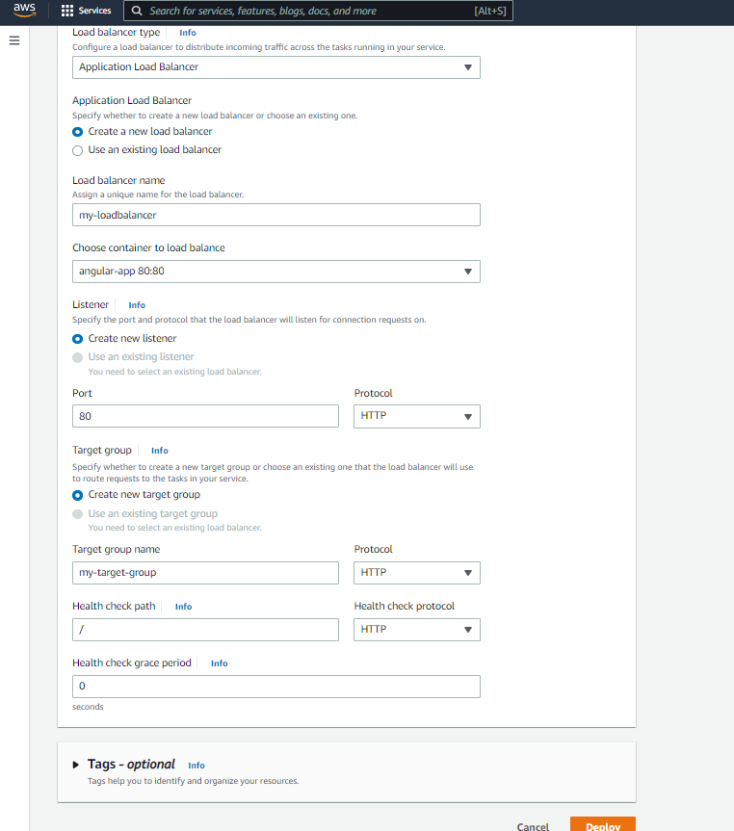

* Now our ECS service have been created

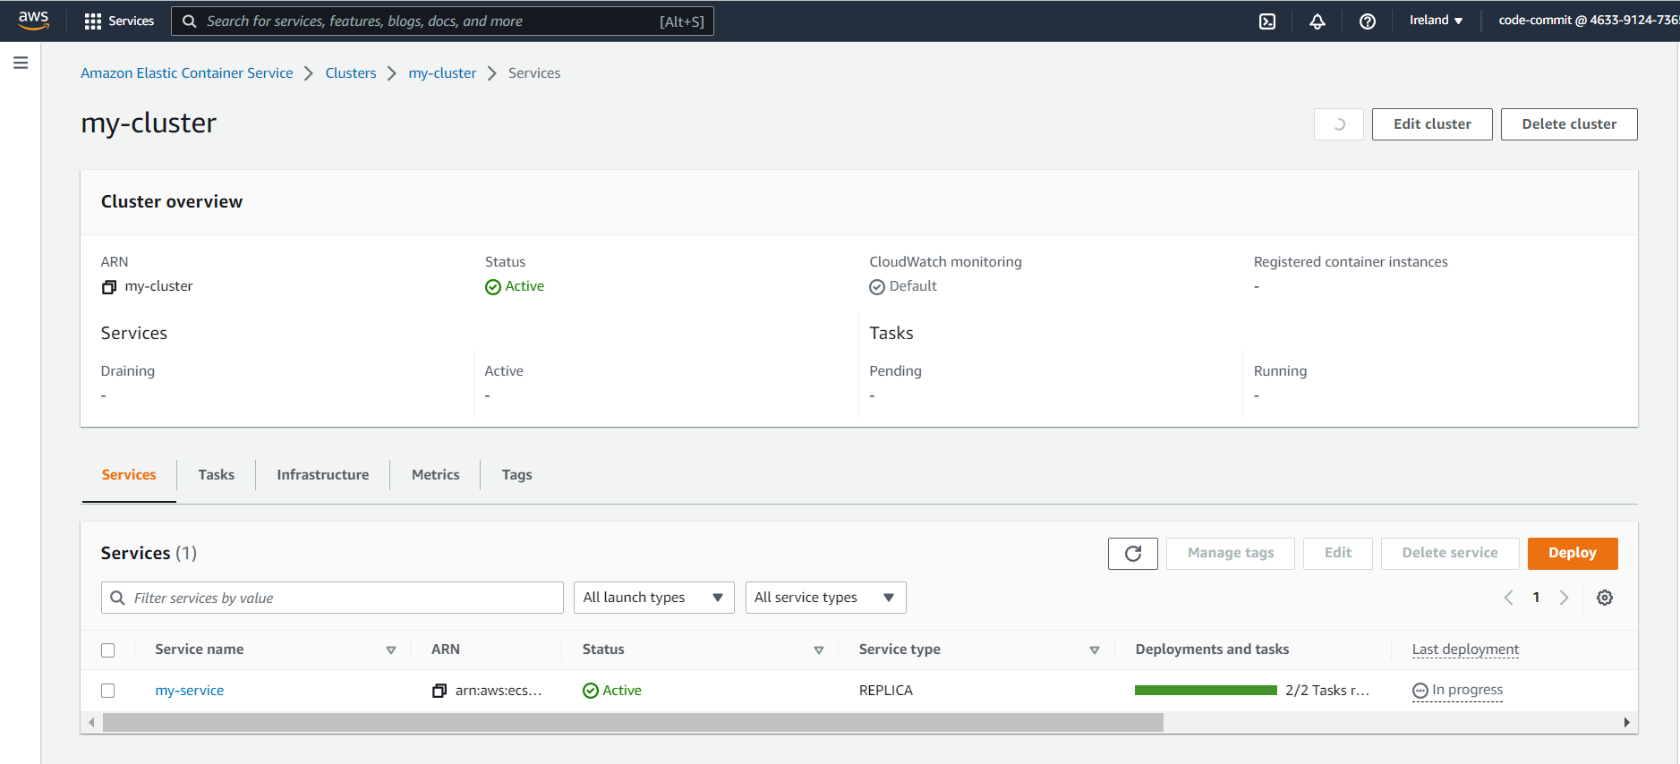

* Below is the details of our container inside our cluster

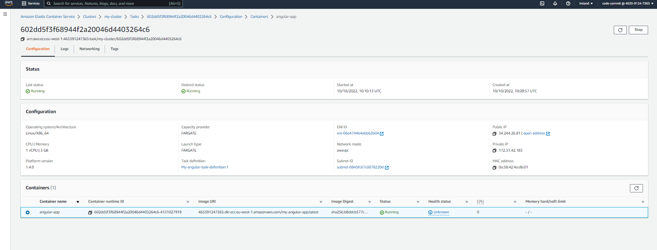

* Now go to our Load balancer for our ECS Service and attach security group for accessing our application in browser

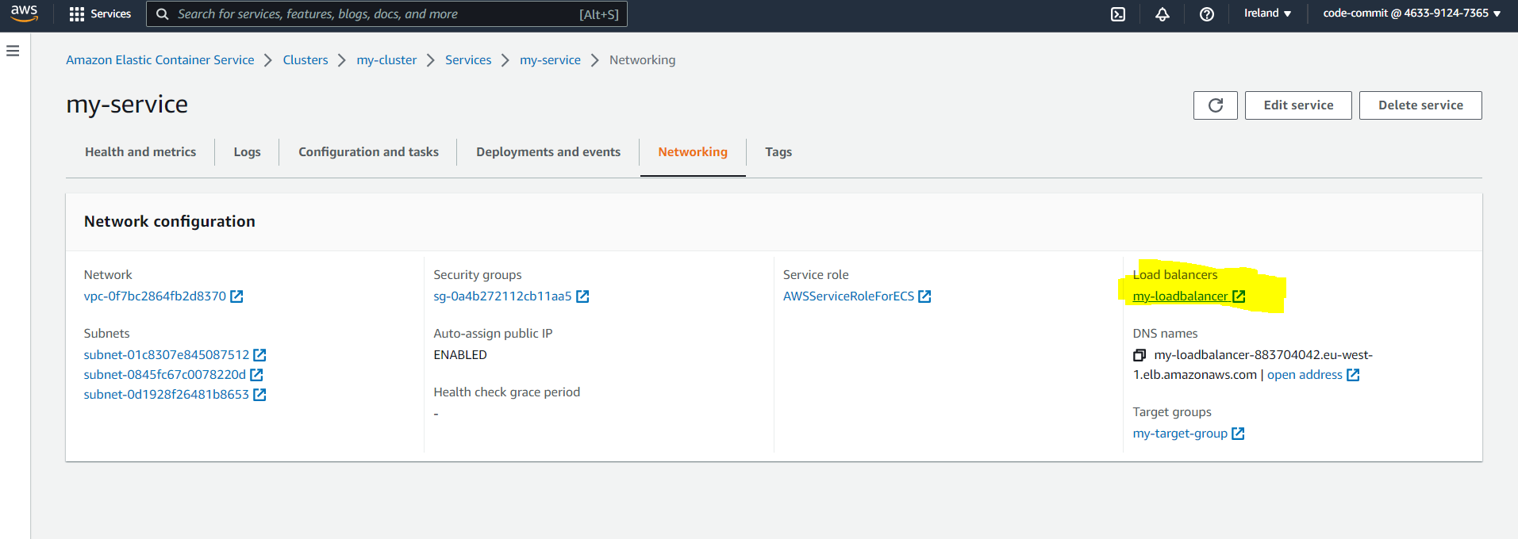

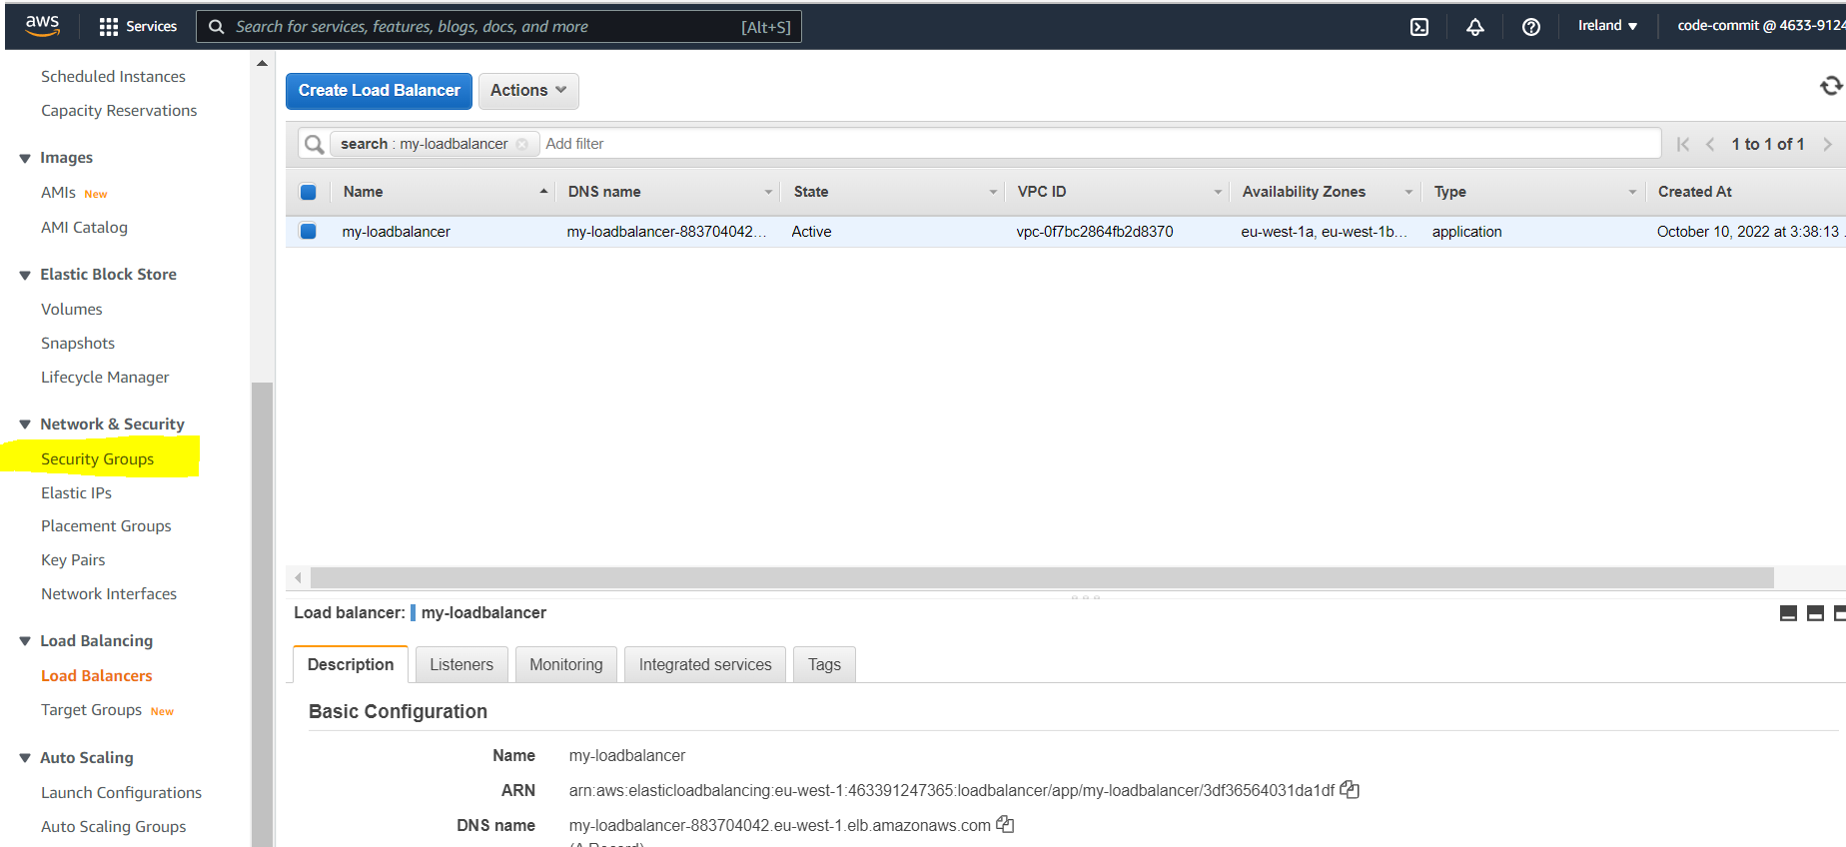

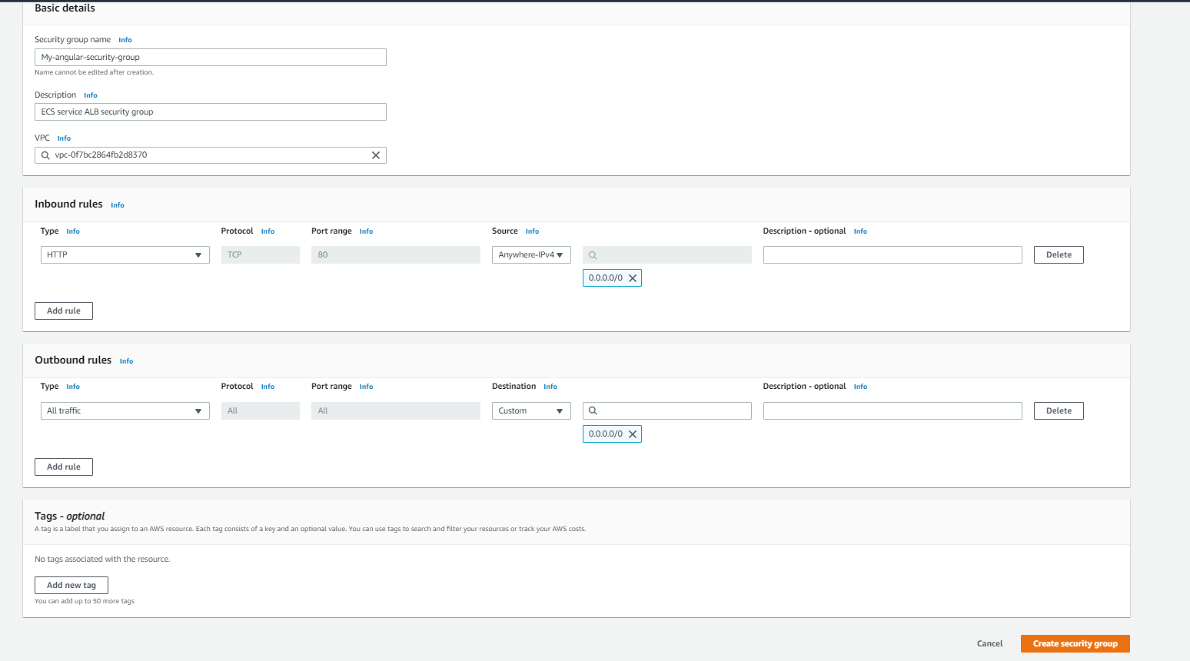

* Then attach this security group to our load balancer

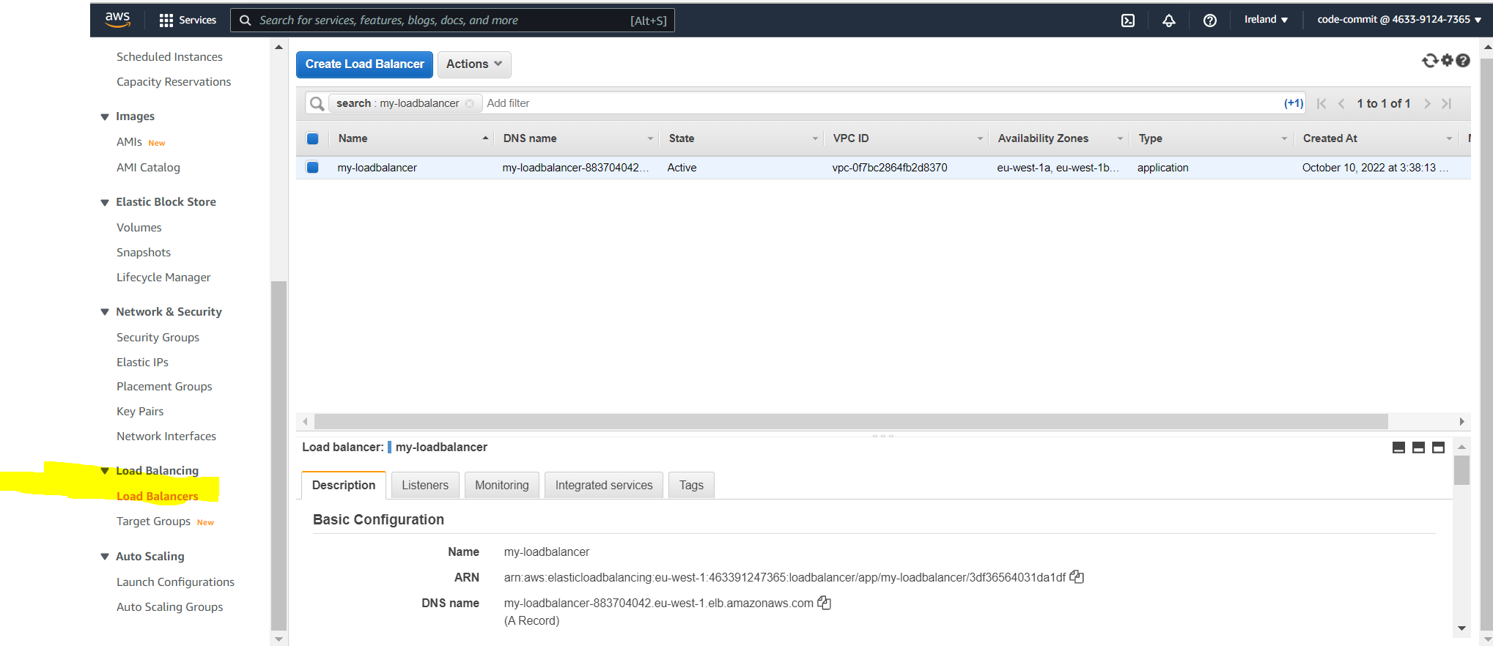

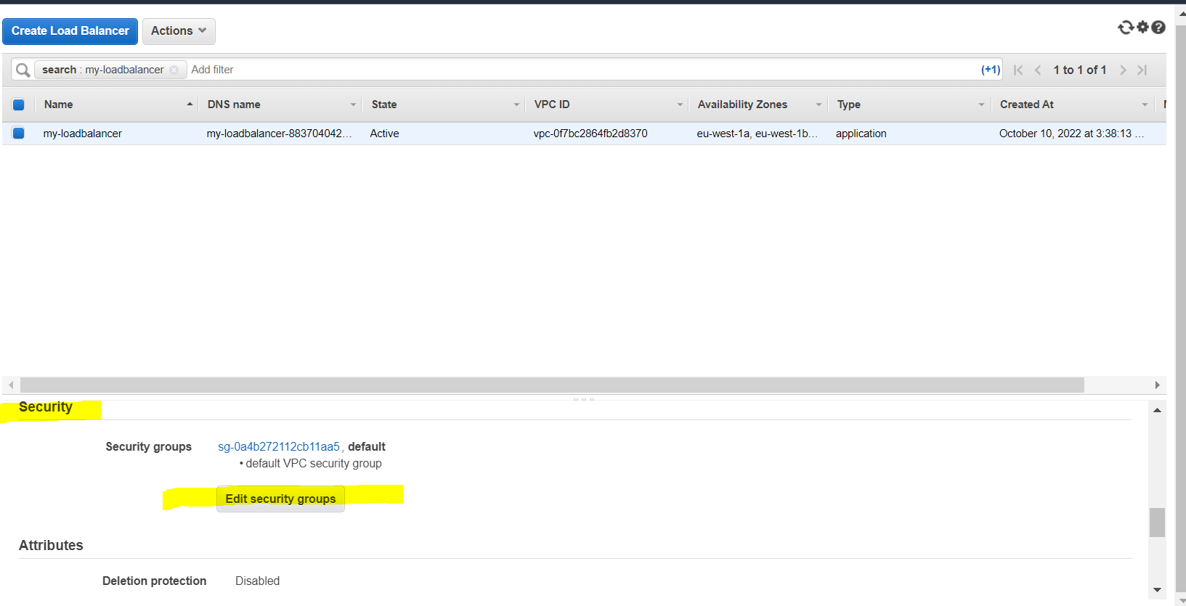

* Select the security group we created and save it

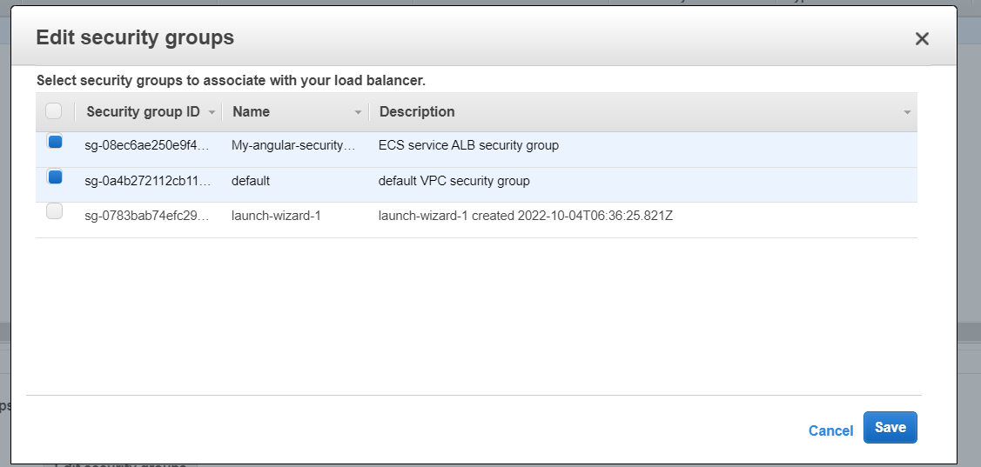

* Now our application will be accessible in browser

9)Adding Deploy Stage : Adding Amazon ECS Standard Deploy action to our pipeline

* Edit our pipeline and add new stage : Deploy stage

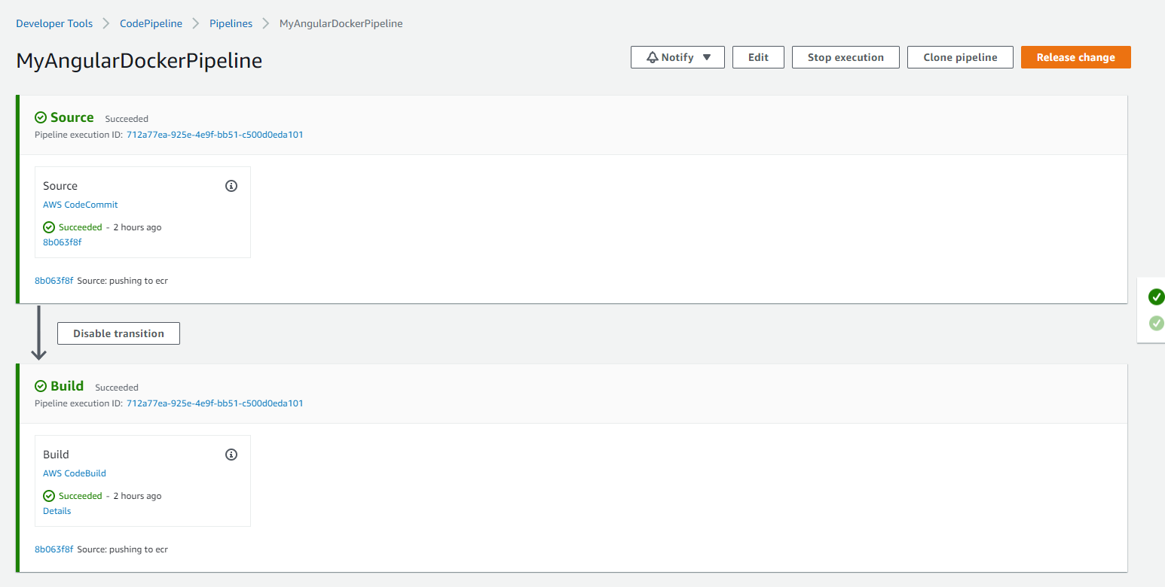

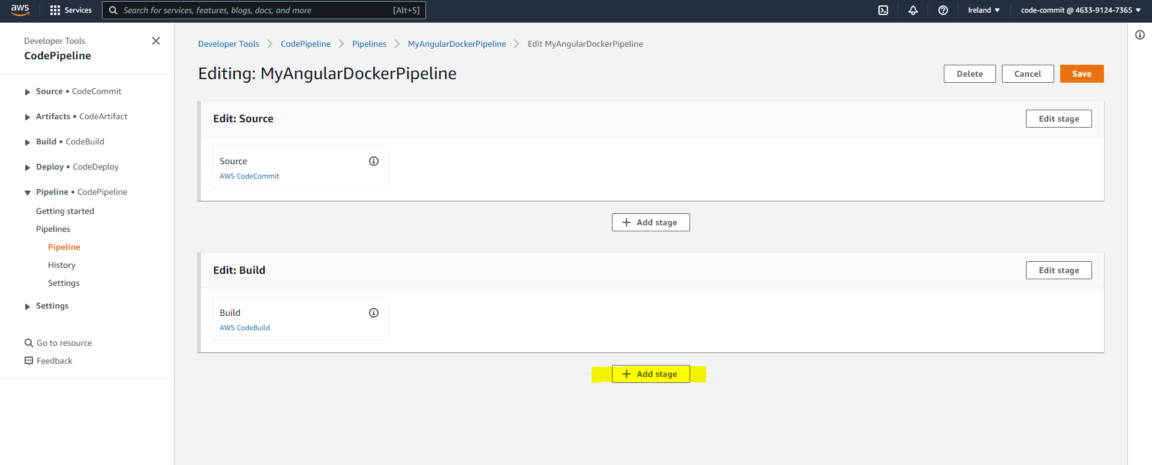

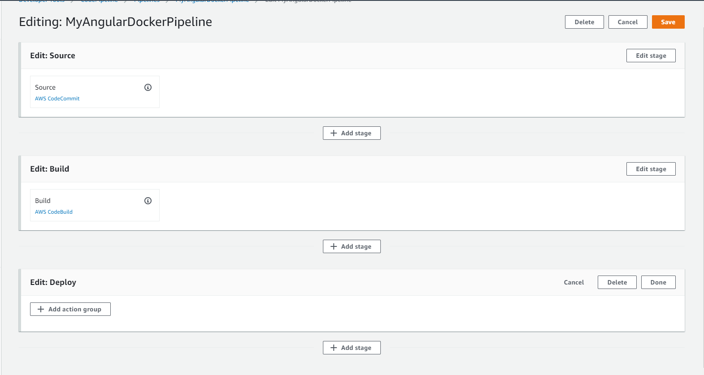

* Now add an action group for deploy stage

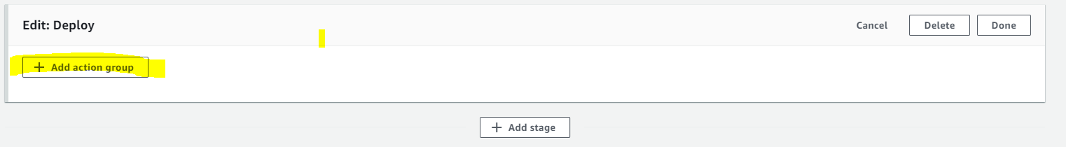

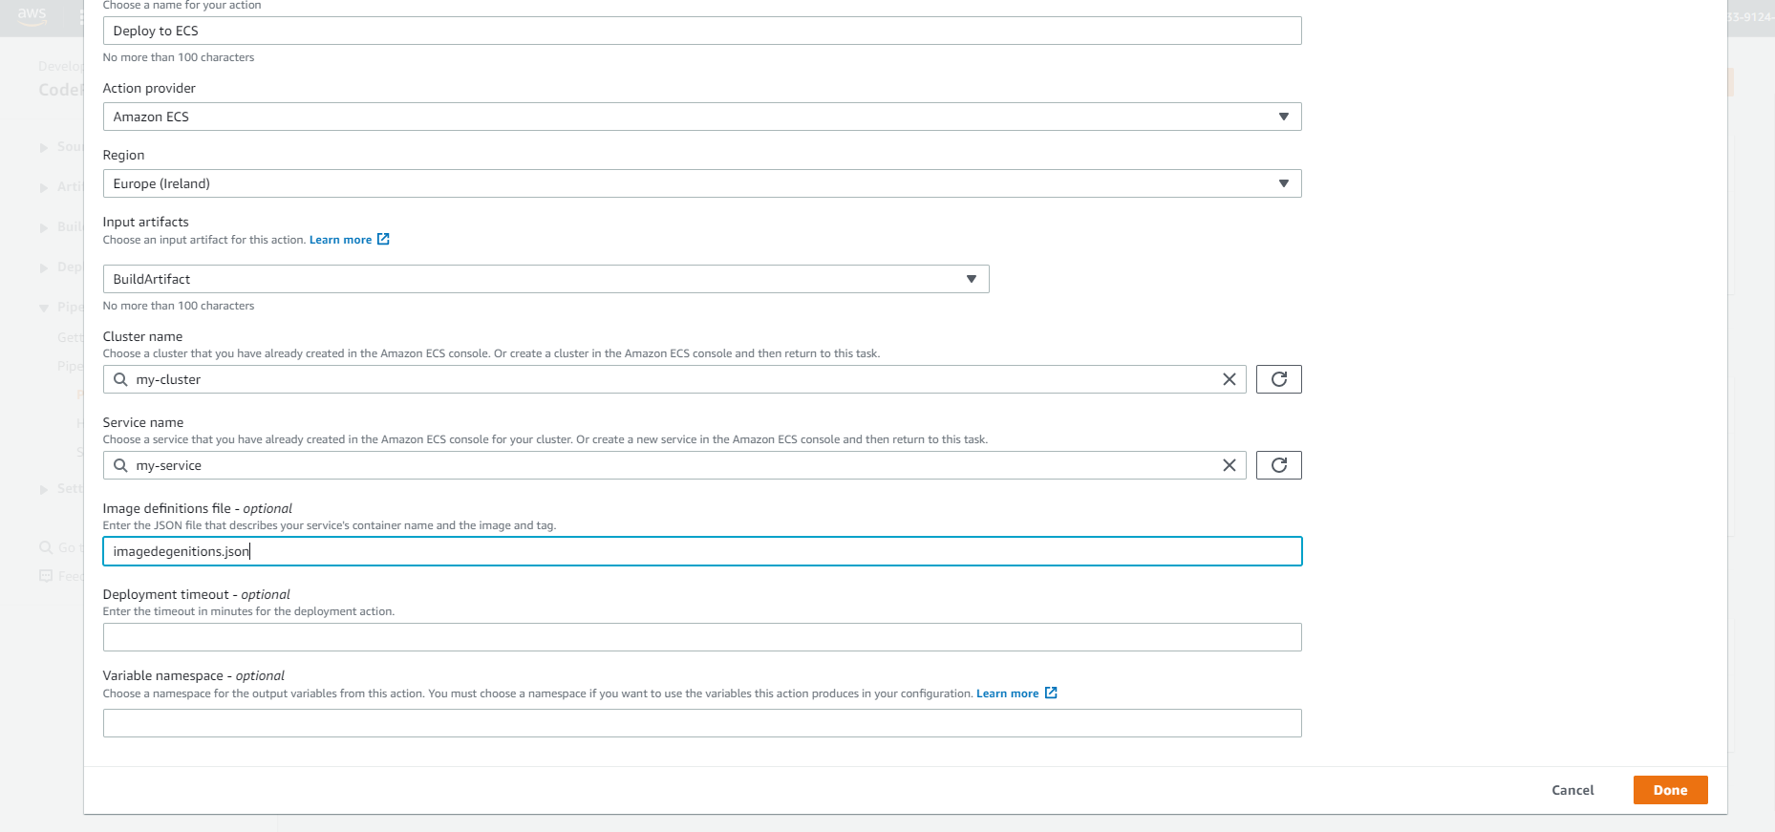

* Here the image definition file is the file which we specify in our Buildspec file
* Now save it and save our pipeline

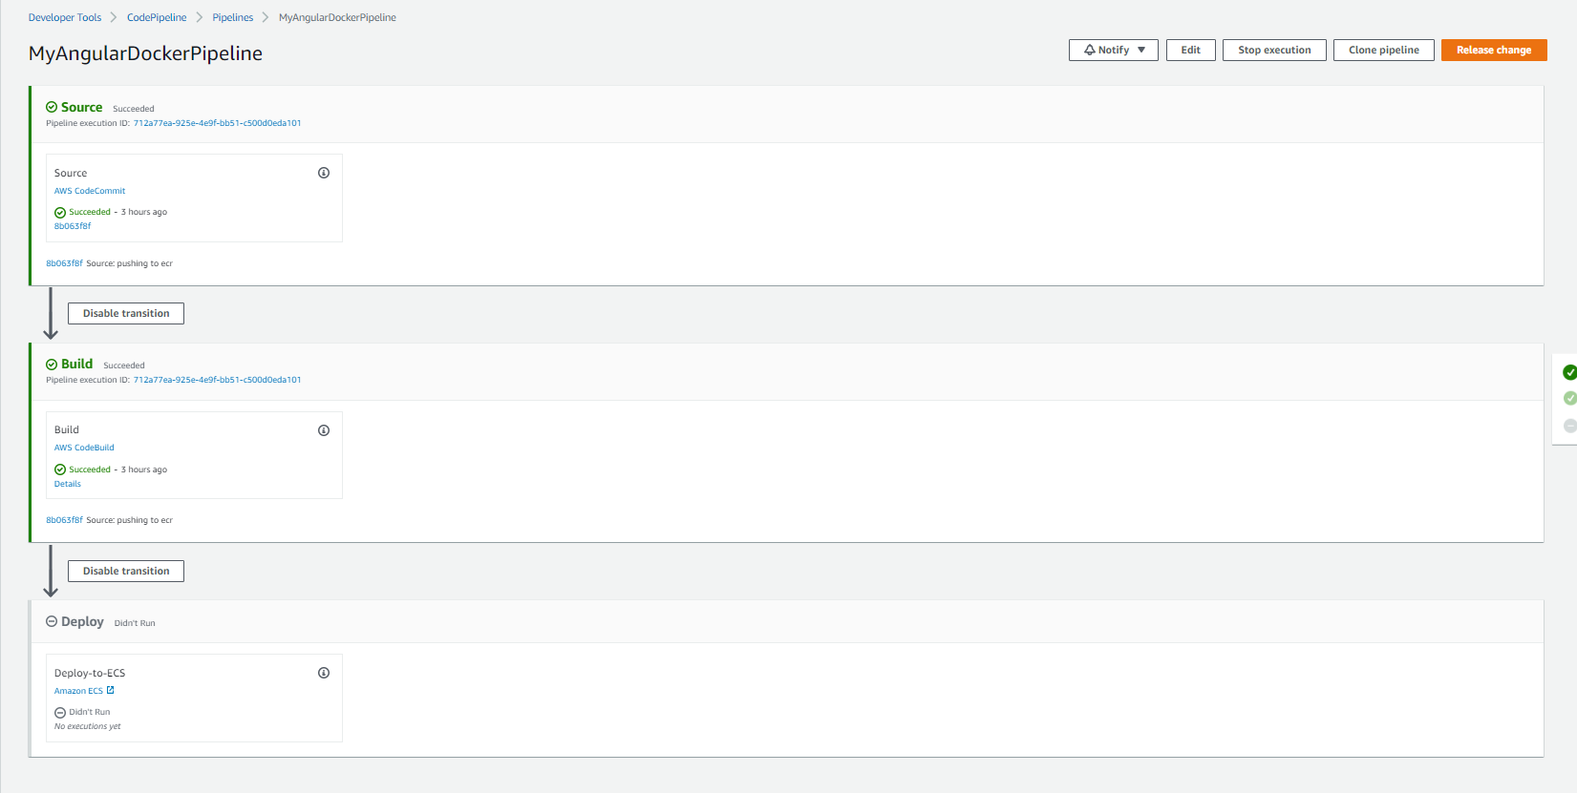

* Now go top buildspec file and edit it and add required changes for our deploy stage.

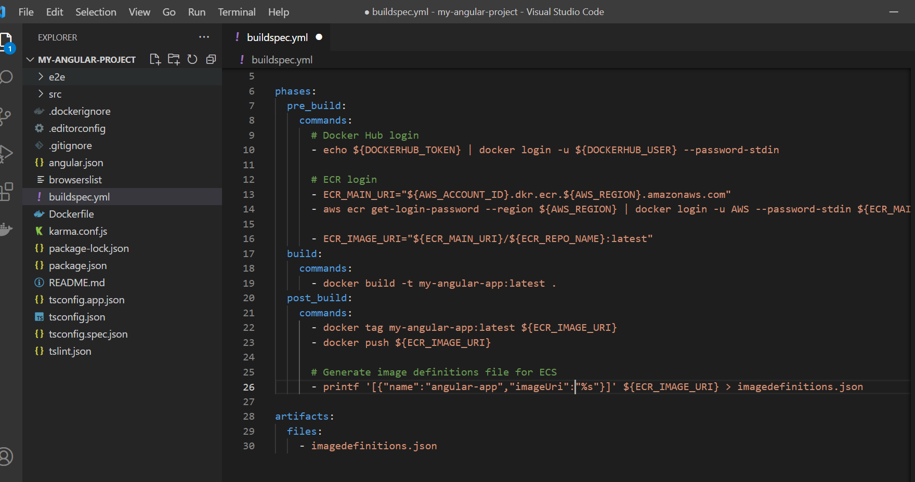

version: 0.2

env:

  variables:

    ECR_REPO_NAME: my-angular-app

phases:

  pre_build:

    commands:

      # Docker Hub login

      - echo ${DOCKERHUB_TOKEN} | docker login -u ${DOCKERHUB_USER} --password-stdin

      # ECR login

      - ECR_MAIN_URI="${AWS_ACCOUNT_ID}.dkr.ecr.${AWS_REGION}.amazonaws.com"

      - aws ecr get-login-password --region ${AWS_REGION} | docker login -u AWS --password-stdin ${ECR_MAIN_URI}

      - ECR_IMAGE_URI="${ECR_MAIN_URI}/${ECR_REPO_NAME}:latest"

  build:

    commands:

      - docker build -t my-angular-app:latest .

  post_build:

    commands:

      - docker tag my-angular-app:latest ${ECR_IMAGE_URI}

      - docker push ${ECR_IMAGE_URI}

      # Generate image definitions file for ECS

      - printf '[{"name":"angular-app","imageUri":"%s"}]' ${ECR_IMAGE_URI} > imagedefinitions.json

artifacts:

  files:

    - imagedefinitions.json

* Now commit our changes and push our code to Code-Commit repository
* We can see our build artifact from the pipeline settings - > artifact store

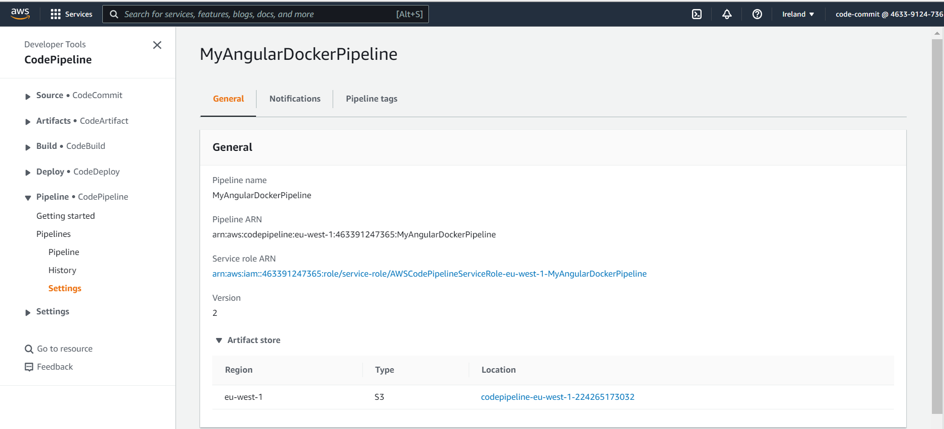

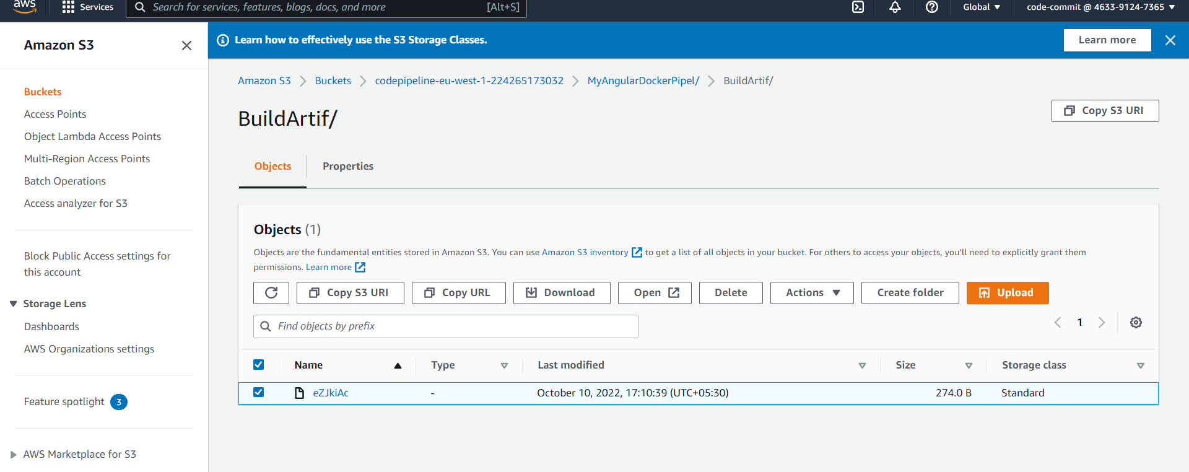

* After committing our changes the pipeline will trigger and it will execute all three stages in pipeline.

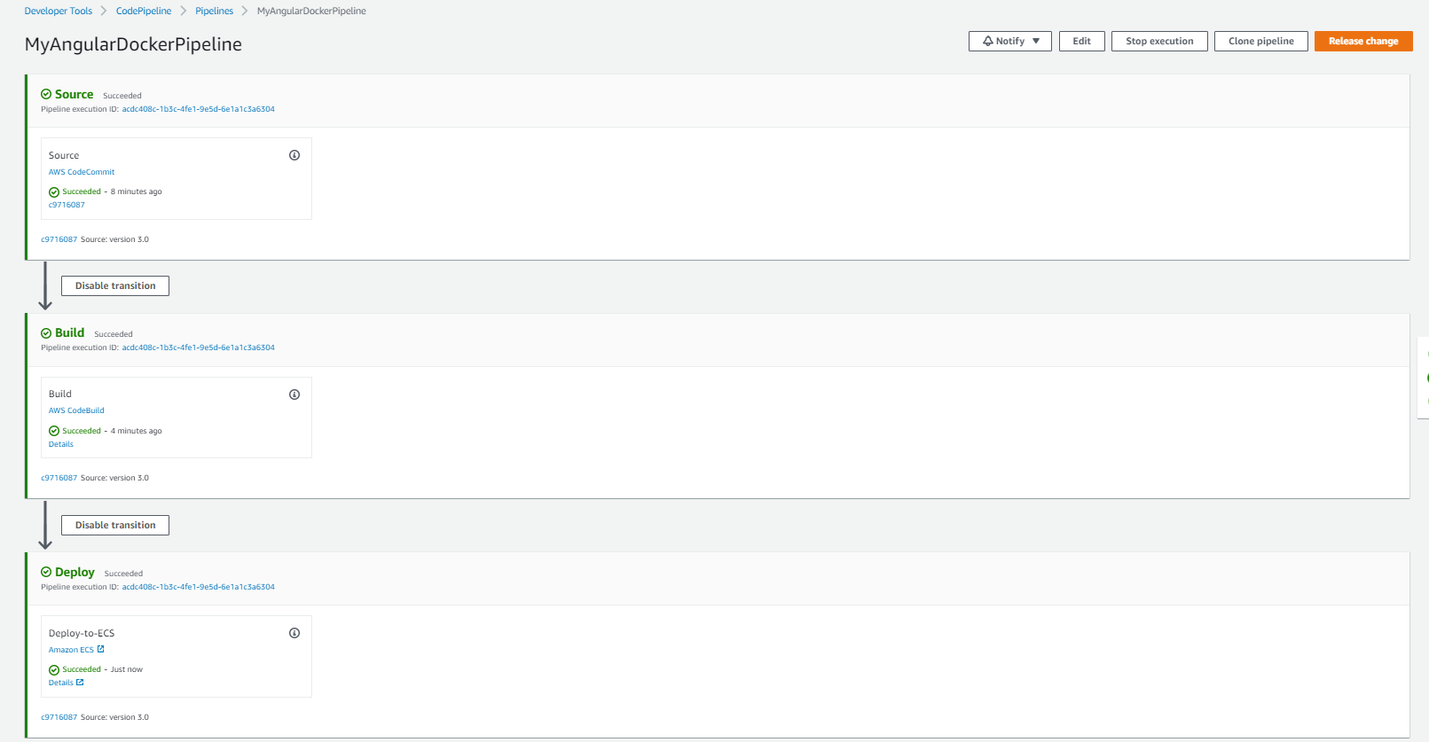

10)Tagging Docker images with Commit ID’s

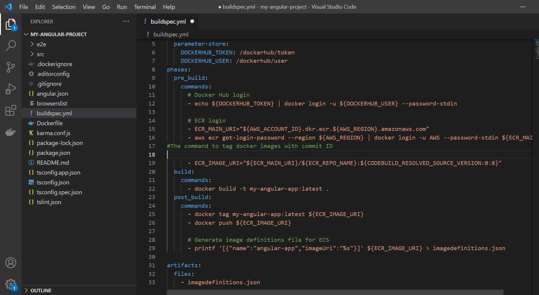

version: 0.2

env:

  variables:

    ECR_REPO_NAME: my-angular-app

  parameter-store:

    DOCKERHUB_TOKEN: /dockerhub/token

    DOCKERHUB_USER: /dockerhub/user

phases:

  pre_build:

    commands:

      # Docker Hub login

      - echo ${DOCKERHUB_TOKEN} | docker login -u ${DOCKERHUB_USER} --password-stdin

      # ECR login

      - ECR_MAIN_URI="${AWS_ACCOUNT_ID}.dkr.ecr.${AWS_REGION}.amazonaws.com"

      - aws ecr get-login-password --region ${AWS_REGION} | docker login -u AWS --password-stdin ${ECR_MAIN_URI}

#The command to tag docker images with commit ID

      - ECR_IMAGE_URI="${ECR_MAIN_URI}/${ECR_REPO_NAME}:${CODEBUILD_RESOLVED_SOURCE_VERSION:0:8}"

  build:

    commands:

      - docker build -t my-angular-app:latest .

  post_build:

    commands:

      - docker tag my-angular-app:latest ${ECR_IMAGE_URI}

      - docker push ${ECR_IMAGE_URI}

      # Generate image definitions file for ECS

      - printf '[{"name":"angular-app","imageUri":"%s"}]' ${ECR_IMAGE_URI} > imagedefinitions.json

artifacts:

  files:

    - imagedefinitions.json

The output

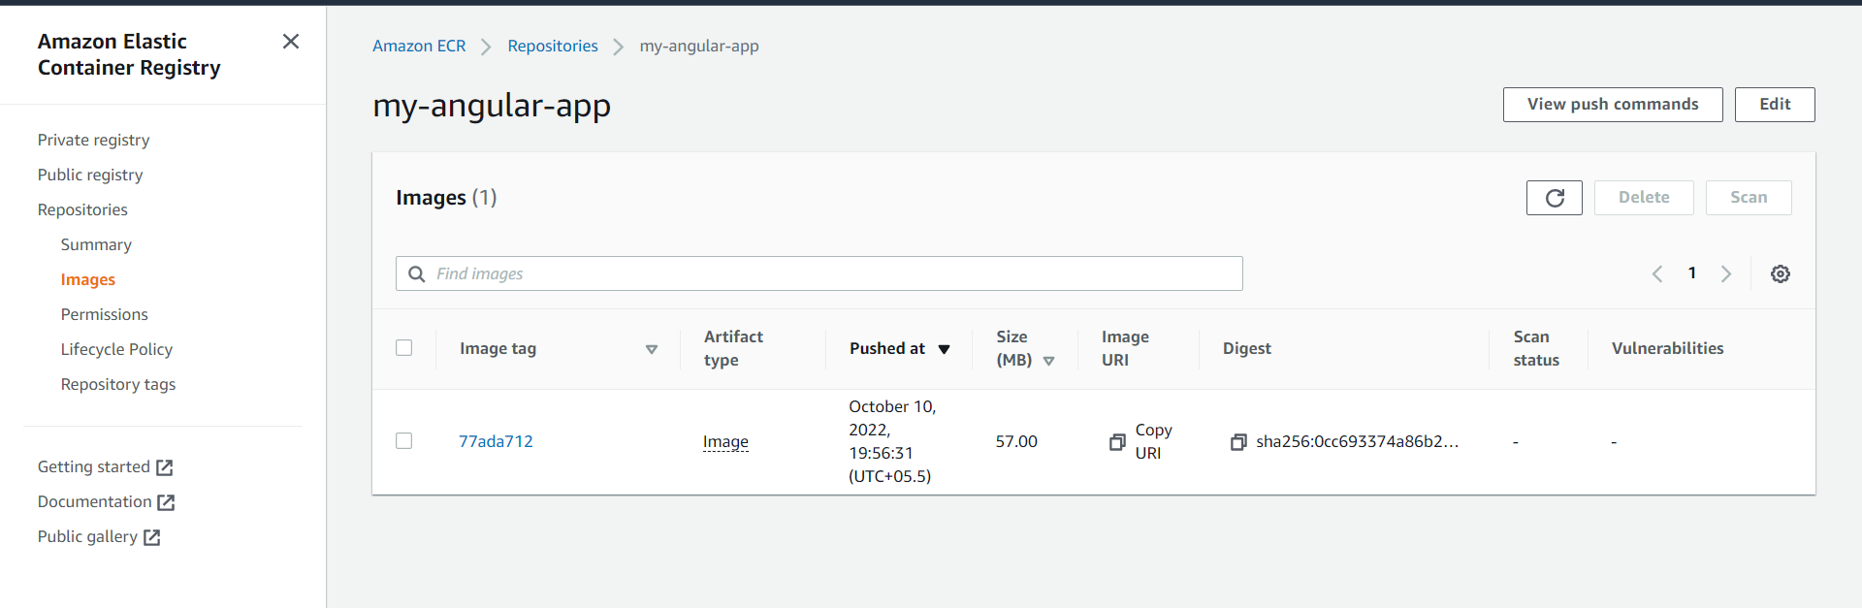

11)Using ECR Public Gallery in our Docker builds (Alternative to Docker hub for images)

* ECR Public gallery contains different images like in Docker hub.

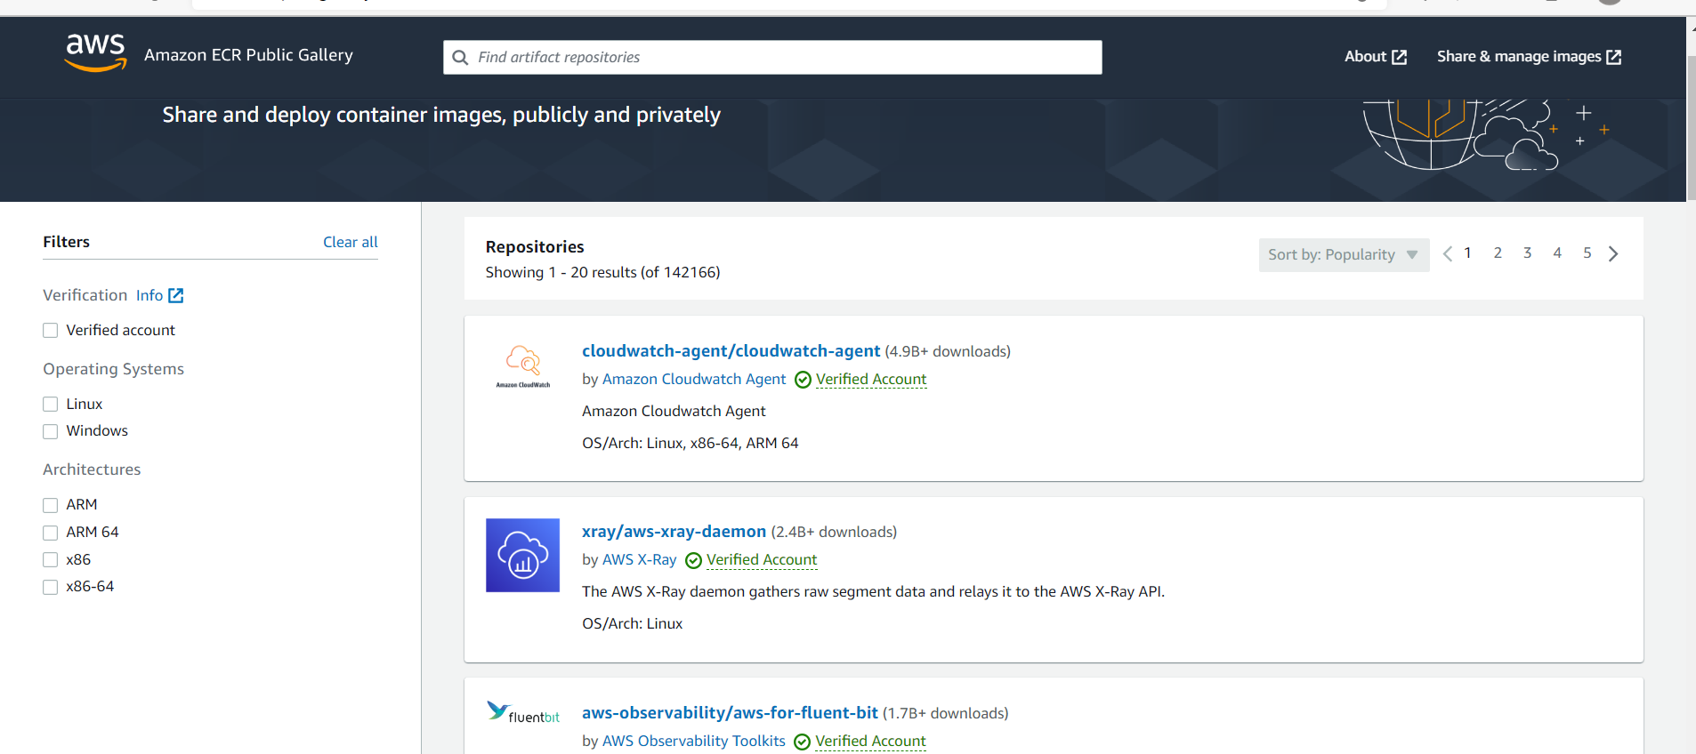

Docker file

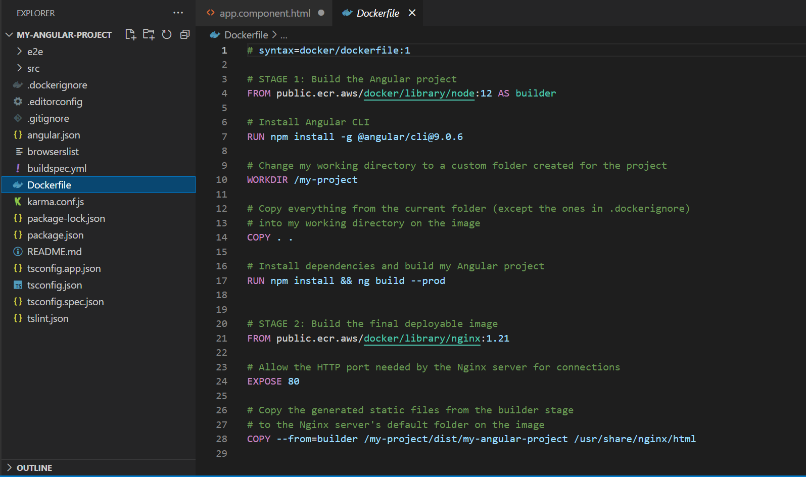

# syntax=docker/dockerfile:1

# STAGE 1: Build the Angular project

#adding ECR Public gallery details in docker file

FROM public.ecr.aws/docker/library/node:12 AS builder

# Install Angular CLI

RUN npm install -g @angular/cli@9.0.6

# Change my working directory to a custom folder created for the project

WORKDIR /my-project

# Copy everything from the current folder (except the ones in .dockerignore)

# into my working directory on the image

COPY . .

# Install dependencies and build my Angular project

RUN npm install && ng build --prod

# STAGE 2: Build the final deployable image

#adding ECR Public gallery details in docker file

FROM public.ecr.aws/docker/library/nginx:1.21

# Allow the HTTP port needed by the Nginx server for connections

EXPOSE 80

# Copy the generated static files from the builder stage

# to the Nginx server's default folder on the image

COPY --from=builder /my-project/dist/my-angular-project /usr/share/nginx/html

Buildspecfile

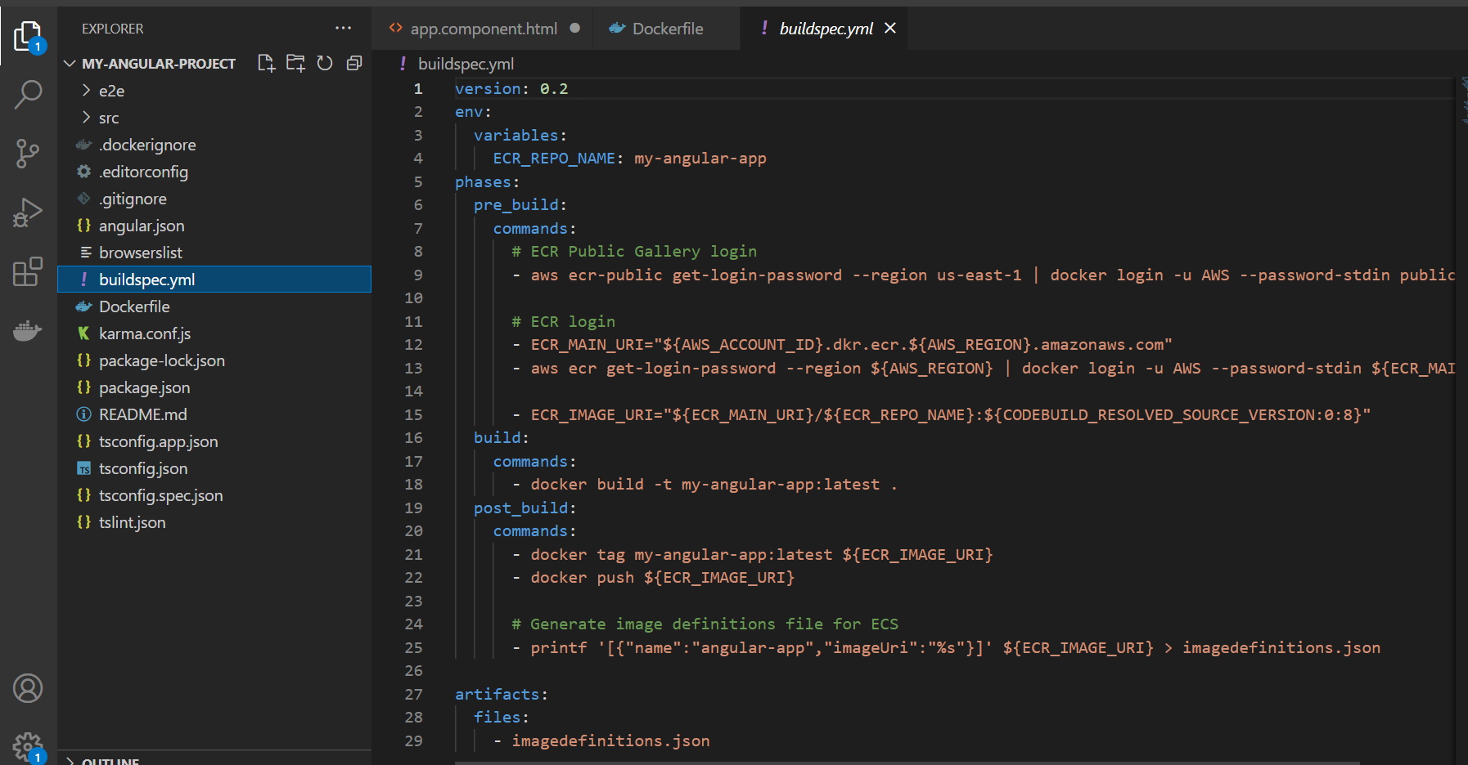

version: 0.2

env:

  variables:

    ECR_REPO_NAME: my-angular-app

phases:

  pre_build:

    commands:

      # ECR Public Gallery login

      - aws ecr-public get-login-password --region us-east-1 | docker login -u AWS --password-stdin public.ecr.aws

      # ECR login

      - ECR_MAIN_URI="${AWS_ACCOUNT_ID}.dkr.ecr.${AWS_REGION}.amazonaws.com"

      - aws ecr get-login-password --region ${AWS_REGION} | docker login -u AWS --password-stdin ${ECR_MAIN_URI}

      - ECR_IMAGE_URI="${ECR_MAIN_URI}/${ECR_REPO_NAME}:${CODEBUILD_RESOLVED_SOURCE_VERSION:0:8}"

  build:

    commands:

      - docker build -t my-angular-app:latest .

  post_build:

    commands:

      - docker tag my-angular-app:latest ${ECR_IMAGE_URI}

      - docker push ${ECR_IMAGE_URI}

      # Generate image definitions file for ECS

      - printf '[{"name":"angular-app","imageUri":"%s"}]' ${ECR_IMAGE_URI} > imagedefinitions.json

artifacts:

  files:

    - imagedefinitions.json

We need to attach the below policy for our build stage

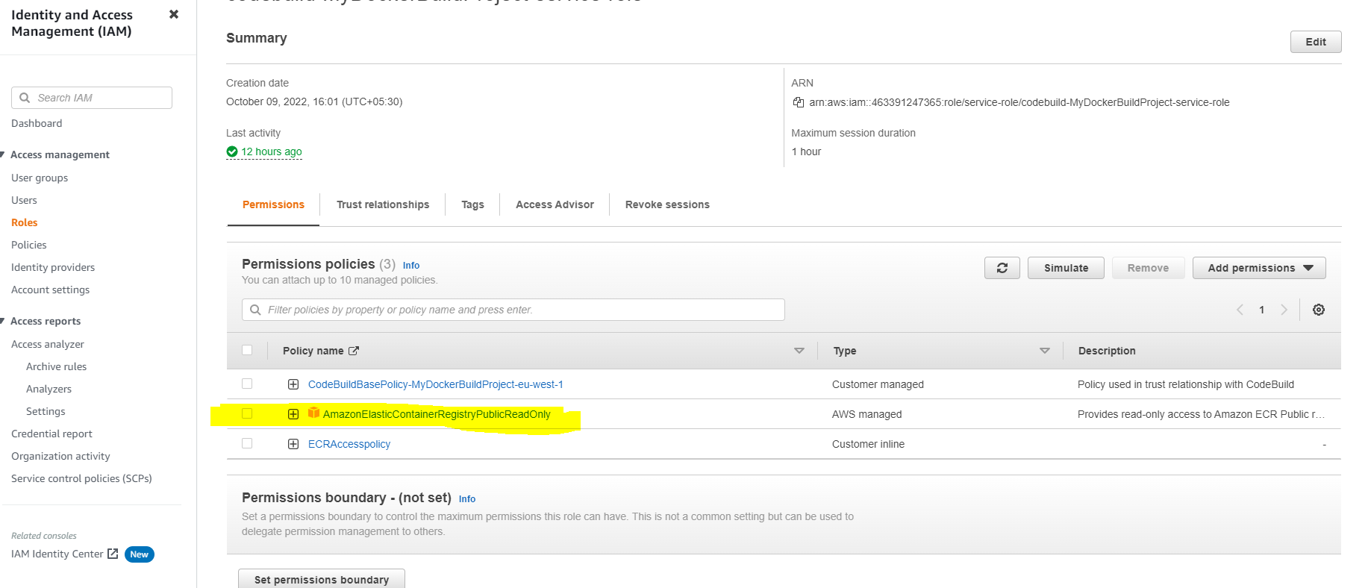

12)Enabling automated Rollbacks on ECS Rolling Deployments

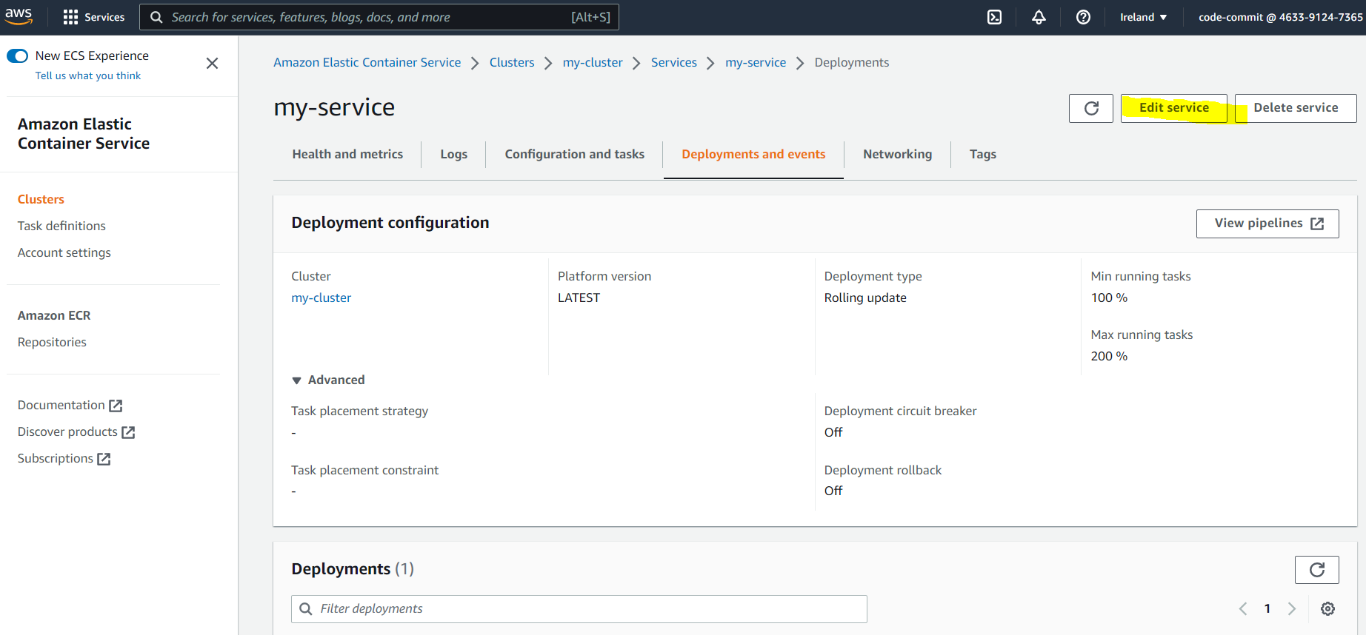

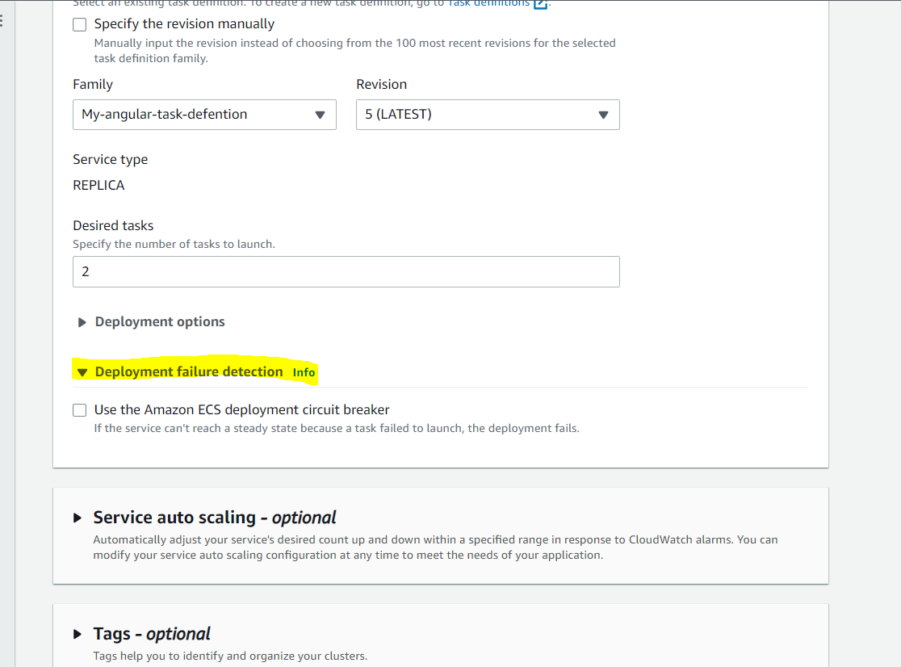

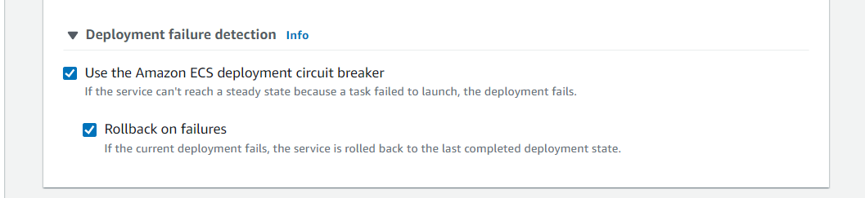

13)Creating ECS Services on ASG Capacity providers for Rolling Deploymnts

* Go to ECS ->Services ->create new ECS service(By clicking Deploy)

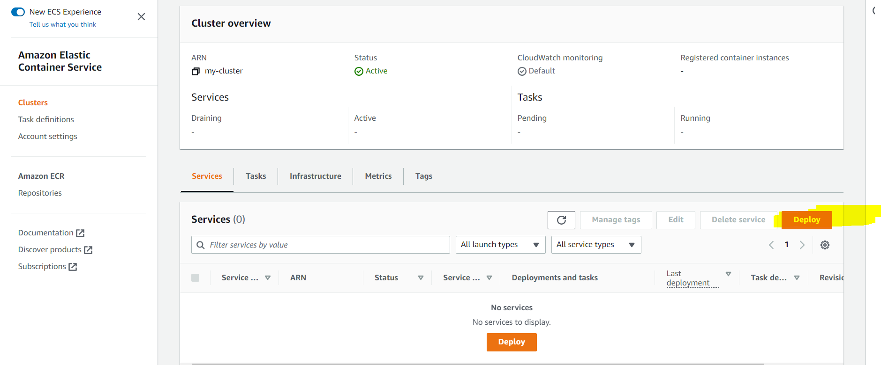

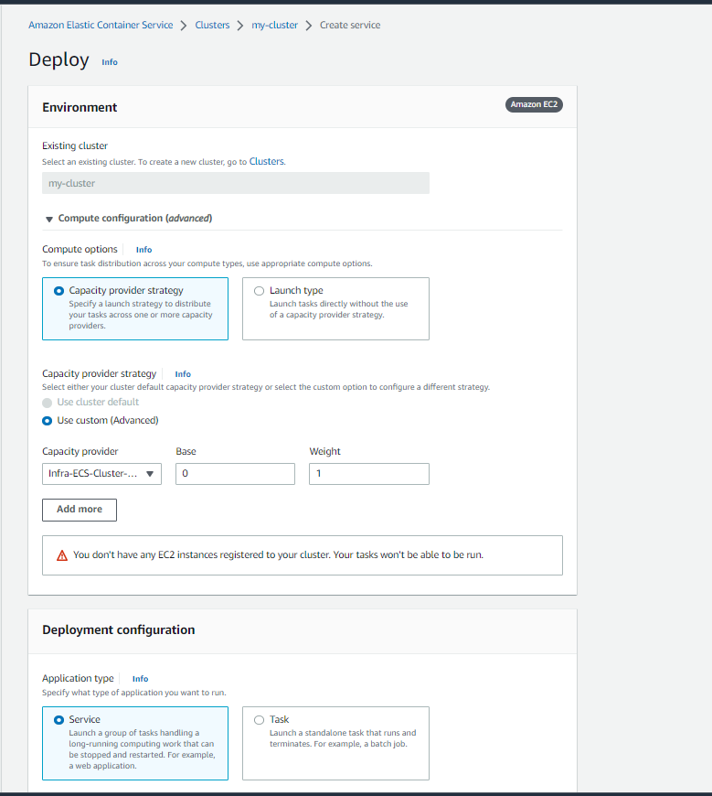

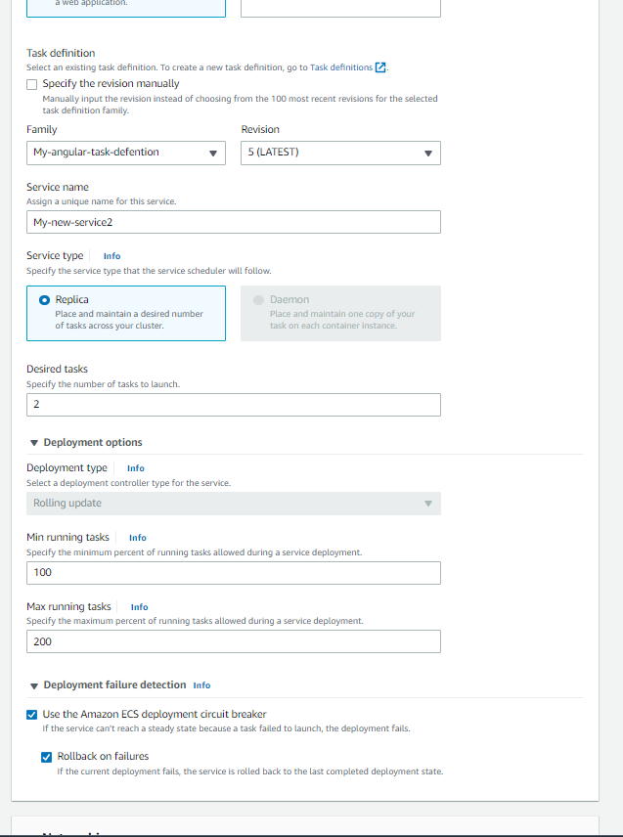

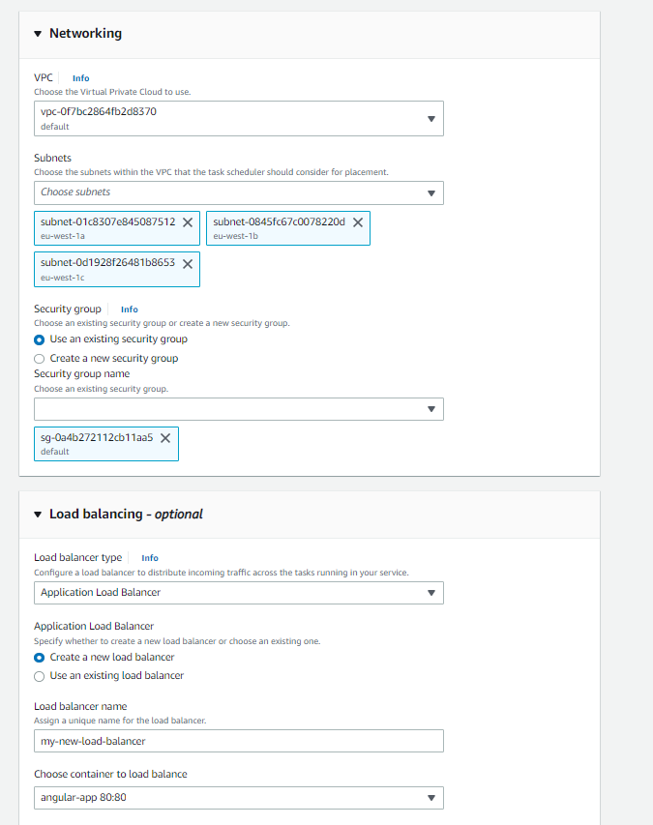

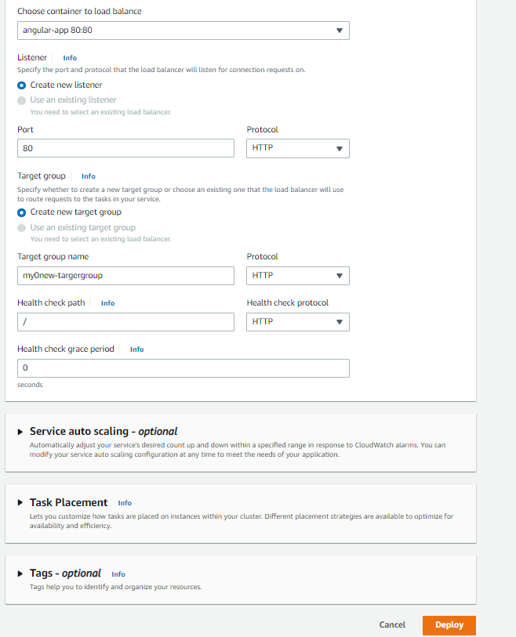

* The new service we have created



